# Phase Coupling Functional Connectomes (Hilbert transform)

Note that unlike the connectivity profiles presented in the results section, the fill scale is independent for each functional connectome presented below with a range spanning from zero to the largest connectivity value in a given connectome. This was done to highlight the connectivity structure in each connectome as clearly as possible, rather than to facilitate visual comparisons between connectomes by using a consistent scale spanning the full range of possible values as was done in the results section of the thesis manuscript.

## Delta band

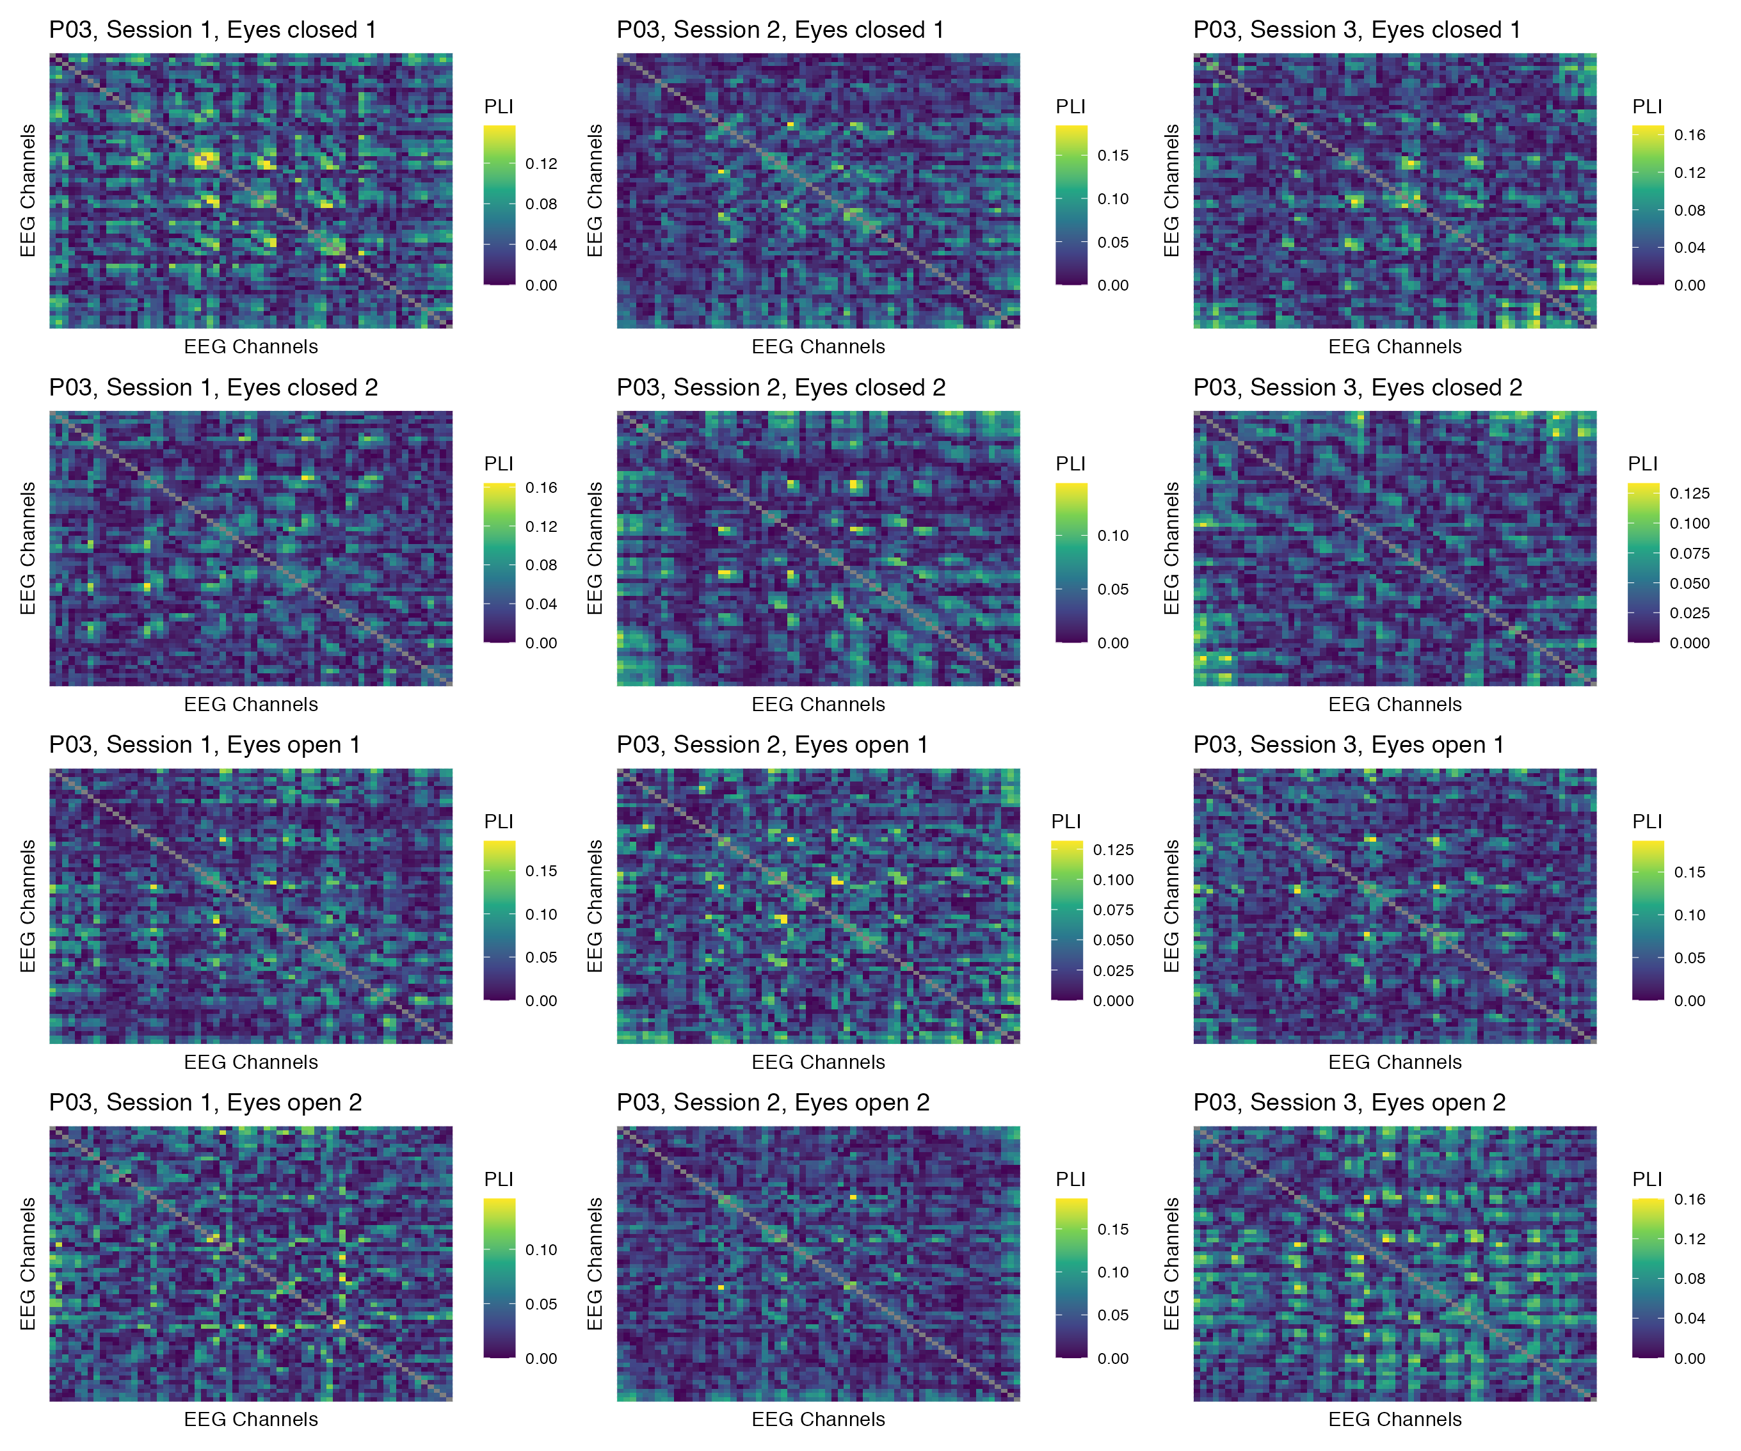

Figure 1: Phase coupling functional connectomes for participant P03 in the delta band. For each functional connectome, EEG channels are ordered as follows (from left to right, and from top to bottom): Fp1, Fp2, AF7, AF3, AFz, AF4, AF8, F7, F5, F3, F1, Fz, F2, F4, F6, F8, FT9, FT7, FC5, FC3, FC1, FCz, FC2, FC4, FC6, FT8, FT10, T7, C5, C3, C1, Cz, C2, C4, C6, T8, TP9, TP7, CP5, CP3, CP1, CPz, CP2, CP4, CP6, TP8, TP10, P7, P5, P3, P1, Pz, P2, P4, P6, P8, PO7, PO3, POz, PO4, PO8, O1, Oz, O2.

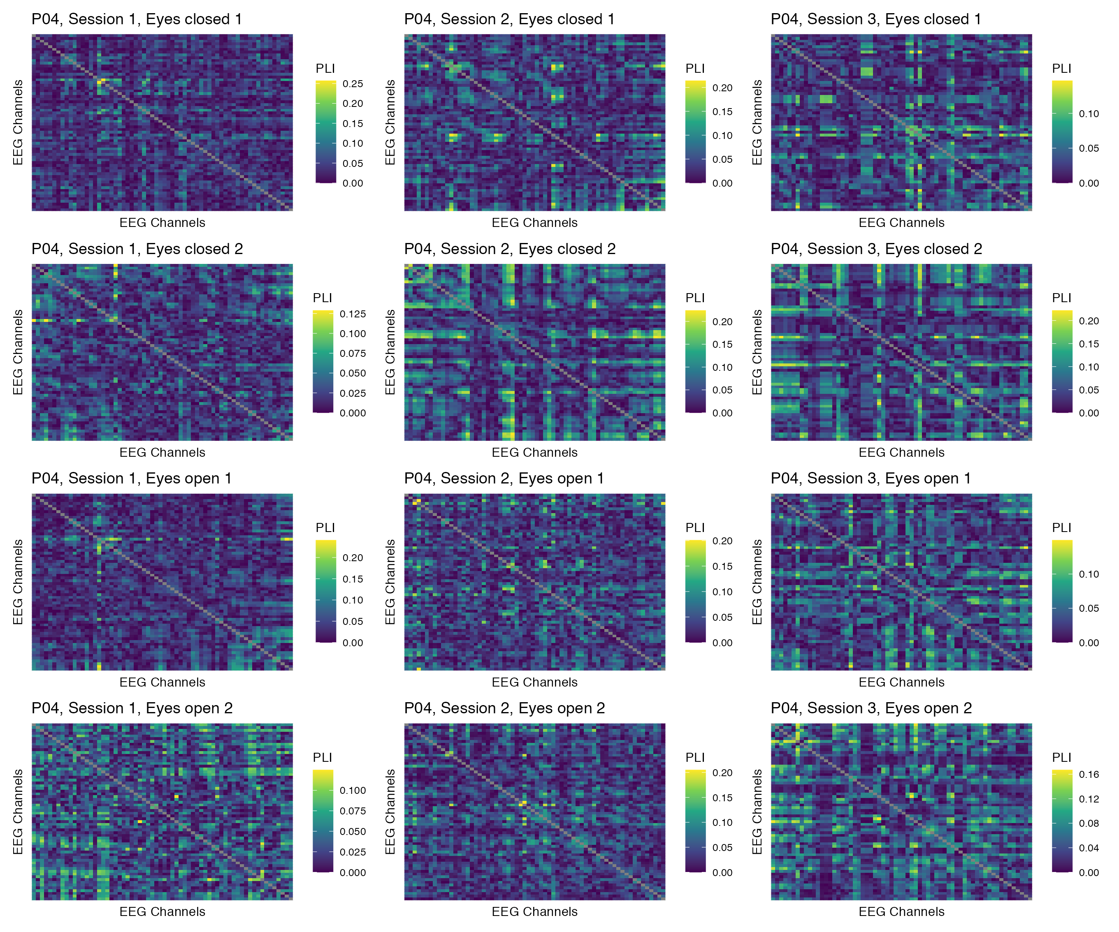

Figure 2: Phase coupling functional connectomes for participant P04 in the delta band. For each functional connectome, EEG channels are ordered as follows (from left to right, and from top to bottom): Fp1, Fp2, AF7, AF3, AFz, AF4, AF8, F7, F5, F3, F1, Fz, F2, F4, F6, F8, FT9, FT7, FC5, FC3, FC1, FCz, FC2, FC4, FC6, FT8, FT10, T7, C5, C3, C1, Cz, C2, C4, C6, T8, TP9, TP7, CP5, CP3, CP1, CPz, CP2, CP4, CP6, TP8, TP10, P7, P5, P3, P1, Pz, P2, P4, P6, P8, PO7, PO3, POz, PO4, PO8, O1, Oz, O2.

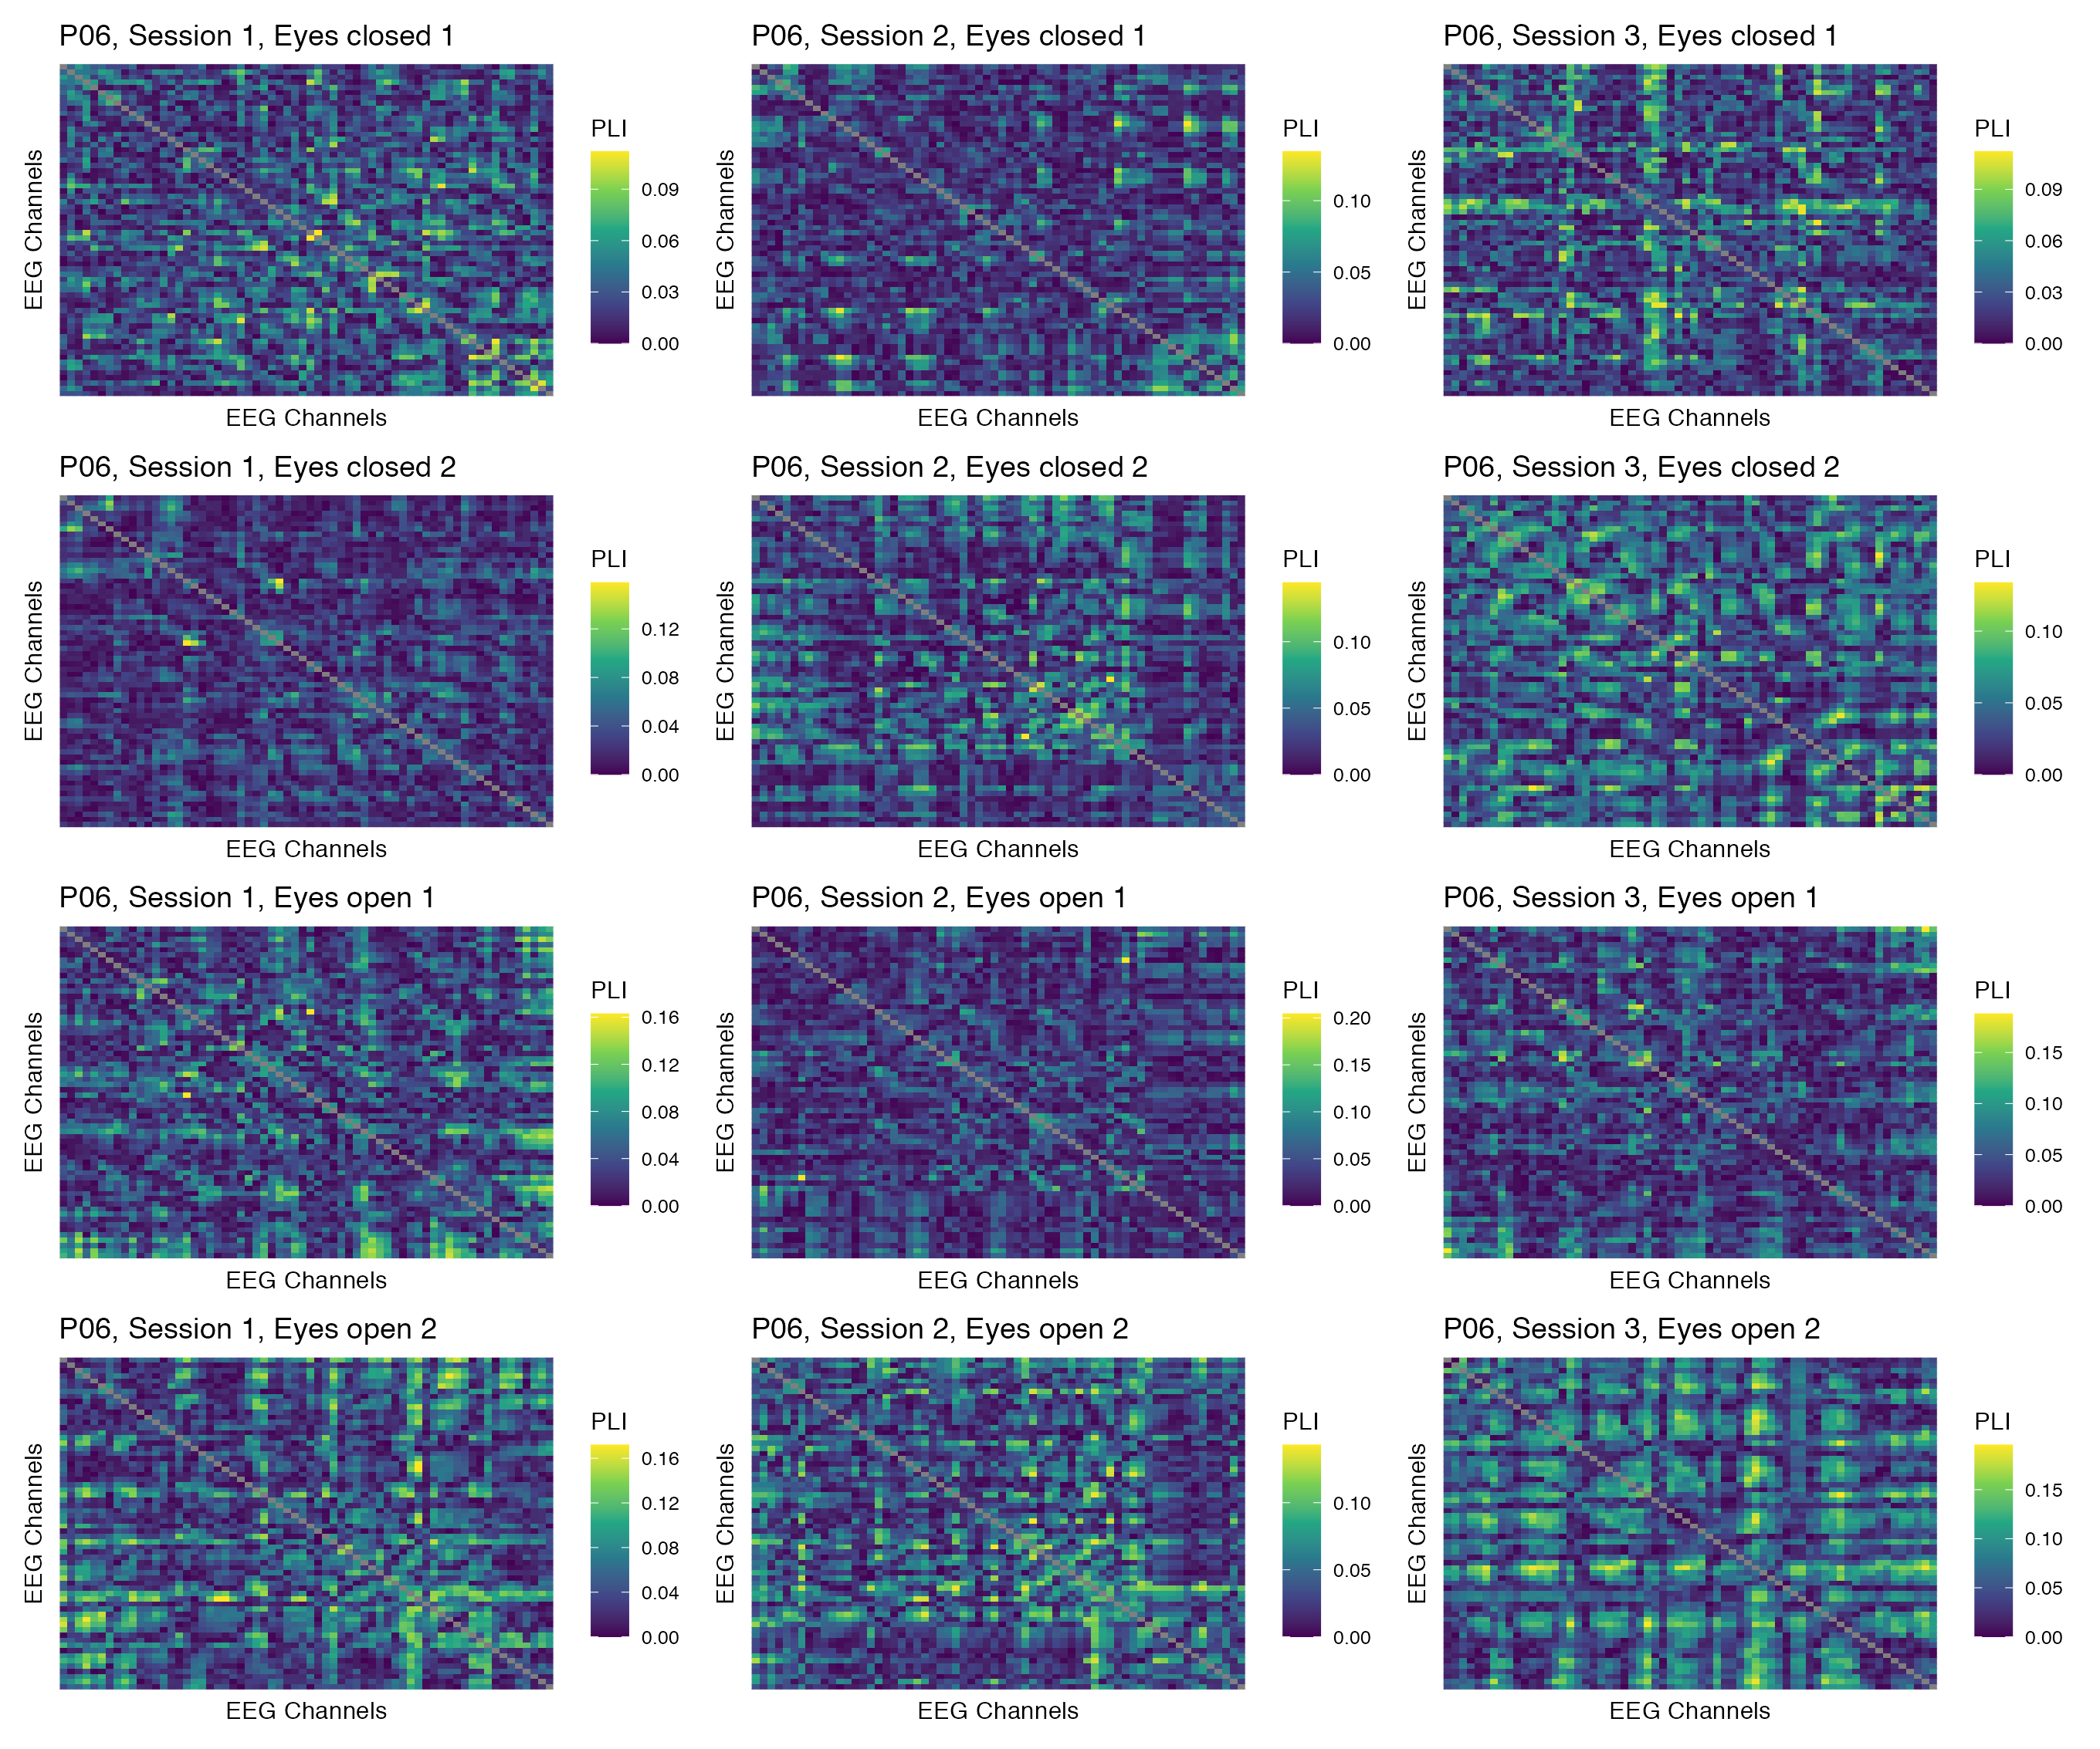

Figure 3: Phase coupling functional connectomes for participant P06 in the delta band. For each functional connectome, EEG channels are ordered as follows (from left to right, and from top to bottom): Fp1, Fp2, AF7, AF3, AFz, AF4, AF8, F7, F5, F3, F1, Fz, F2, F4, F6, F8, FT9, FT7, FC5, FC3, FC1, FCz, FC2, FC4, FC6, FT8, FT10, T7, C5, C3, C1, Cz, C2, C4, C6, T8, TP9, TP7, CP5, CP3, CP1, CPz, CP2, CP4, CP6, TP8, TP10, P7, P5, P3, P1, Pz, P2, P4, P6, P8, PO7, PO3, POz, PO4, PO8, O1, Oz, O2.

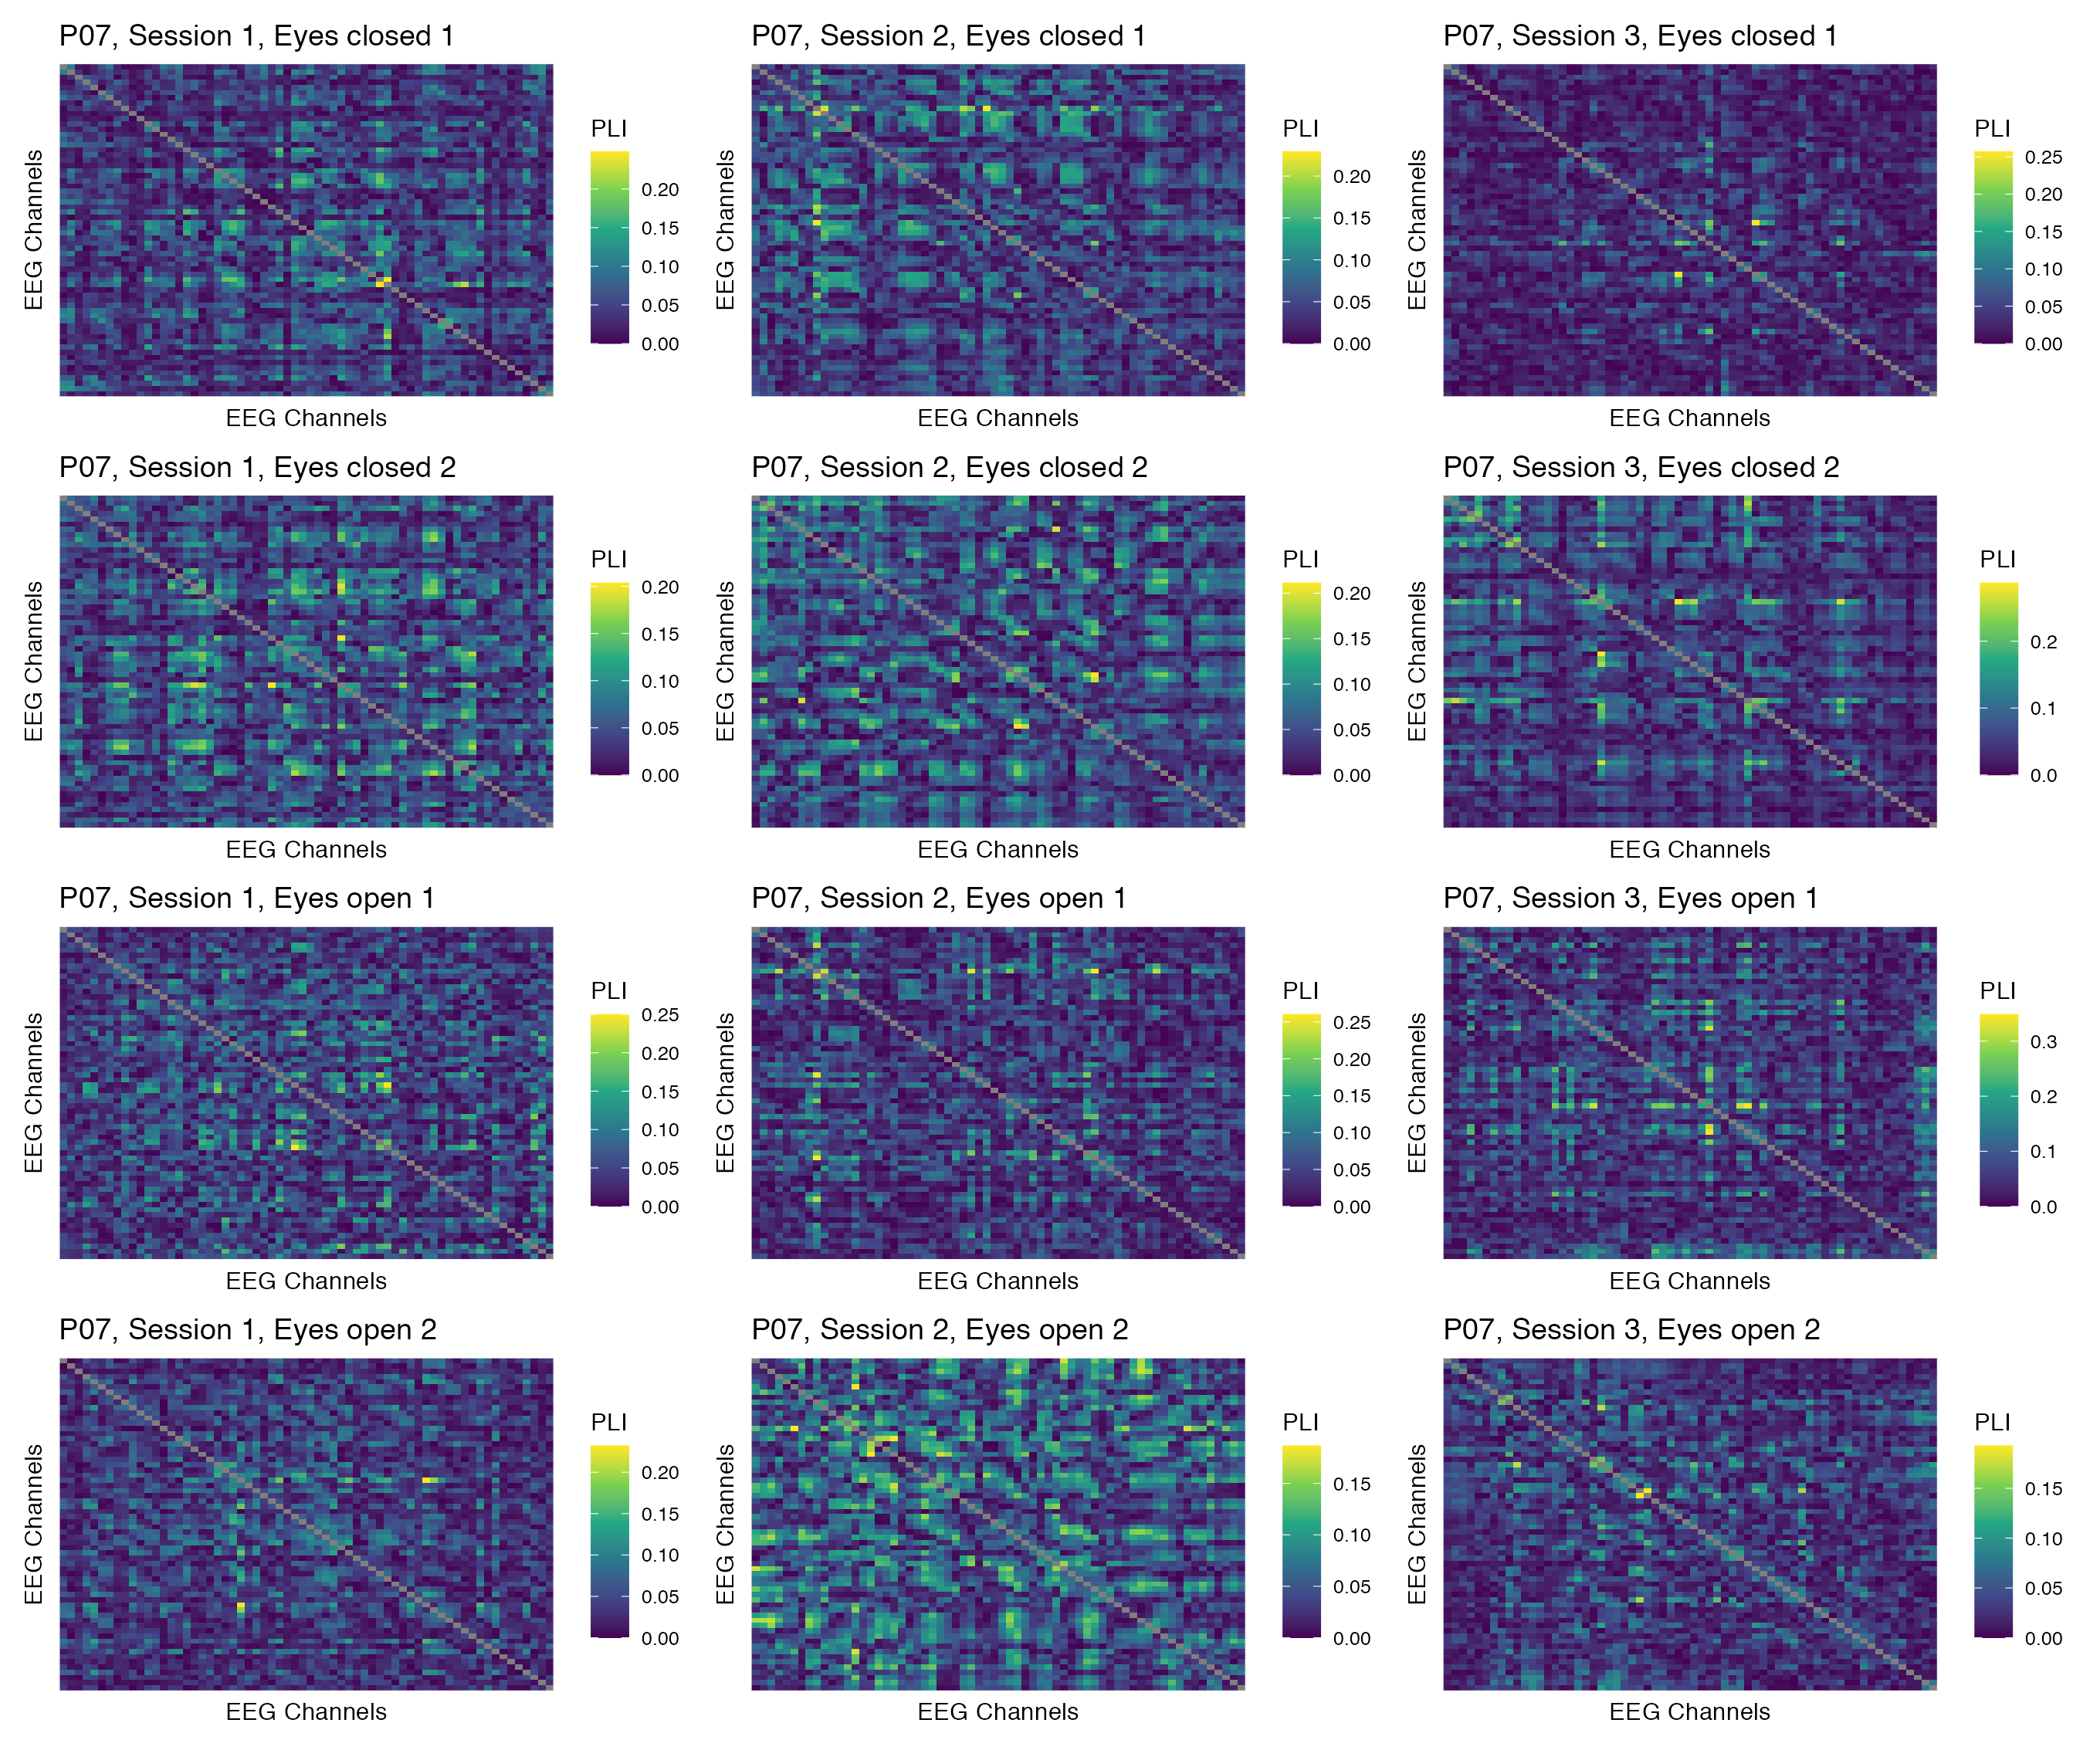

Figure 4: Phase coupling functional connectomes for participant P07 in the delta band. For each functional connectome, EEG channels are ordered as follows (from left to right, and from top to bottom): Fp1, Fp2, AF7, AF3, AFz, AF4, AF8, F7, F5, F3, F1, Fz, F2, F4, F6, F8, FT9, FT7, FC5, FC3, FC1, FCz, FC2, FC4, FC6, FT8, FT10, T7, C5, C3, C1, Cz, C2, C4, C6, T8, TP9, TP7, CP5, CP3, CP1, CPz, CP2, CP4, CP6, TP8, TP10, P7, P5, P3, P1, Pz, P2, P4, P6, P8, PO7, PO3, POz, PO4, PO8, O1, Oz, O2.

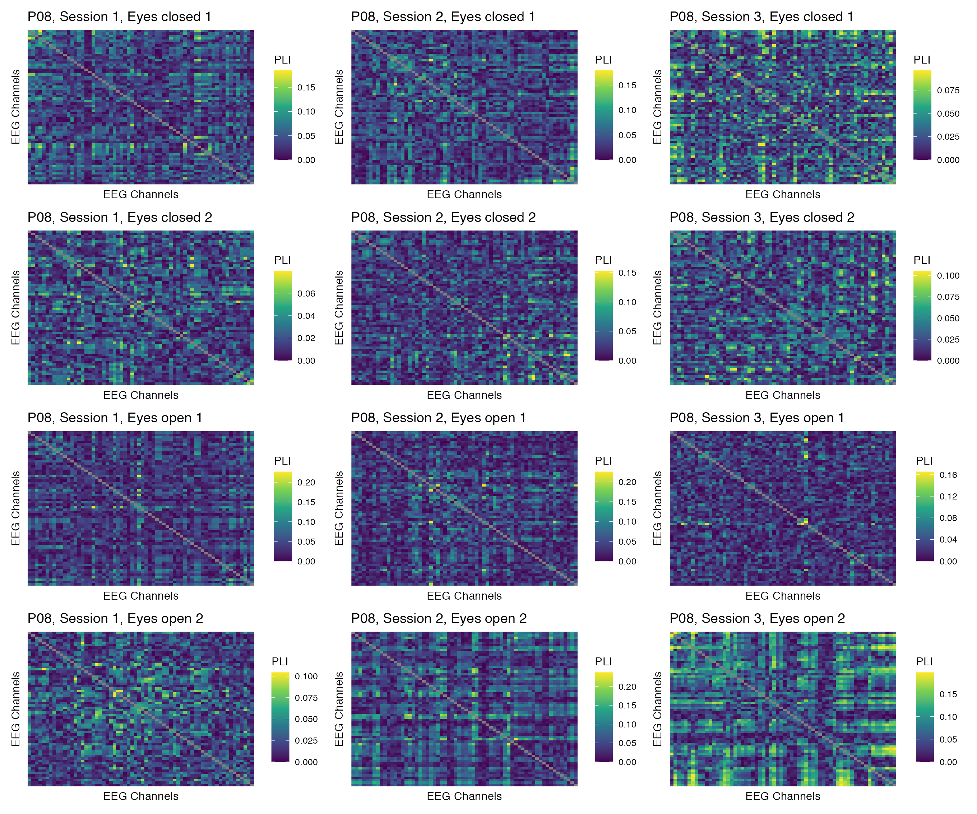

Figure 5: Phase coupling functional connectomes for participant P08 in the delta band. For each functional connectome, EEG channels are ordered as follows (from left to right, and from top to bottom): Fp1, Fp2, AF7, AF3, AFz, AF4, AF8, F7, F5, F3, F1, Fz, F2, F4, F6, F8, FT9, FT7, FC5, FC3, FC1, FCz, FC2, FC4, FC6, FT8, FT10, T7, C5, C3, C1, Cz, C2, C4, C6, T8, TP9, TP7, CP5, CP3, CP1, CPz, CP2, CP4, CP6, TP8, TP10, P7, P5, P3, P1, Pz, P2, P4, P6, P8, PO7, PO3, POz, PO4, PO8, O1, Oz, O2.

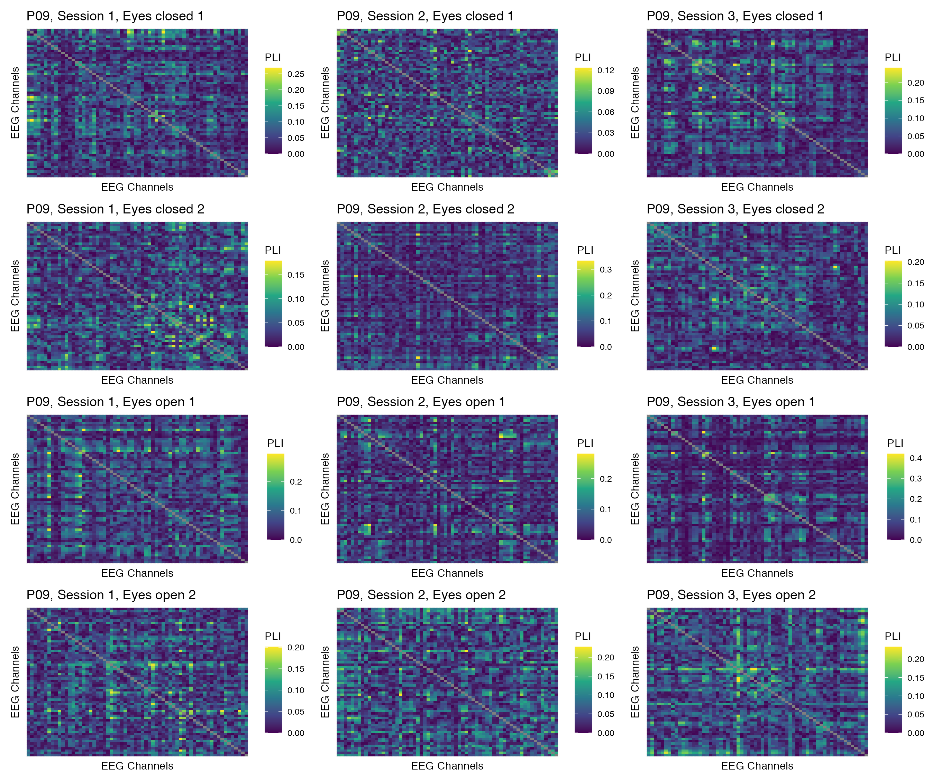

Figure 6: Phase coupling functional connectomes for participant P09 in the delta band. For each functional connectome, EEG channels are ordered as follows (from left to right, and from top to bottom): Fp1, Fp2, AF7, AF3, AFz, AF4, AF8, F7, F5, F3, F1, Fz, F2, F4, F6, F8, FT9, FT7, FC5, FC3, FC1, FCz, FC2, FC4, FC6, FT8, FT10, T7, C5, C3, C1, Cz, C2, C4, C6, T8, TP9, TP7, CP5, CP3, CP1, CPz, CP2, CP4, CP6, TP8, TP10, P7, P5, P3, P1, Pz, P2, P4, P6, P8, PO7, PO3, POz, PO4, PO8, O1, Oz, O2.

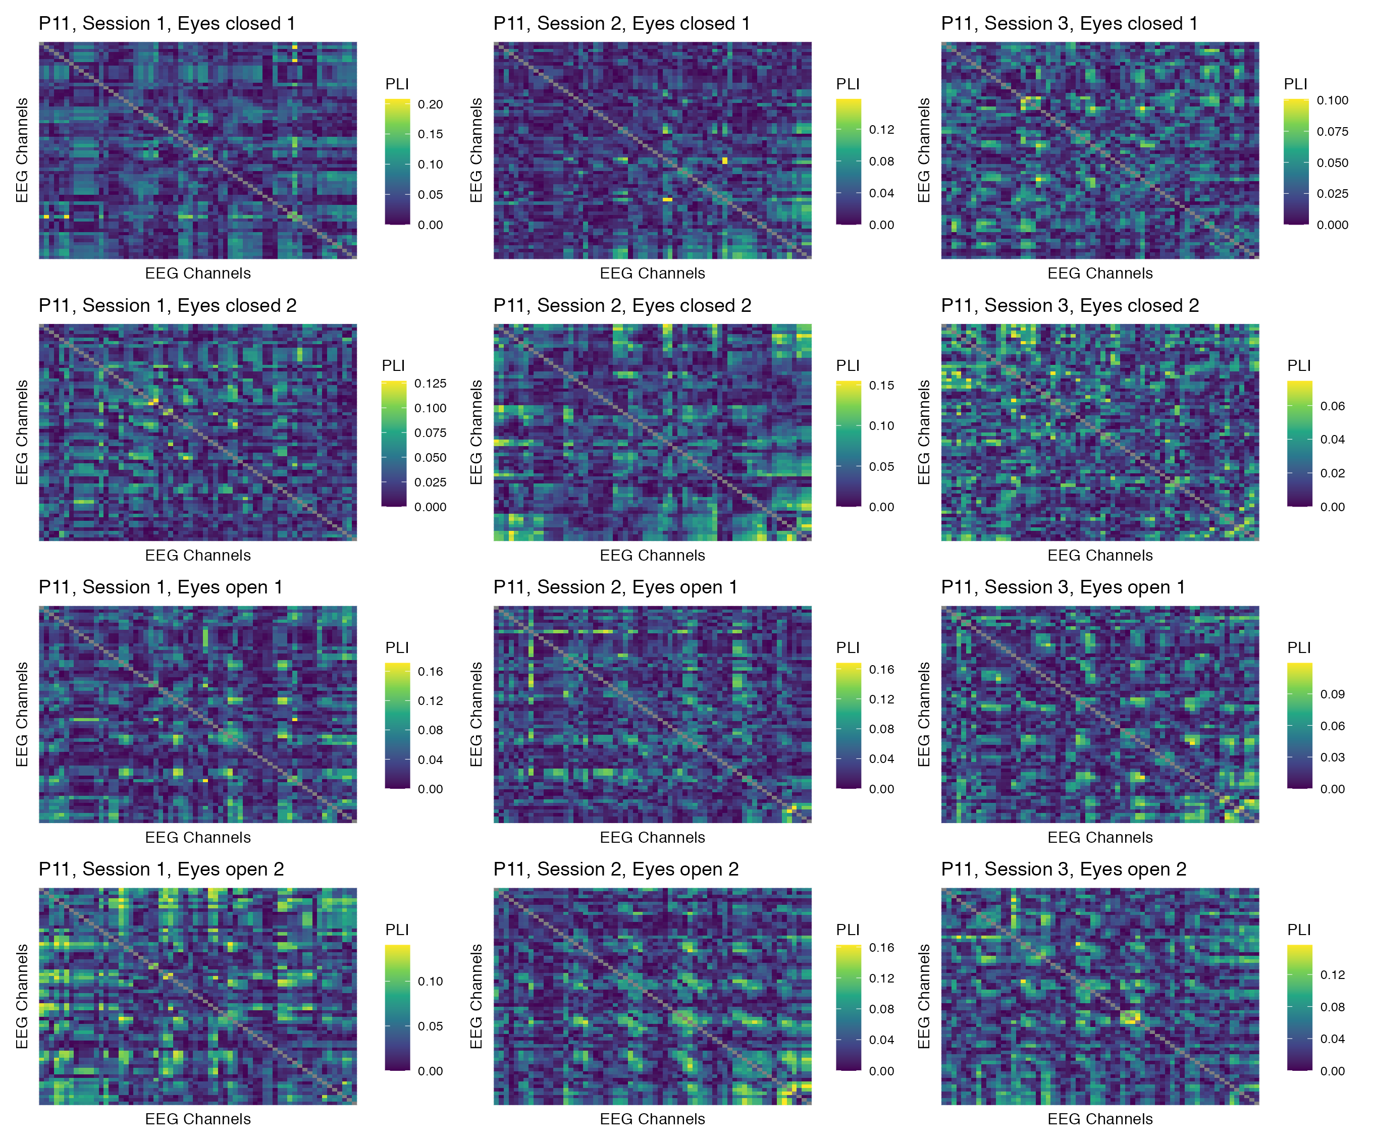

Figure 7: Phase coupling functional connectomes for participant P11 in the delta band. For each functional connectome, EEG channels are ordered as follows (from left to right, and from top to bottom): Fp1, Fp2, AF7, AF3, AFz, AF4, AF8, F7, F5, F3, F1, Fz, F2, F4, F6, F8, FT9, FT7, FC5, FC3, FC1, FCz, FC2, FC4, FC6, FT8, FT10, T7, C5, C3, C1, Cz, C2, C4, C6, T8, TP9, TP7, CP5, CP3, CP1, CPz, CP2, CP4, CP6, TP8, TP10, P7, P5, P3, P1, Pz, P2, P4, P6, P8, PO7, PO3, POz, PO4, PO8, O1, Oz, O2.

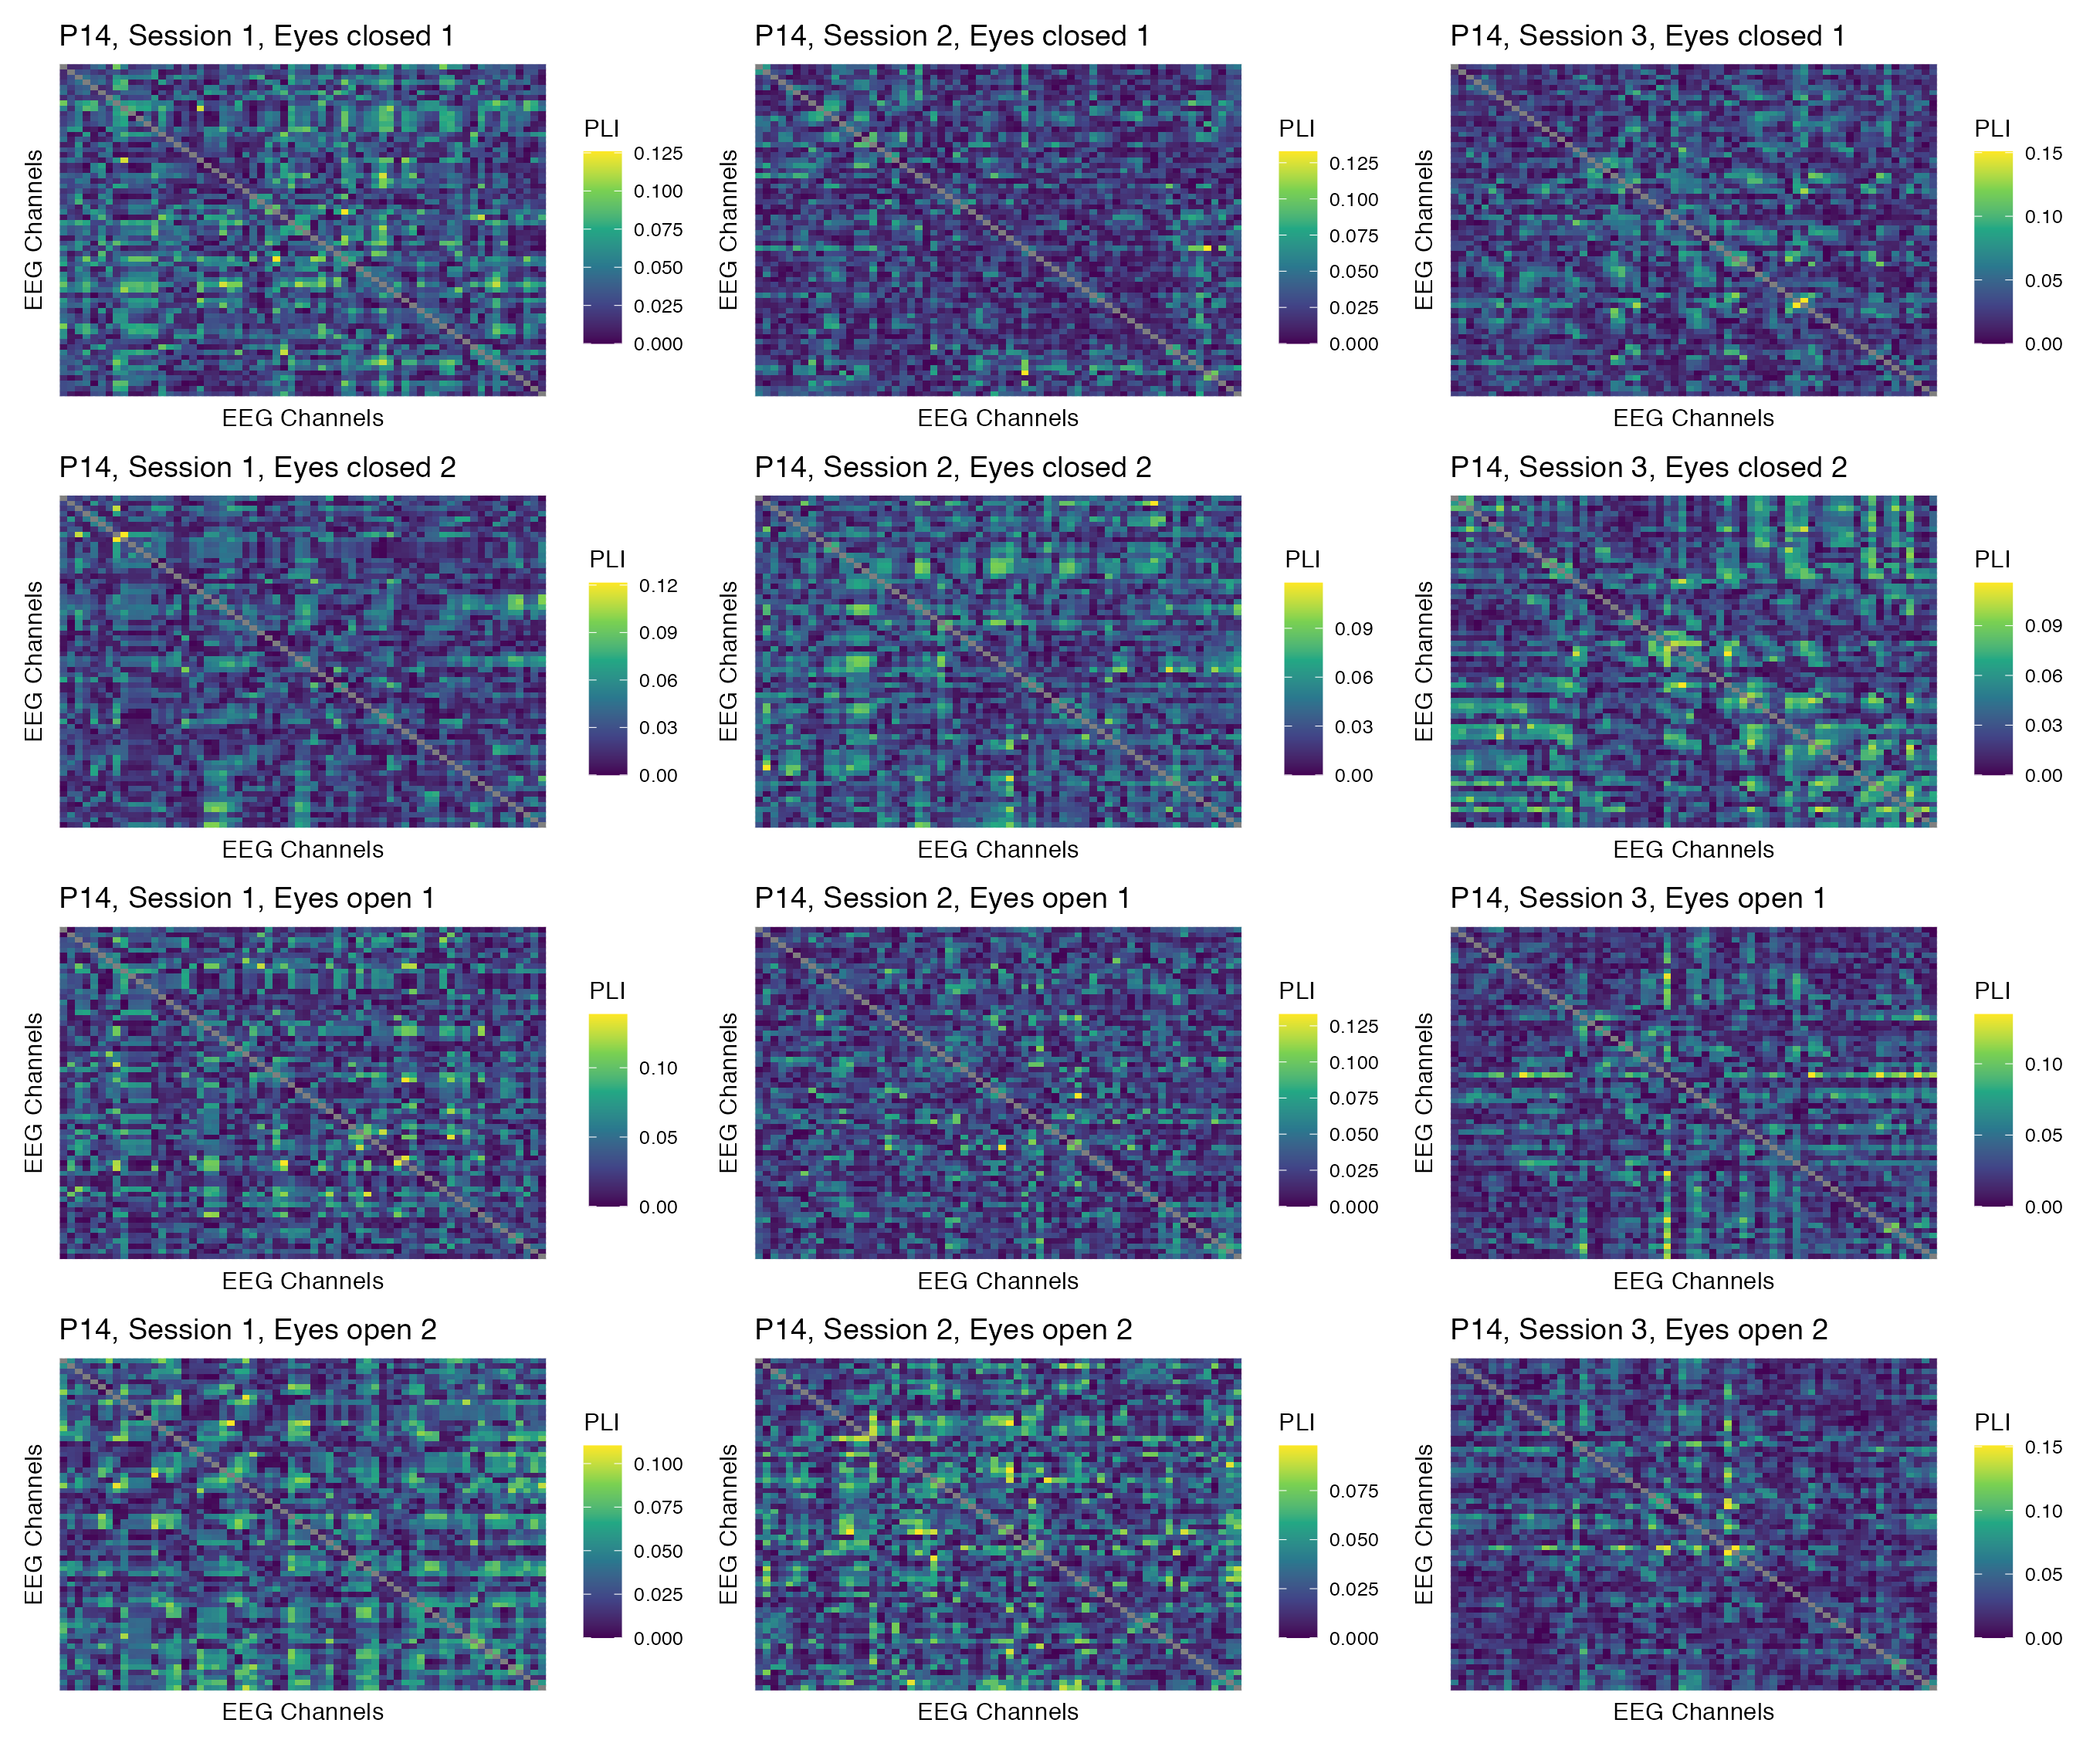

Figure 8: Phase coupling functional connectomes for participant P14 in the delta band. For each functional connectome, EEG channels are ordered as follows (from left to right, and from top to bottom): Fp1, Fp2, AF7, AF3, AFz, AF4, AF8, F7, F5, F3, F1, Fz, F2, F4, F6, F8, FT9, FT7, FC5, FC3, FC1, FCz, FC2, FC4, FC6, FT8, FT10, T7, C5, C3, C1, Cz, C2, C4, C6, T8, TP9, TP7, CP5, CP3, CP1, CPz, CP2, CP4, CP6, TP8, TP10, P7, P5, P3, P1, Pz, P2, P4, P6, P8, PO7, PO3, POz, PO4, PO8, O1, Oz, O2.

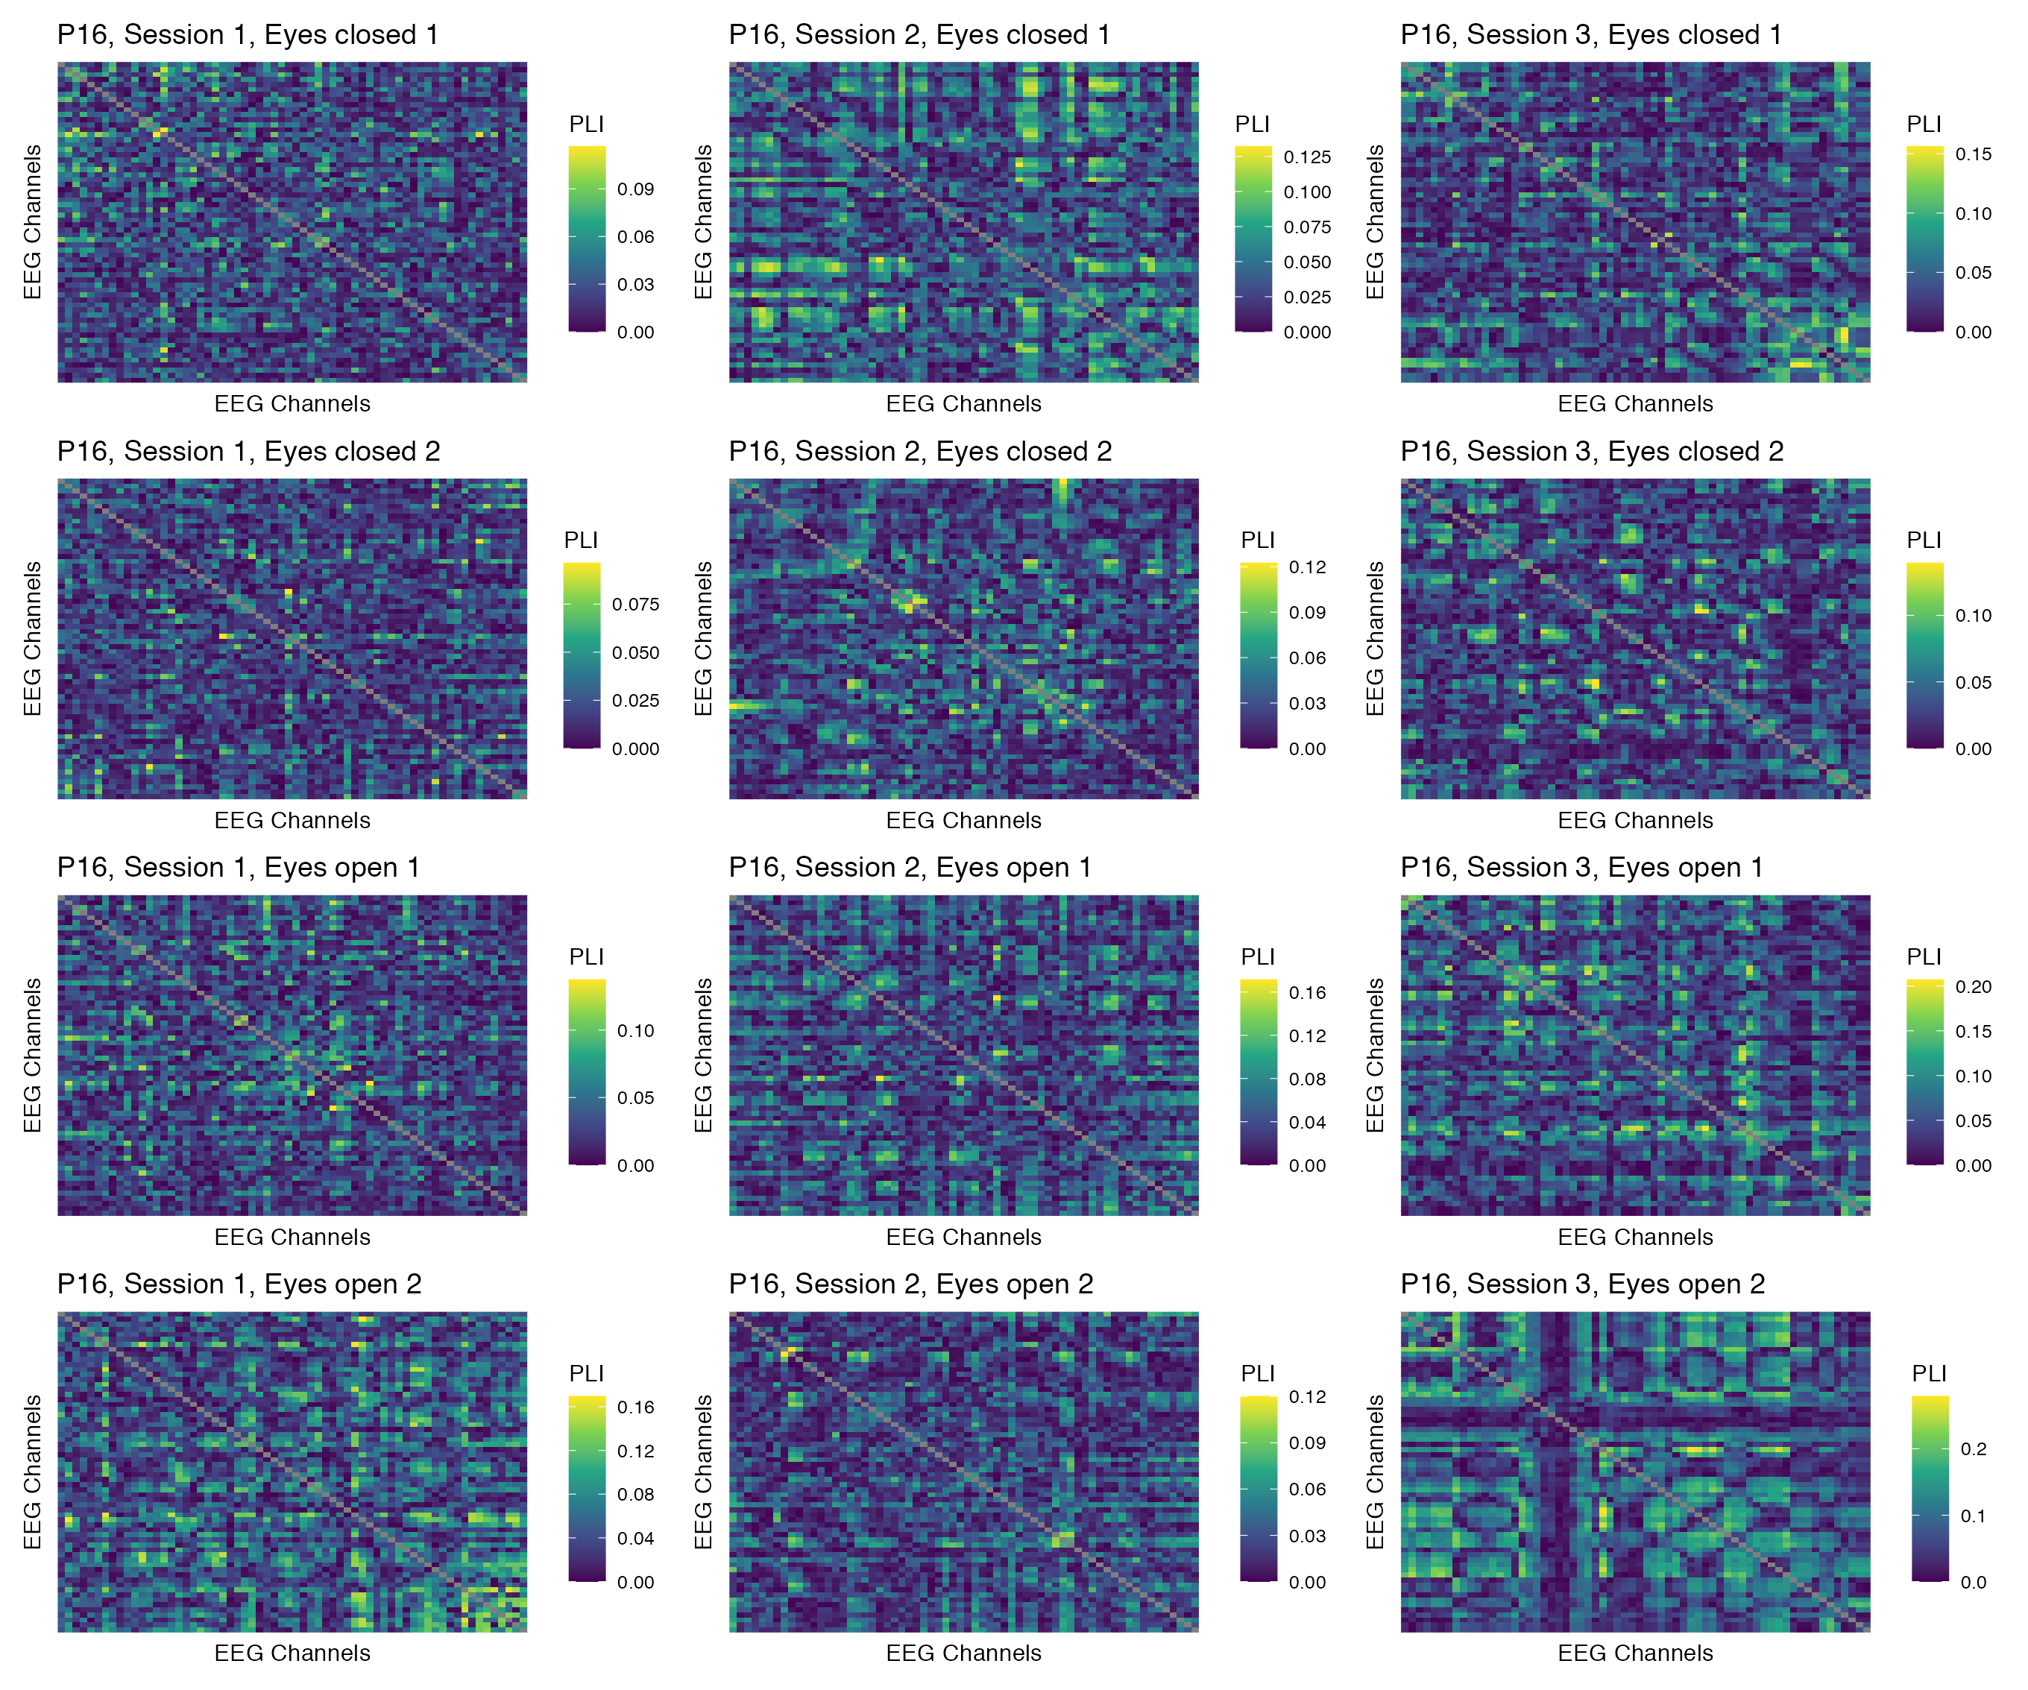

Figure 9: Phase coupling functional connectomes for participant P16 in the delta band. For each functional connectome, EEG channels are ordered as follows (from left to right, and from top to bottom): Fp1, Fp2, AF7, AF3, AFz, AF4, AF8, F7, F5, F3, F1, Fz, F2, F4, F6, F8, FT9, FT7, FC5, FC3, FC1, FCz, FC2, FC4, FC6, FT8, FT10, T7, C5, C3, C1, Cz, C2, C4, C6, T8, TP9, TP7, CP5, CP3, CP1, CPz, CP2, CP4, CP6, TP8, TP10, P7, P5, P3, P1, Pz, P2, P4, P6, P8, PO7, PO3, POz, PO4, PO8, O1, Oz, O2.

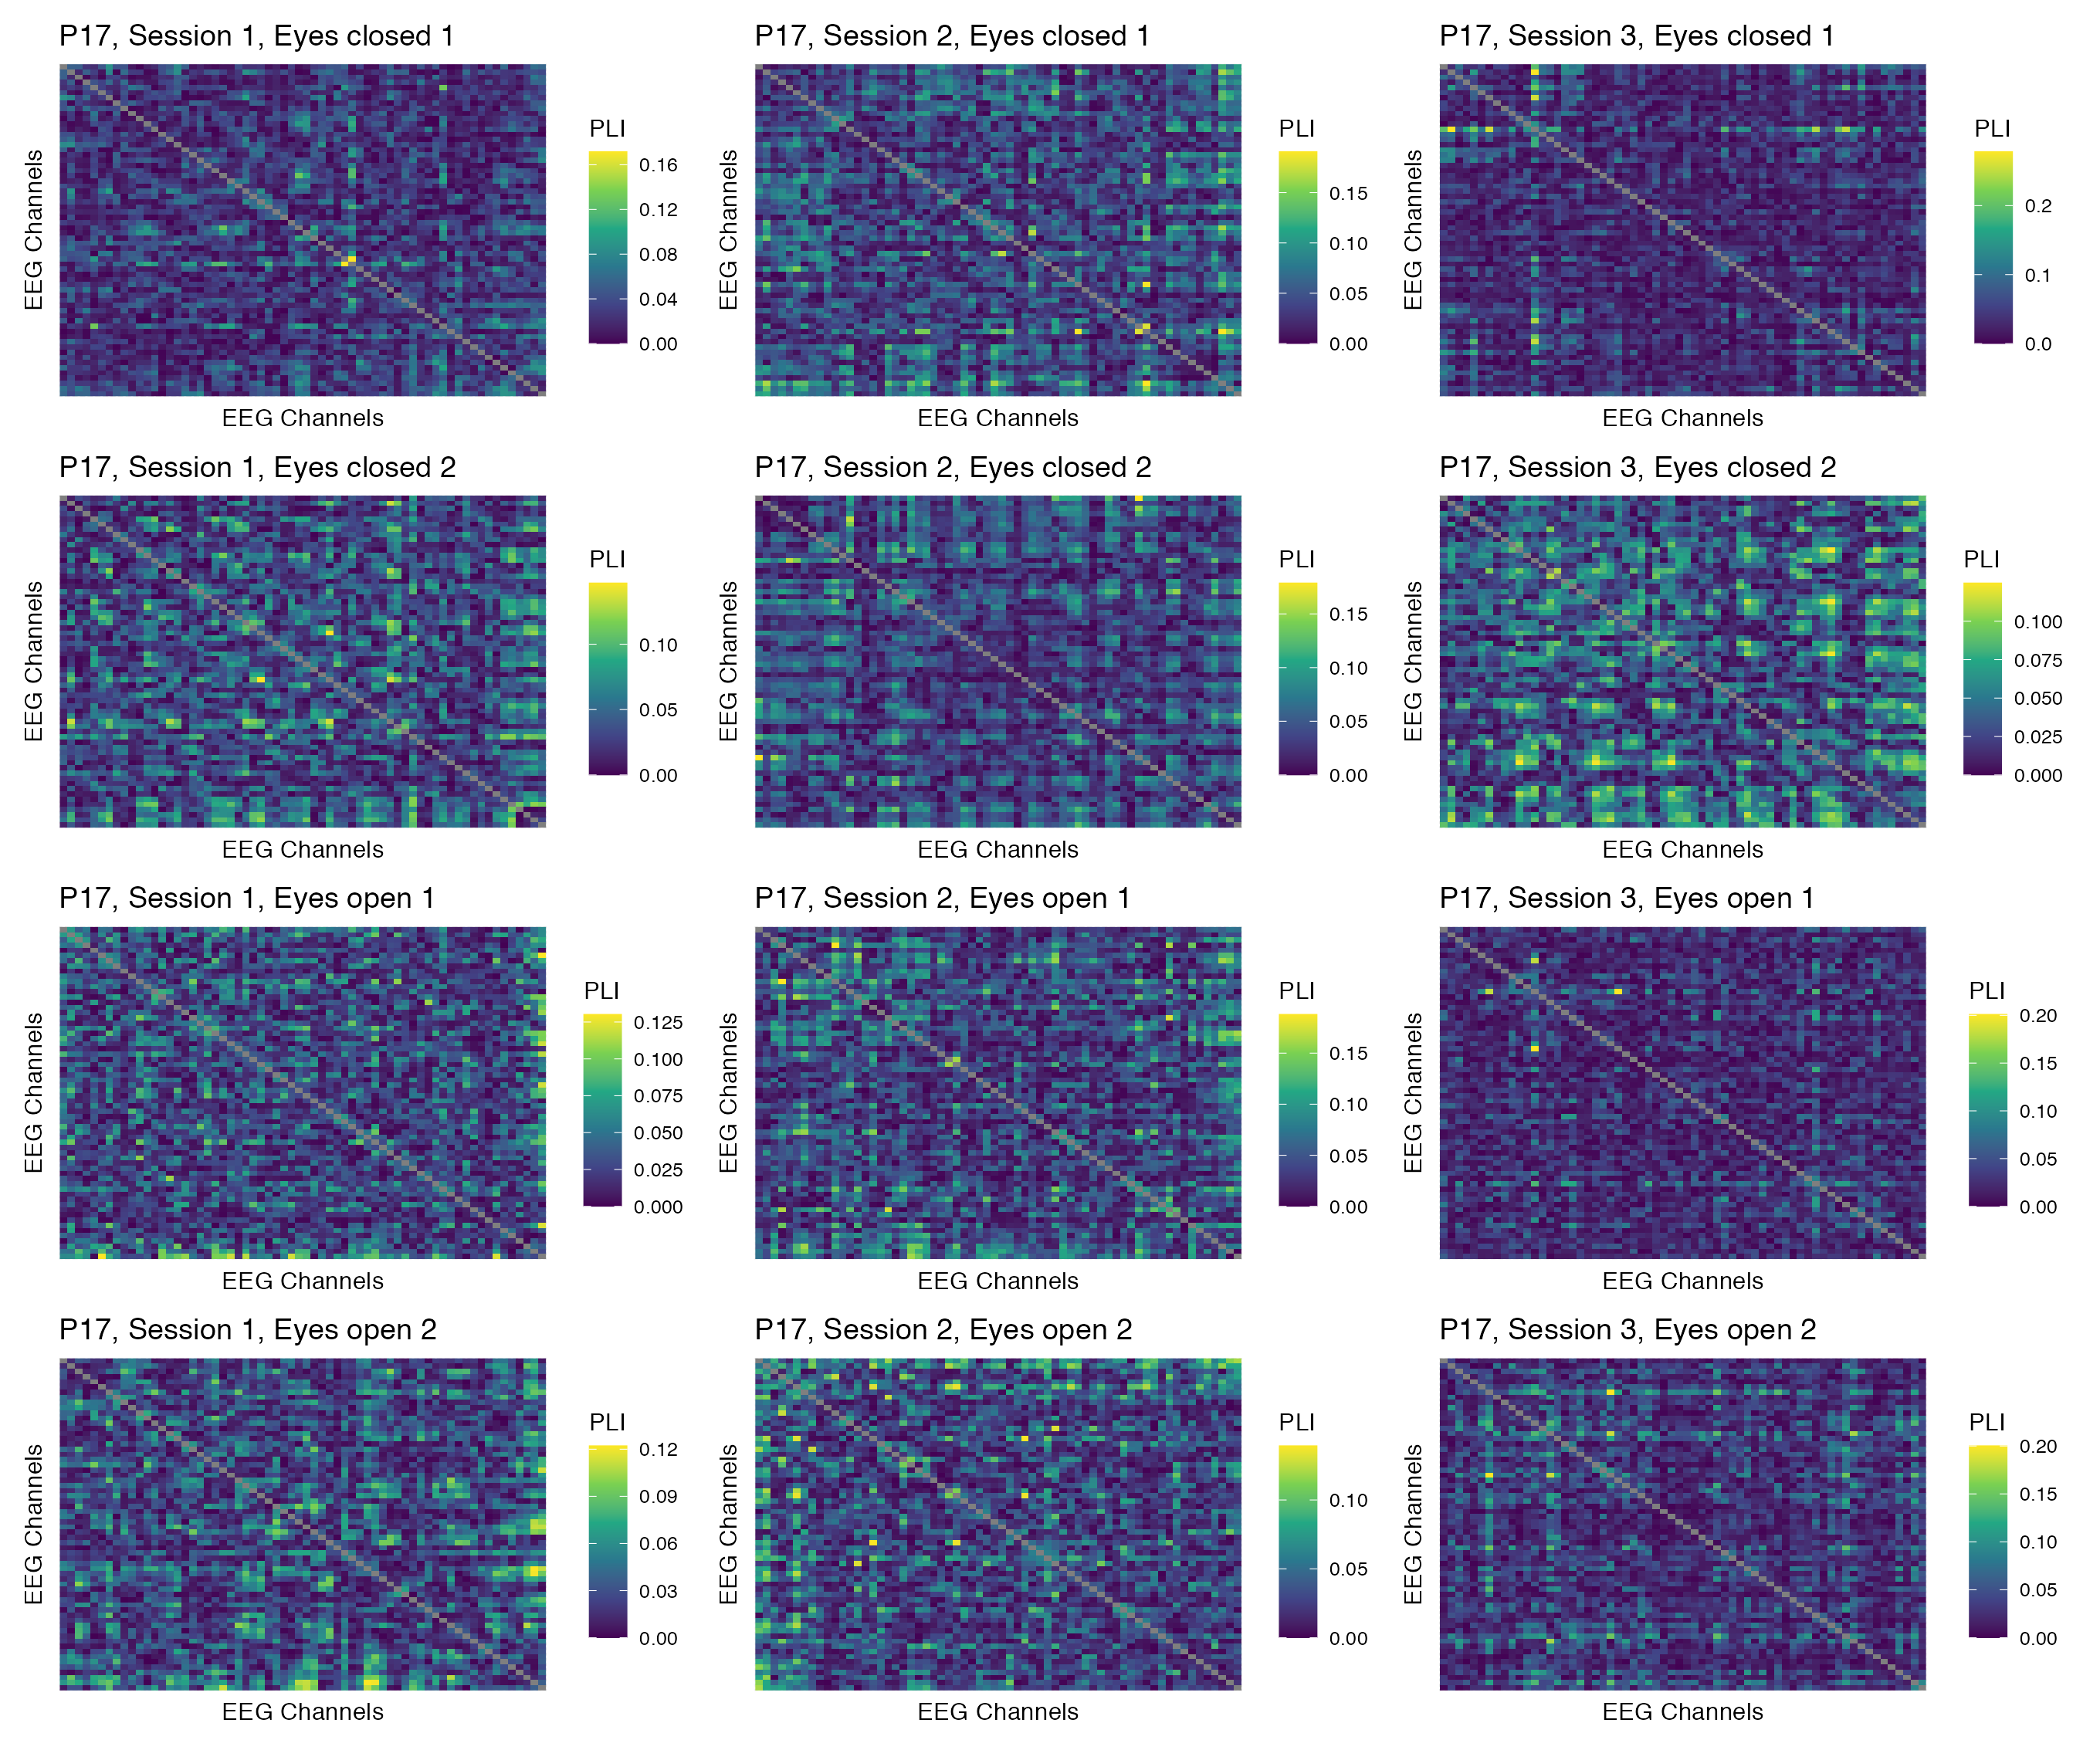

Figure 10: Phase coupling functional connectomes for participant P17 in the delta band. For each functional connectome, EEG channels are ordered as follows (from left to right, and from top to bottom): Fp1, Fp2, AF7, AF3, AFz, AF4, AF8, F7, F5, F3, F1, Fz, F2, F4, F6, F8, FT9, FT7, FC5, FC3, FC1, FCz, FC2, FC4, FC6, FT8, FT10, T7, C5, C3, C1, Cz, C2, C4, C6, T8, TP9, TP7, CP5, CP3, CP1, CPz, CP2, CP4, CP6, TP8, TP10, P7, P5, P3, P1, Pz, P2, P4, P6, P8, PO7, PO3, POz, PO4, PO8, O1, Oz, O2.

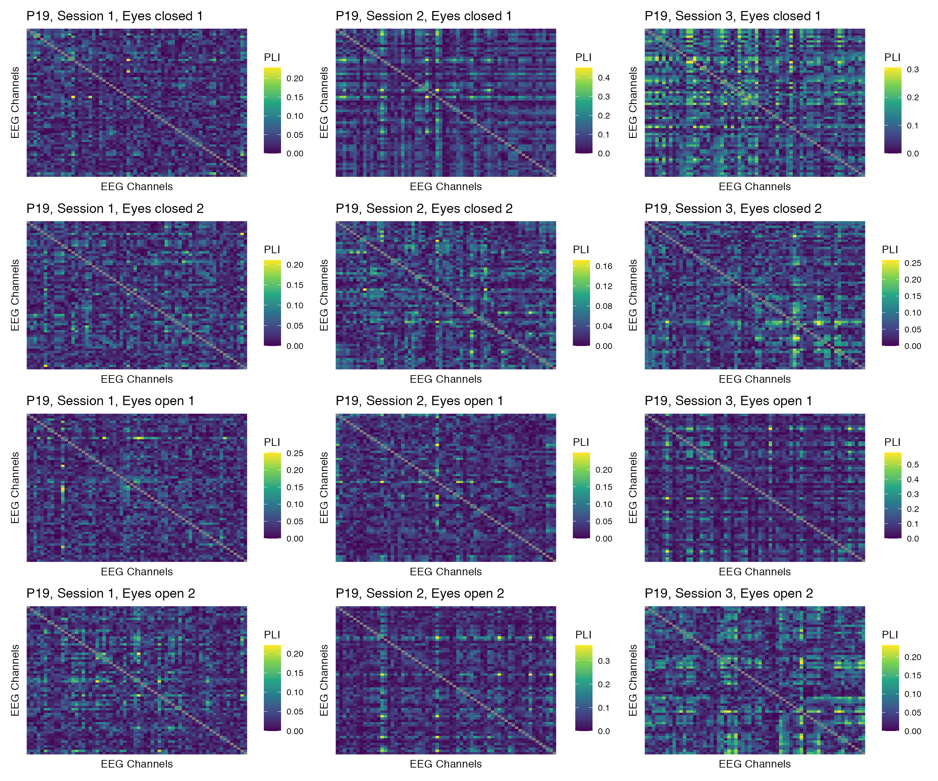

Figure 11: Phase coupling functional connectomes for participant P19 in the delta band. For each functional connectome, EEG channels are ordered as follows (from left to right, and from top to bottom): Fp1, Fp2, AF7, AF3, AFz, AF4, AF8, F7, F5, F3, F1, Fz, F2, F4, F6, F8, FT9, FT7, FC5, FC3, FC1, FCz, FC2, FC4, FC6, FT8, FT10, T7, C5, C3, C1, Cz, C2, C4, C6, T8, TP9, TP7, CP5, CP3, CP1, CPz, CP2, CP4, CP6, TP8, TP10, P7, P5, P3, P1, Pz, P2, P4, P6, P8, PO7, PO3, POz, PO4, PO8, O1, Oz, O2.

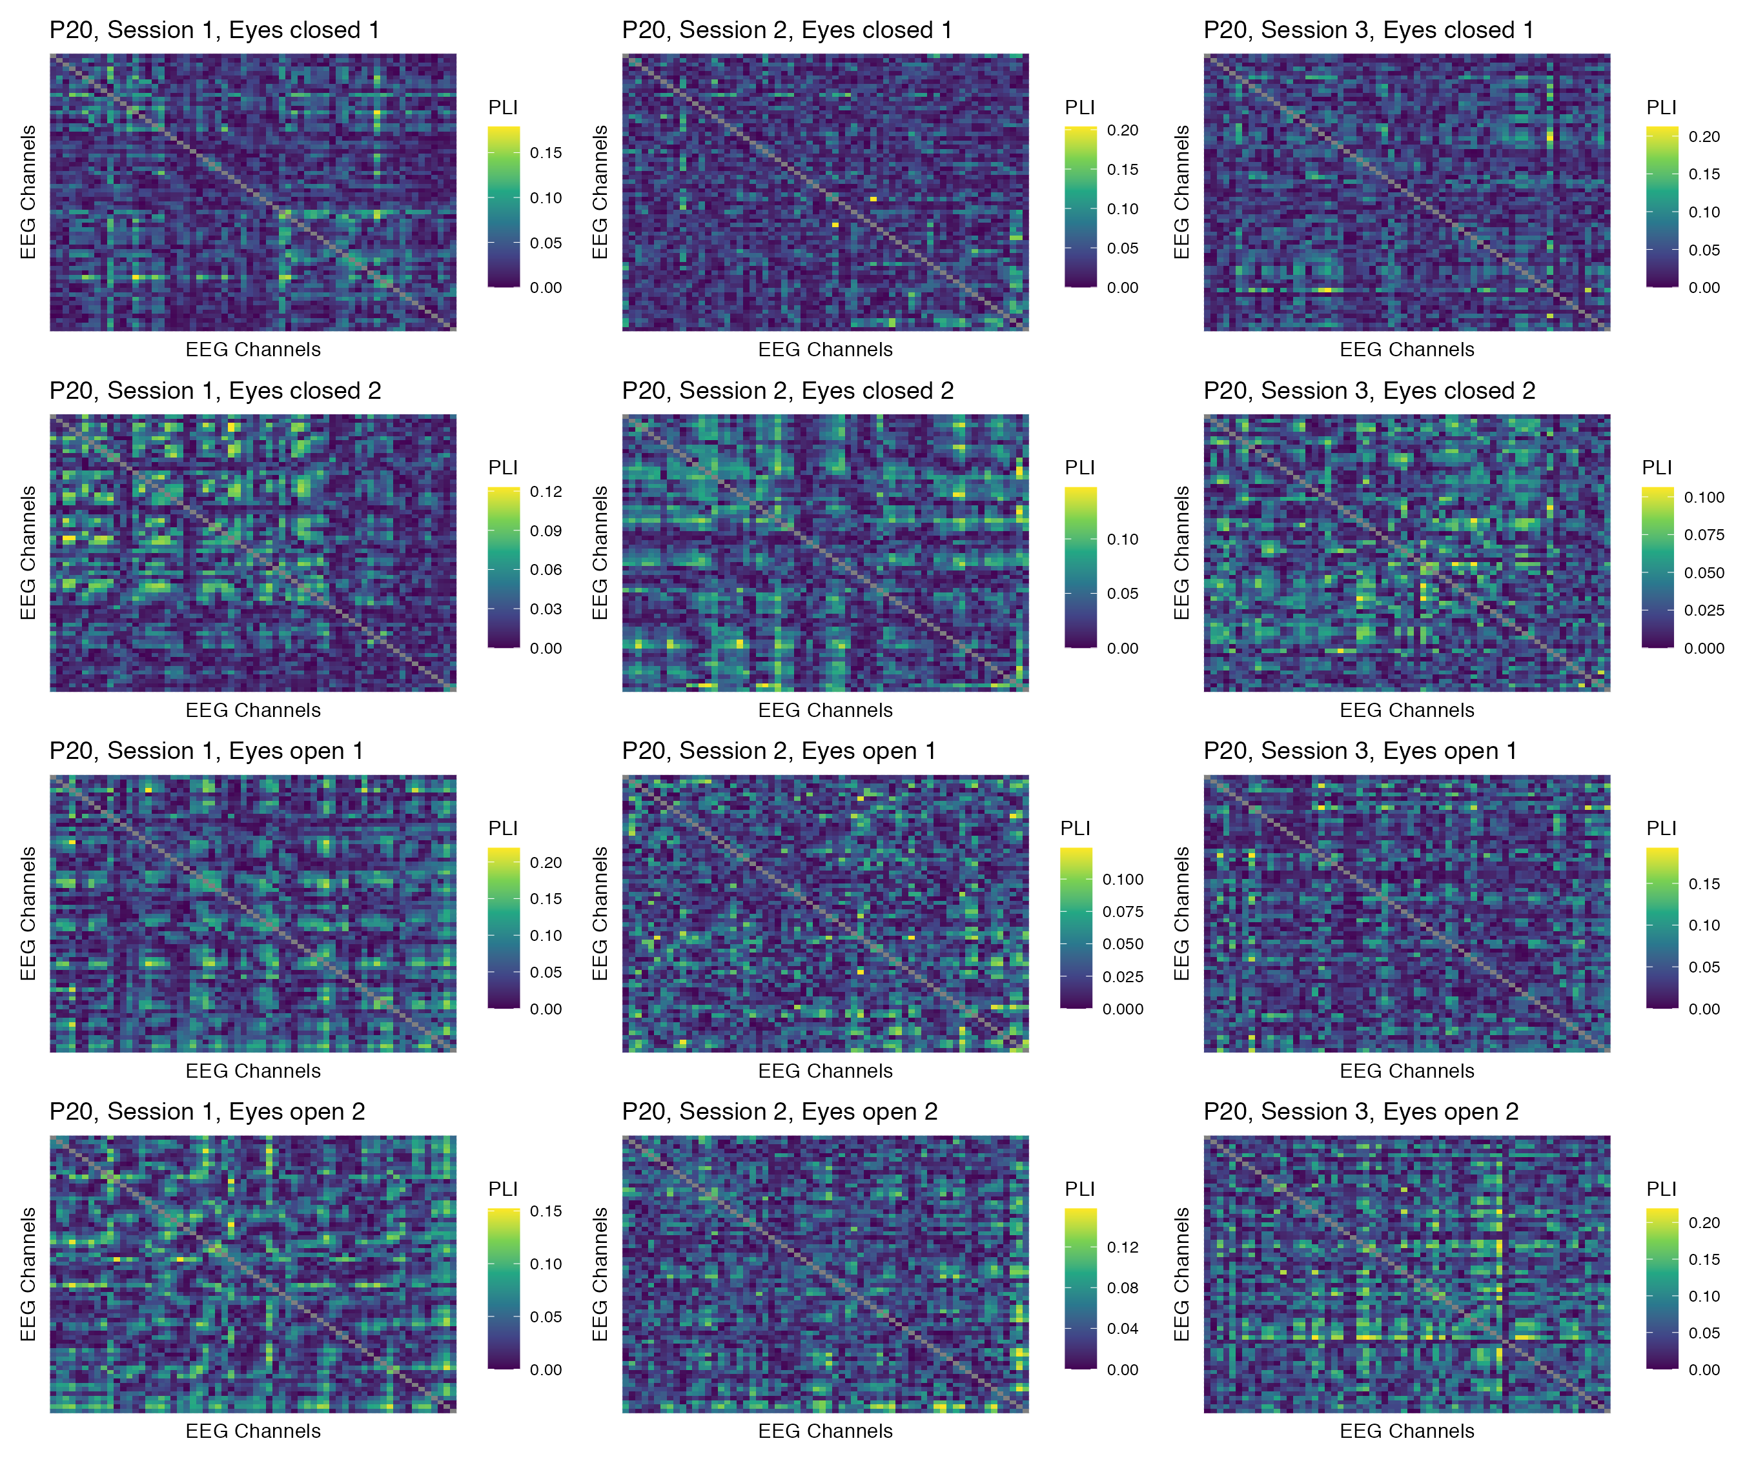

Figure 12: Phase coupling functional connectomes for participant P20 in the delta band. For each functional connectome, EEG channels are ordered as follows (from left to right, and from top to bottom): Fp1, Fp2, AF7, AF3, AFz, AF4, AF8, F7, F5, F3, F1, Fz, F2, F4, F6, F8, FT9, FT7, FC5, FC3, FC1, FCz, FC2, FC4, FC6, FT8, FT10, T7, C5, C3, C1, Cz, C2, C4, C6, T8, TP9, TP7, CP5, CP3, CP1, CPz, CP2, CP4, CP6, TP8, TP10, P7, P5, P3, P1, Pz, P2, P4, P6, P8, PO7, PO3, POz, PO4, PO8, O1, Oz, O2.

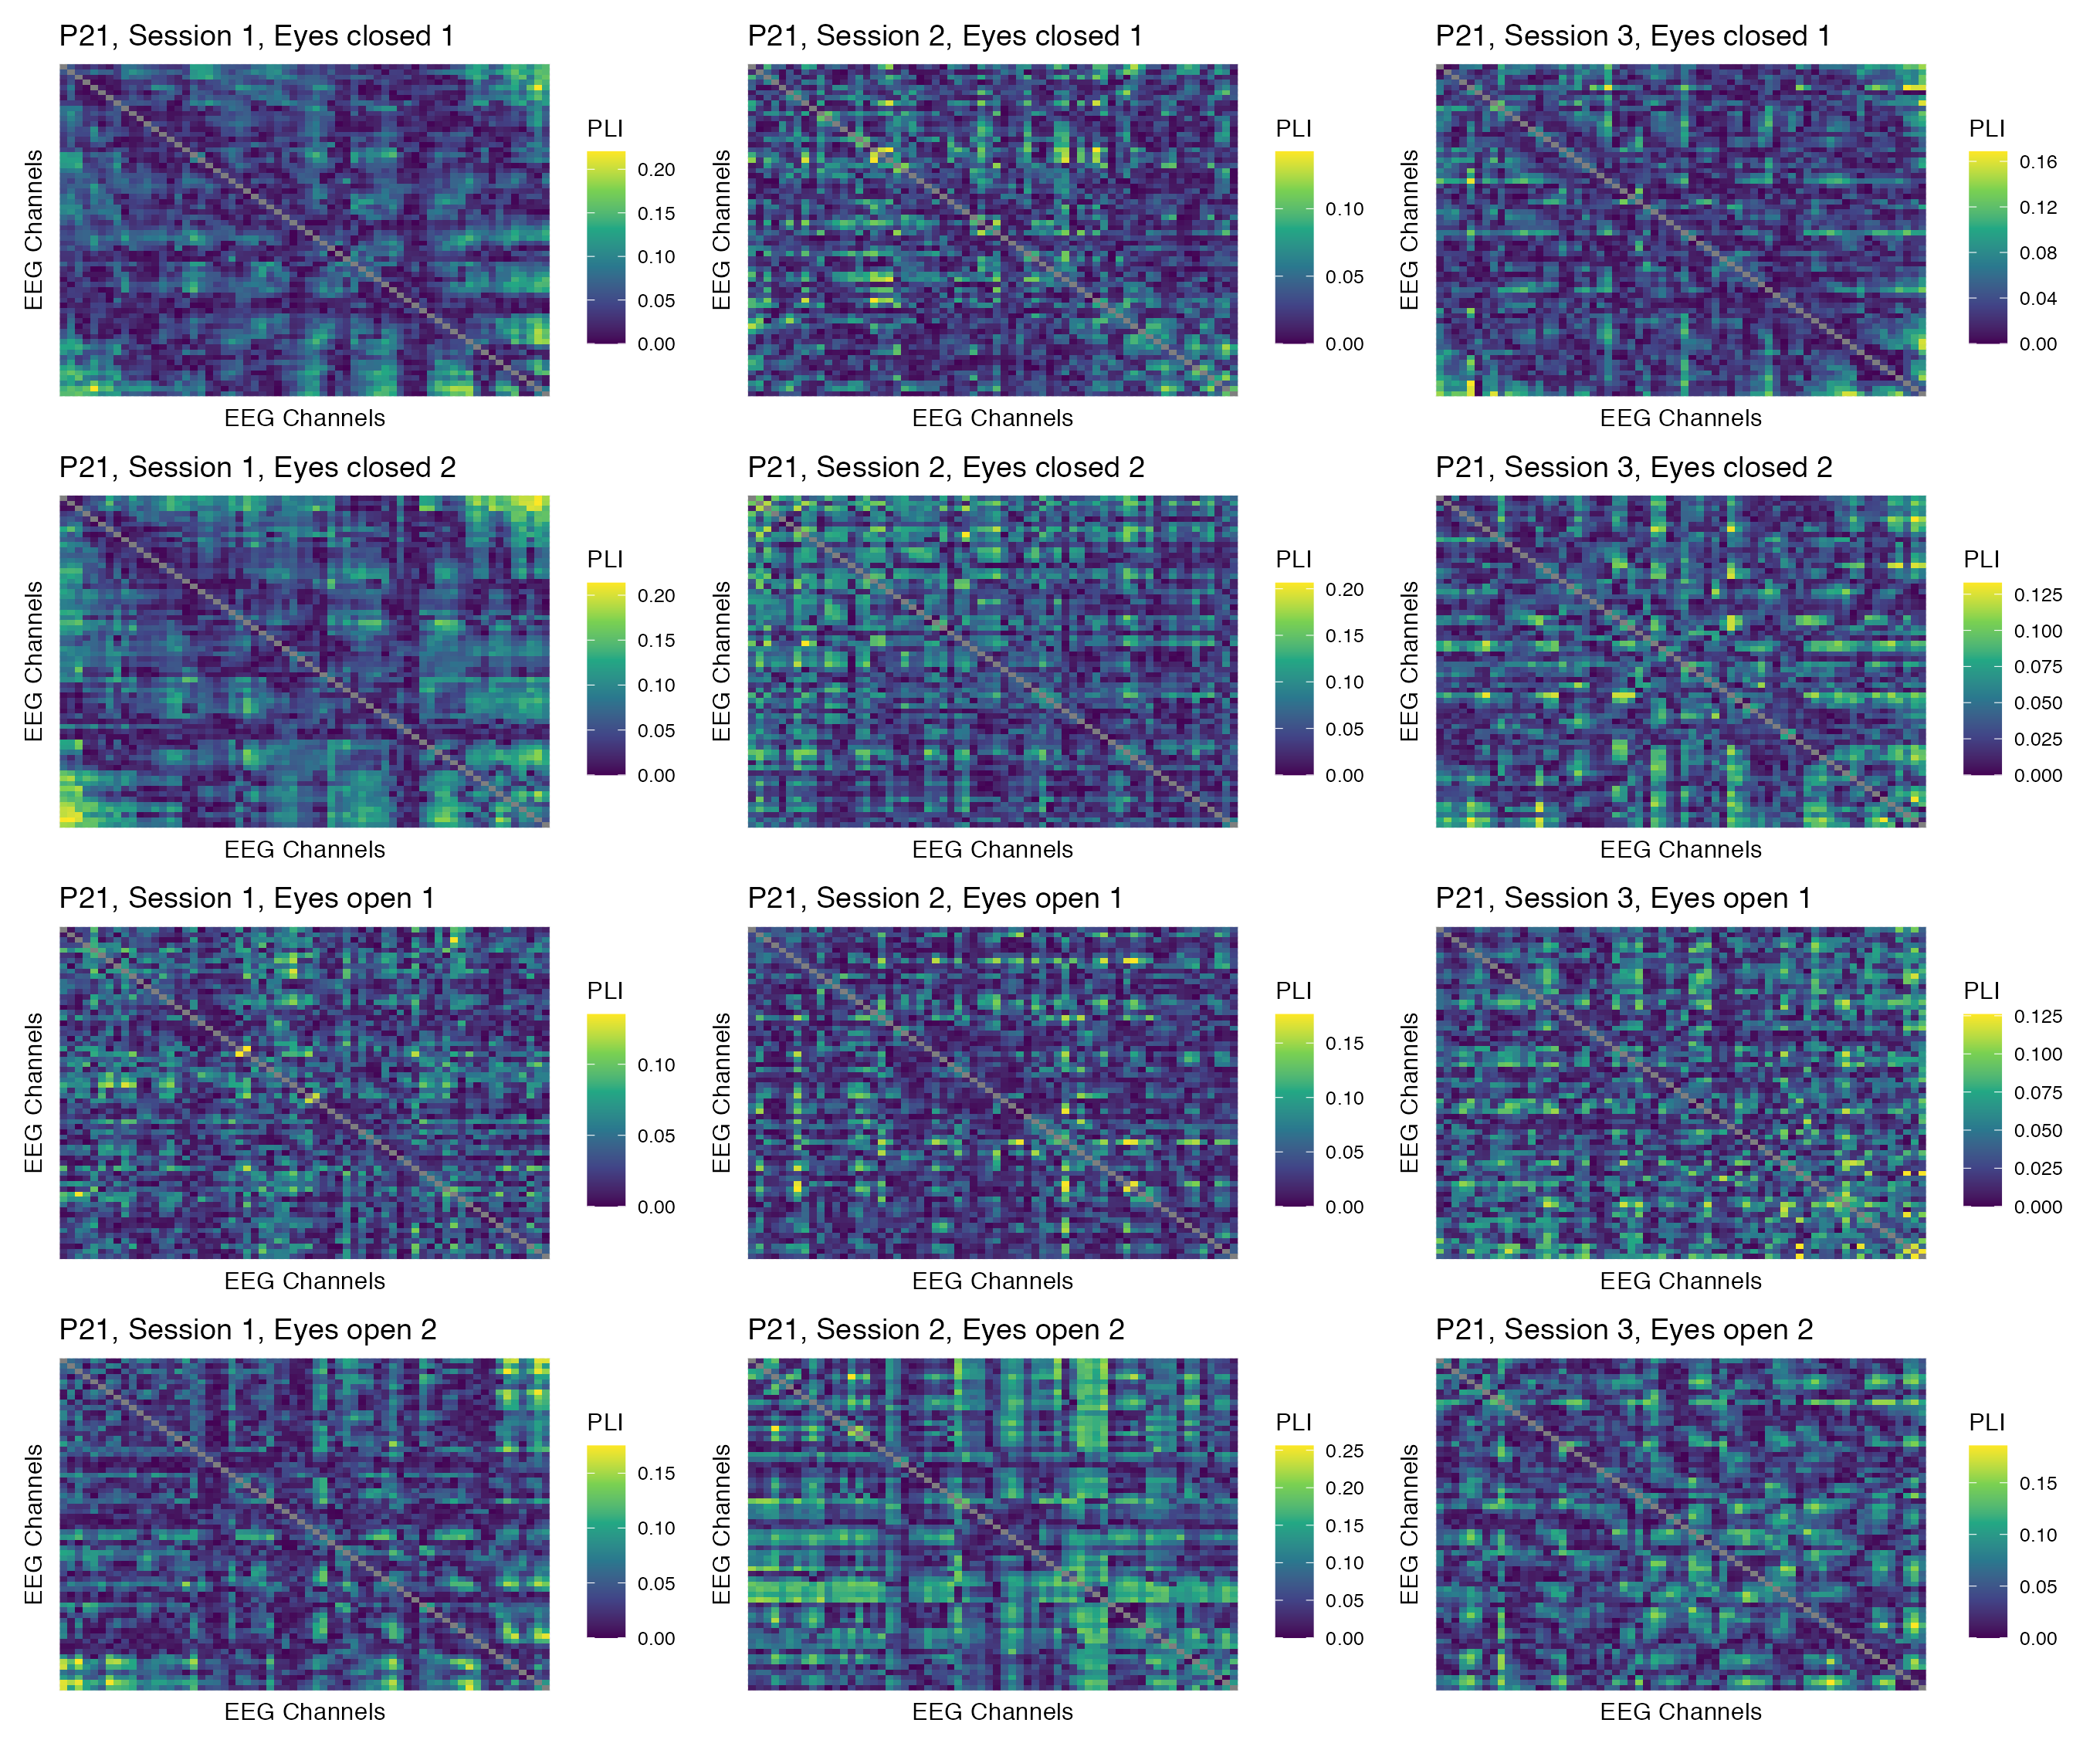

Figure 13: Phase coupling functional connectomes for participant P21 in the delta band. For each functional connectome, EEG channels are ordered as follows (from left to right, and from top to bottom): Fp1, Fp2, AF7, AF3, AFz, AF4, AF8, F7, F5, F3, F1, Fz, F2, F4, F6, F8, FT9, FT7, FC5, FC3, FC1, FCz, FC2, FC4, FC6, FT8, FT10, T7, C5, C3, C1, Cz, C2, C4, C6, T8, TP9, TP7, CP5, CP3, CP1, CPz, CP2, CP4, CP6, TP8, TP10, P7, P5, P3, P1, Pz, P2, P4, P6, P8, PO7, PO3, POz, PO4, PO8, O1, Oz, O2.

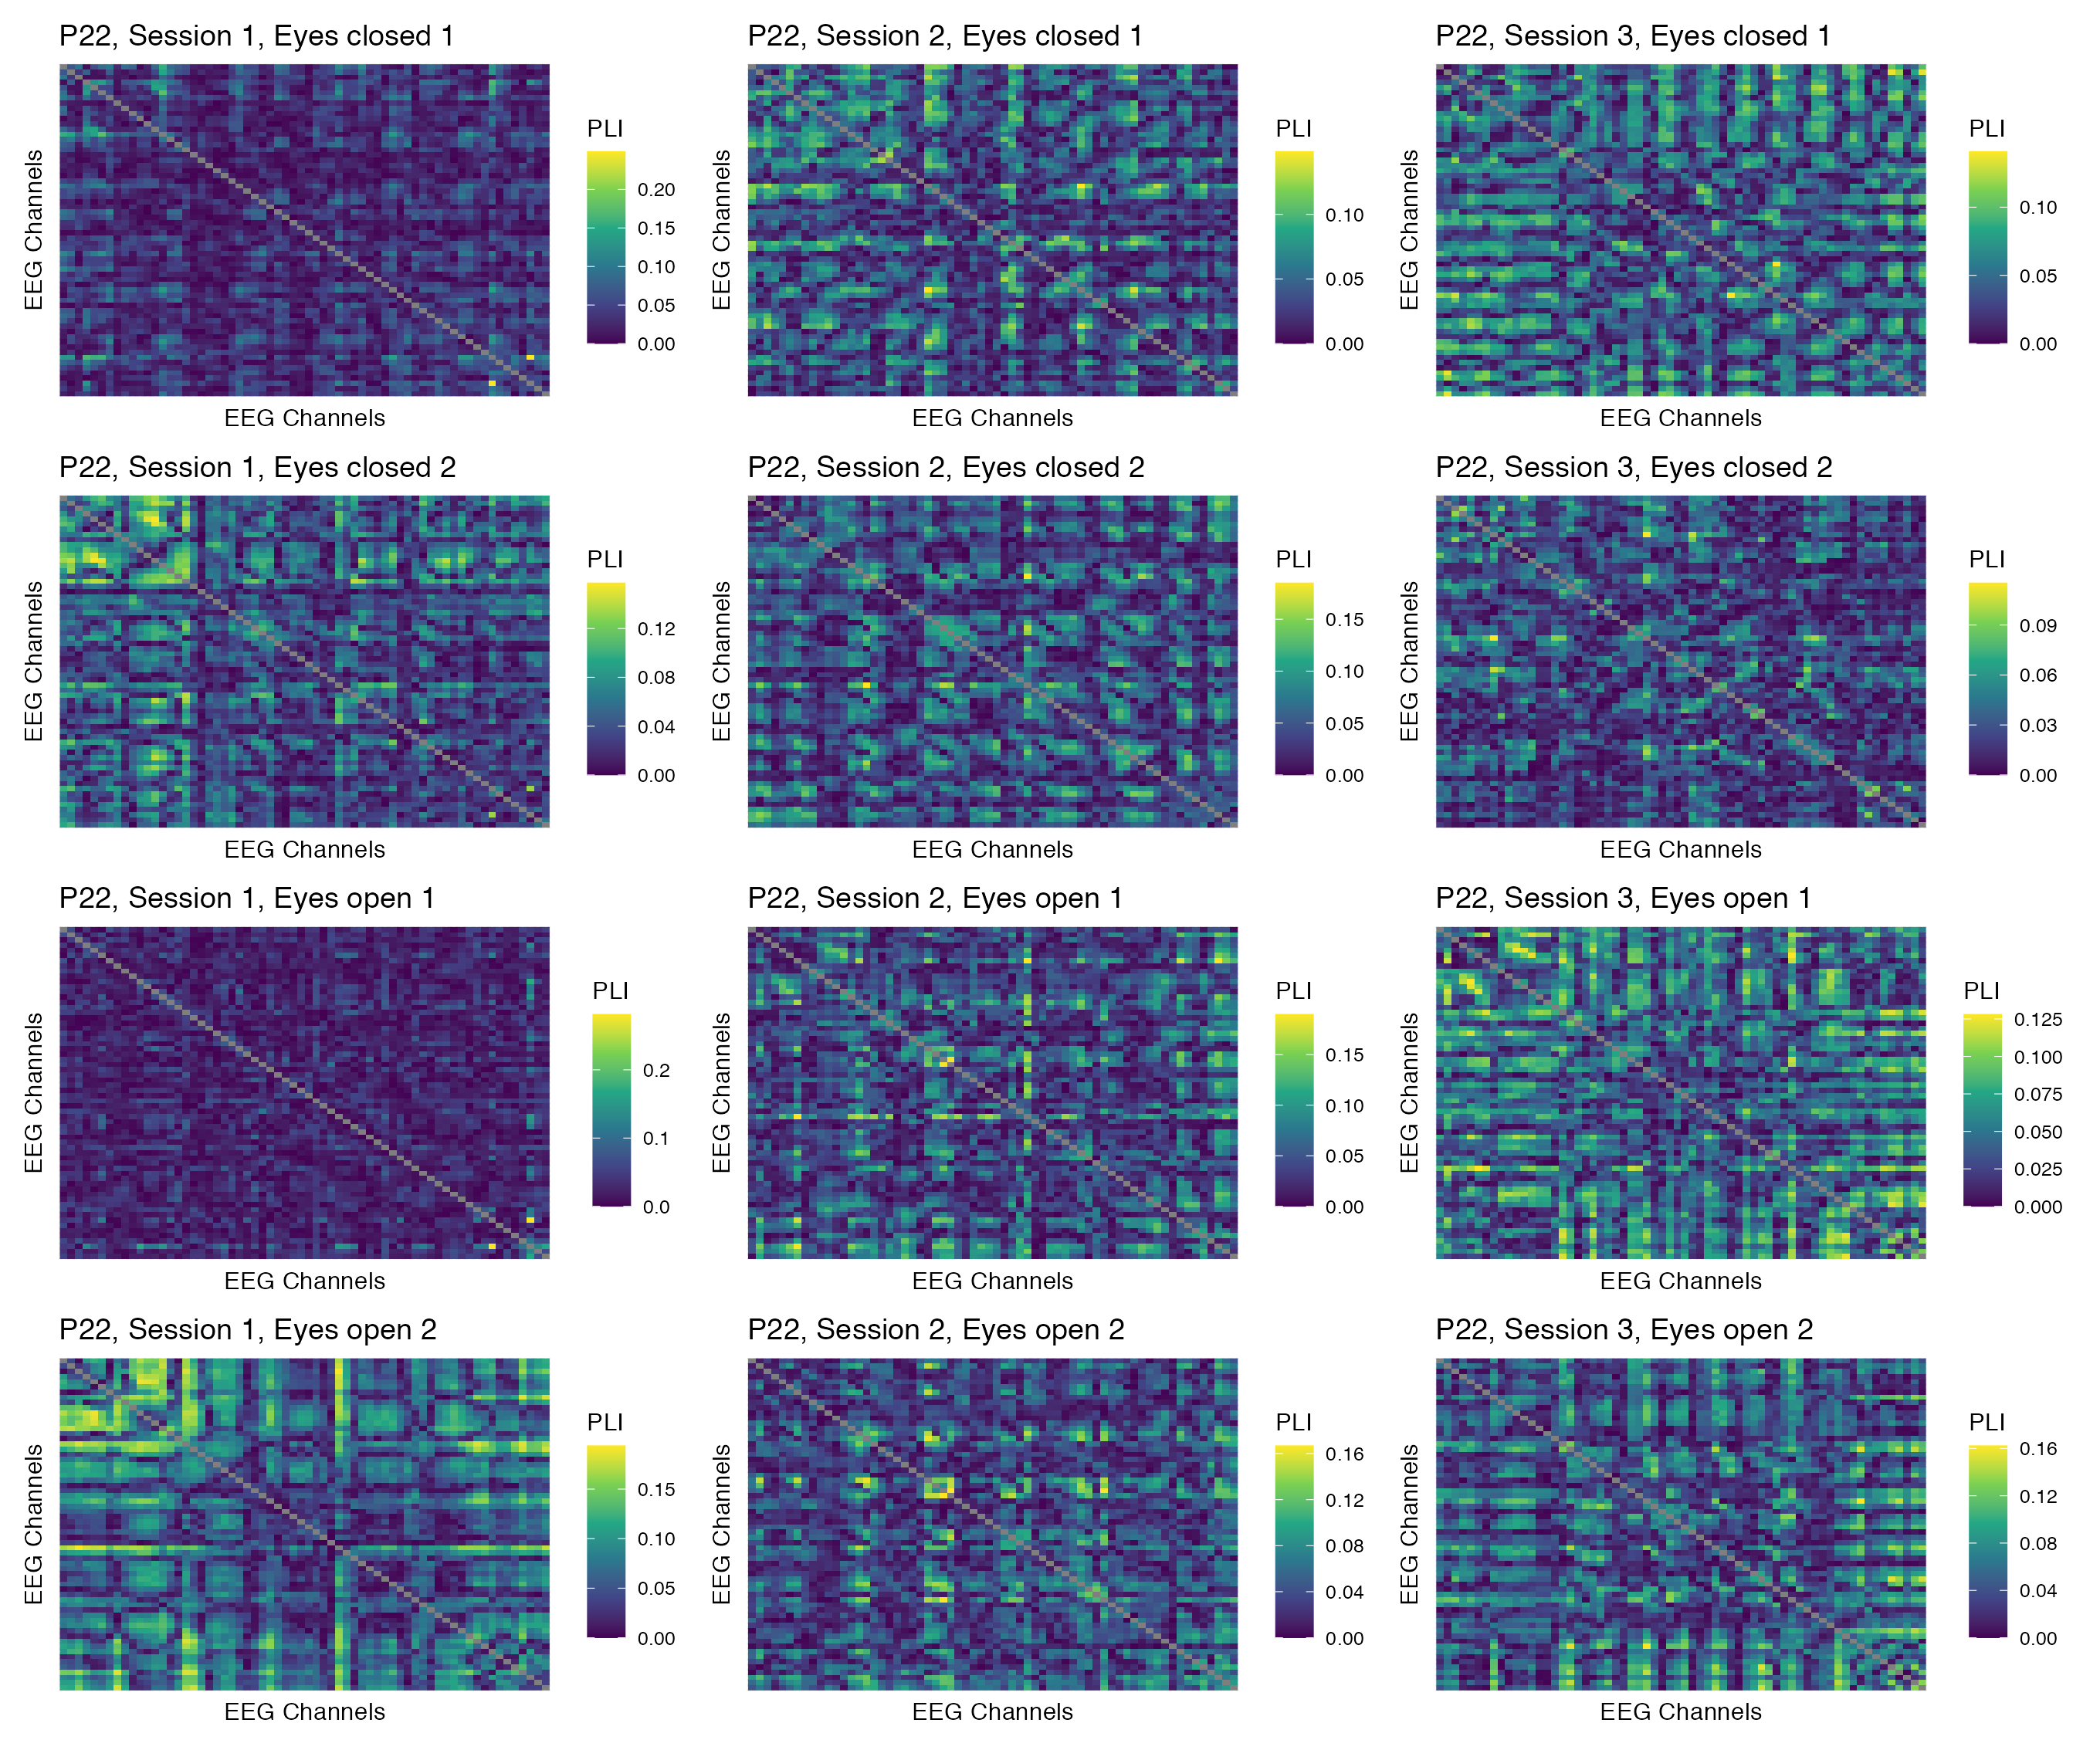

Figure 14: Phase coupling functional connectomes for participant P22 in the delta band. For each functional connectome, EEG channels are ordered as follows (from left to right, and from top to bottom): Fp1, Fp2, AF7, AF3, AFz, AF4, AF8, F7, F5, F3, F1, Fz, F2, F4, F6, F8, FT9, FT7, FC5, FC3, FC1, FCz, FC2, FC4, FC6, FT8, FT10, T7, C5, C3, C1, Cz, C2, C4, C6, T8, TP9, TP7, CP5, CP3, CP1, CPz, CP2, CP4, CP6, TP8, TP10, P7, P5, P3, P1, Pz, P2, P4, P6, P8, PO7, PO3, POz, PO4, PO8, O1, Oz, O2.

## Theta band

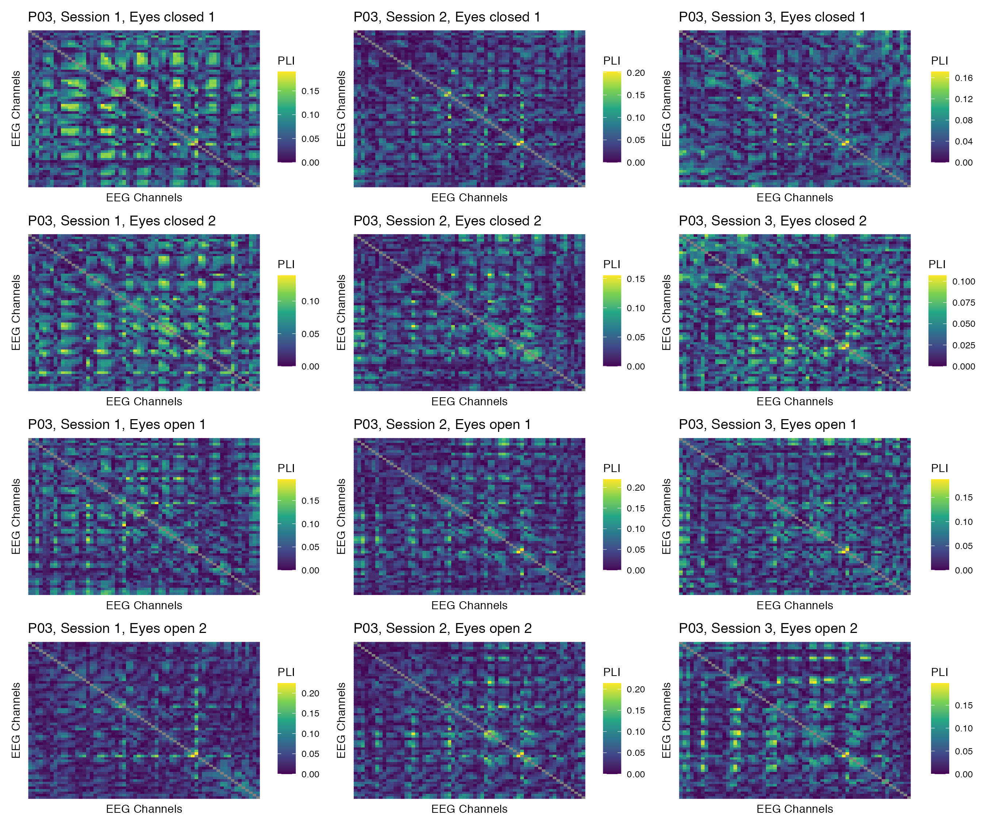

Figure 15: Phase coupling functional connectomes for participant P03 in the theta band. For each functional connectome, EEG channels are ordered as follows (from left to right, and from top to bottom): Fp1, Fp2, AF7, AF3, AFz, AF4, AF8, F7, F5, F3, F1, Fz, F2, F4, F6, F8, FT9, FT7, FC5, FC3, FC1, FCz, FC2, FC4, FC6, FT8, FT10, T7, C5, C3, C1, Cz, C2, C4, C6, T8, TP9, TP7, CP5, CP3, CP1, CPz, CP2, CP4, CP6, TP8, TP10, P7, P5, P3, P1, Pz, P2, P4, P6, P8, PO7, PO3, POz, PO4, PO8, O1, Oz, O2.

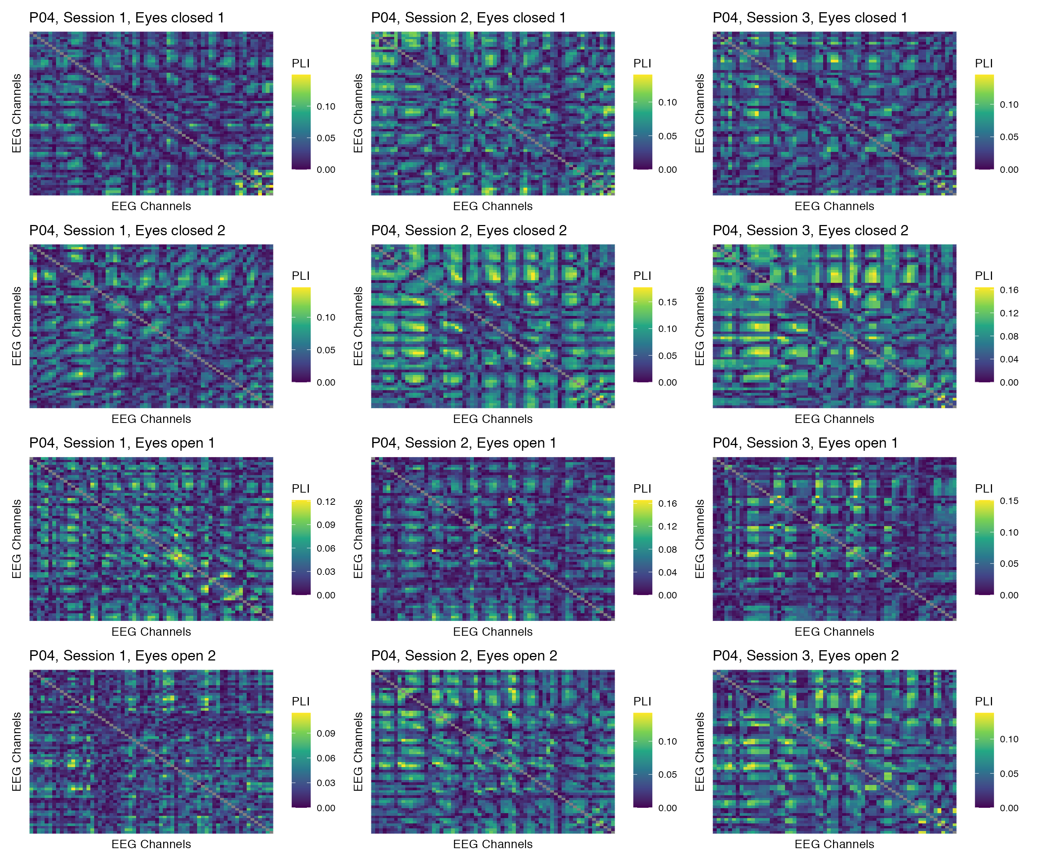

Figure 16: Phase coupling functional connectomes for participant P04 in the theta band. For each functional connectome, EEG channels are ordered as follows (from left to right, and from top to bottom): Fp1, Fp2, AF7, AF3, AFz, AF4, AF8, F7, F5, F3, F1, Fz, F2, F4, F6, F8, FT9, FT7, FC5, FC3, FC1, FCz, FC2, FC4, FC6, FT8, FT10, T7, C5, C3, C1, Cz, C2, C4, C6, T8, TP9, TP7, CP5, CP3, CP1, CPz, CP2, CP4, CP6, TP8, TP10, P7, P5, P3, P1, Pz, P2, P4, P6, P8, PO7, PO3, POz, PO4, PO8, O1, Oz, O2.

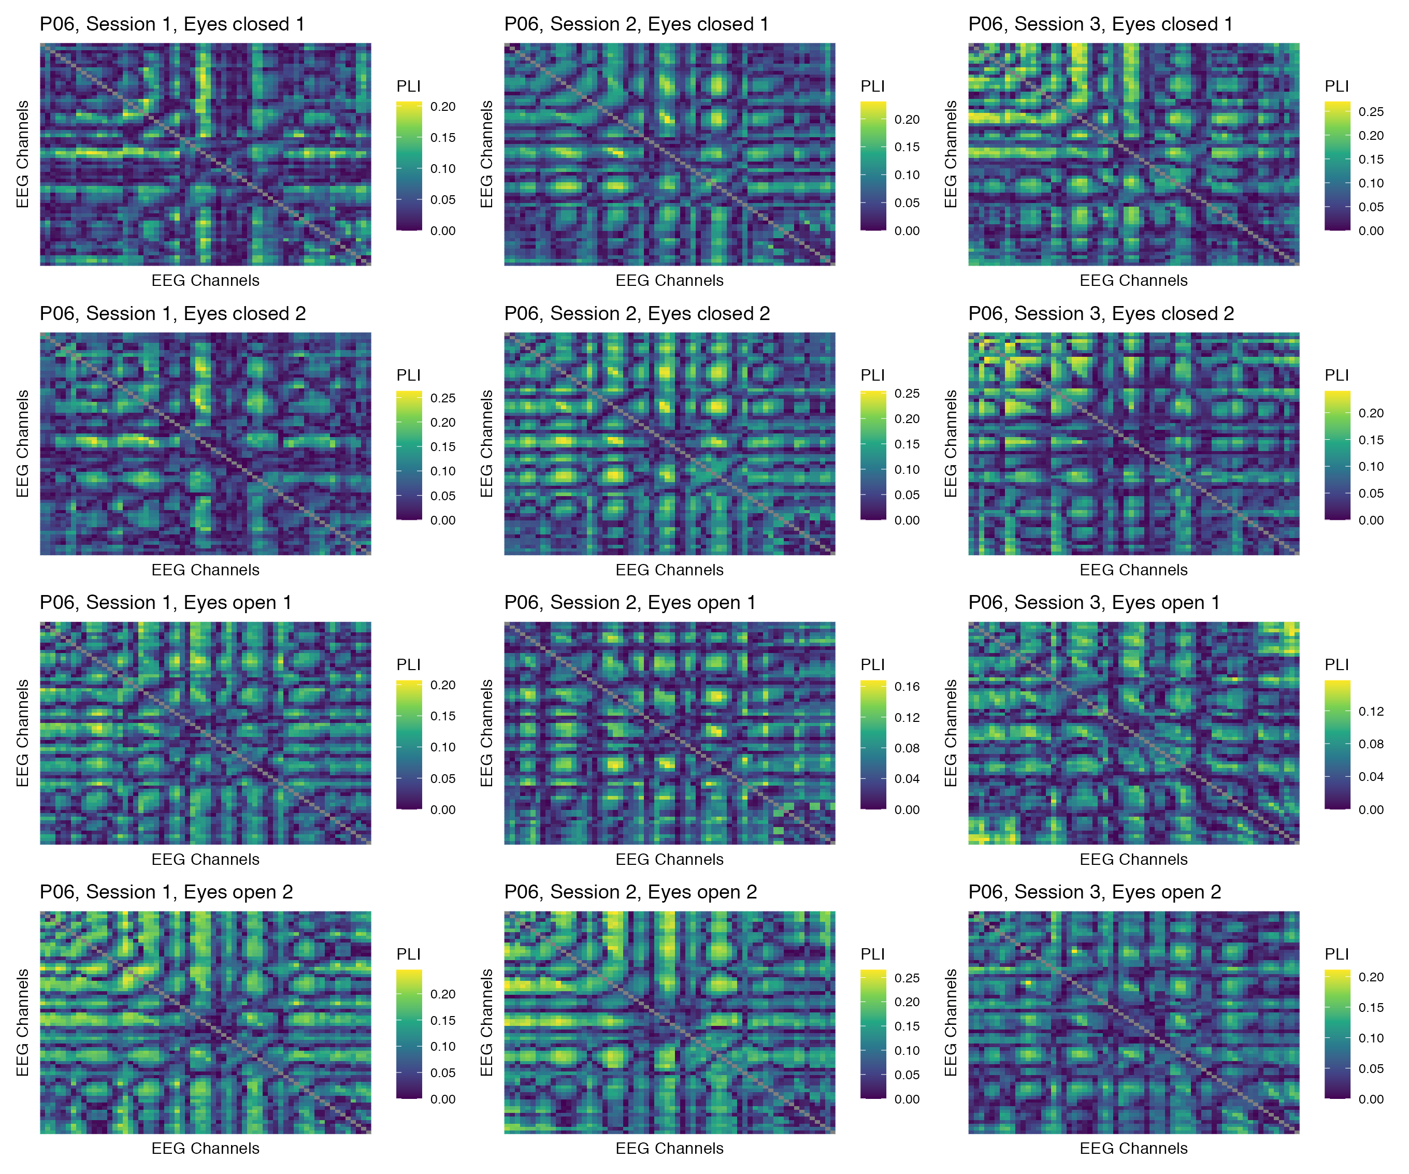

Figure 17: Phase coupling functional connectomes for participant P06 in the theta band. For each functional connectome, EEG channels are ordered as follows (from left to right, and from top to bottom): Fp1, Fp2, AF7, AF3, AFz, AF4, AF8, F7, F5, F3, F1, Fz, F2, F4, F6, F8, FT9, FT7, FC5, FC3, FC1, FCz, FC2, FC4, FC6, FT8, FT10, T7, C5, C3, C1, Cz, C2, C4, C6, T8, TP9, TP7, CP5, CP3, CP1, CPz, CP2, CP4, CP6, TP8, TP10, P7, P5, P3, P1, Pz, P2, P4, P6, P8, PO7, PO3, POz, PO4, PO8, O1, Oz, O2.

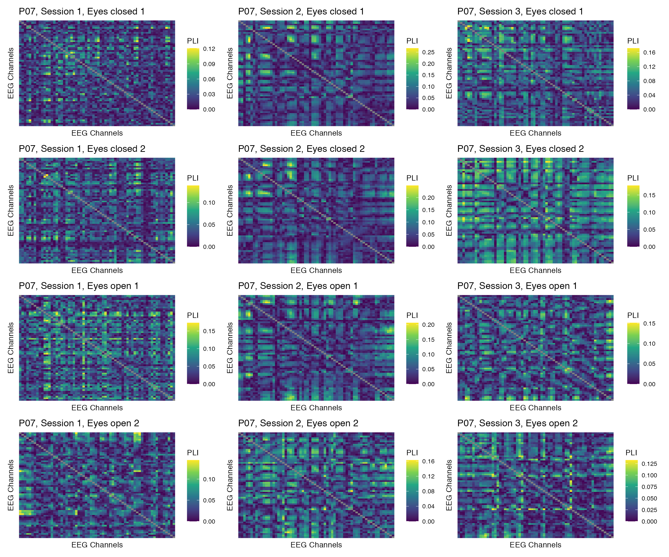

Figure 18: Phase coupling functional connectomes for participant P07 in the theta band. For each functional connectome, EEG channels are ordered as follows (from left to right, and from top to bottom): Fp1, Fp2, AF7, AF3, AFz, AF4, AF8, F7, F5, F3, F1, Fz, F2, F4, F6, F8, FT9, FT7, FC5, FC3, FC1, FCz, FC2, FC4, FC6, FT8, FT10, T7, C5, C3, C1, Cz, C2, C4, C6, T8, TP9, TP7, CP5, CP3, CP1, CPz, CP2, CP4, CP6, TP8, TP10, P7, P5, P3, P1, Pz, P2, P4, P6, P8, PO7, PO3, POz, PO4, PO8, O1, Oz, O2.

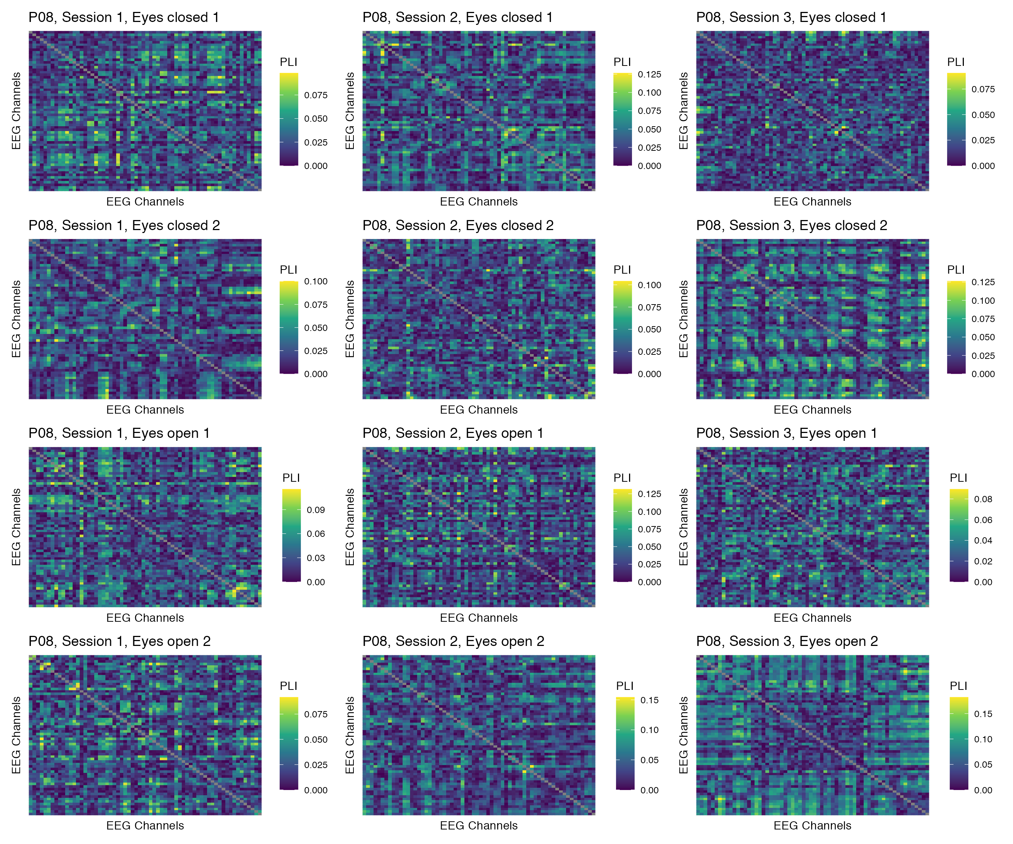

Figure 19: Phase coupling functional connectomes for participant P08 in the theta band. For each functional connectome, EEG channels are ordered as follows (from left to right, and from top to bottom): Fp1, Fp2, AF7, AF3, AFz, AF4, AF8, F7, F5, F3, F1, Fz, F2, F4, F6, F8, FT9, FT7, FC5, FC3, FC1, FCz, FC2, FC4, FC6, FT8, FT10, T7, C5, C3, C1, Cz, C2, C4, C6, T8, TP9, TP7, CP5, CP3, CP1, CPz, CP2, CP4, CP6, TP8, TP10, P7, P5, P3, P1, Pz, P2, P4, P6, P8, PO7, PO3, POz, PO4, PO8, O1, Oz, O2.

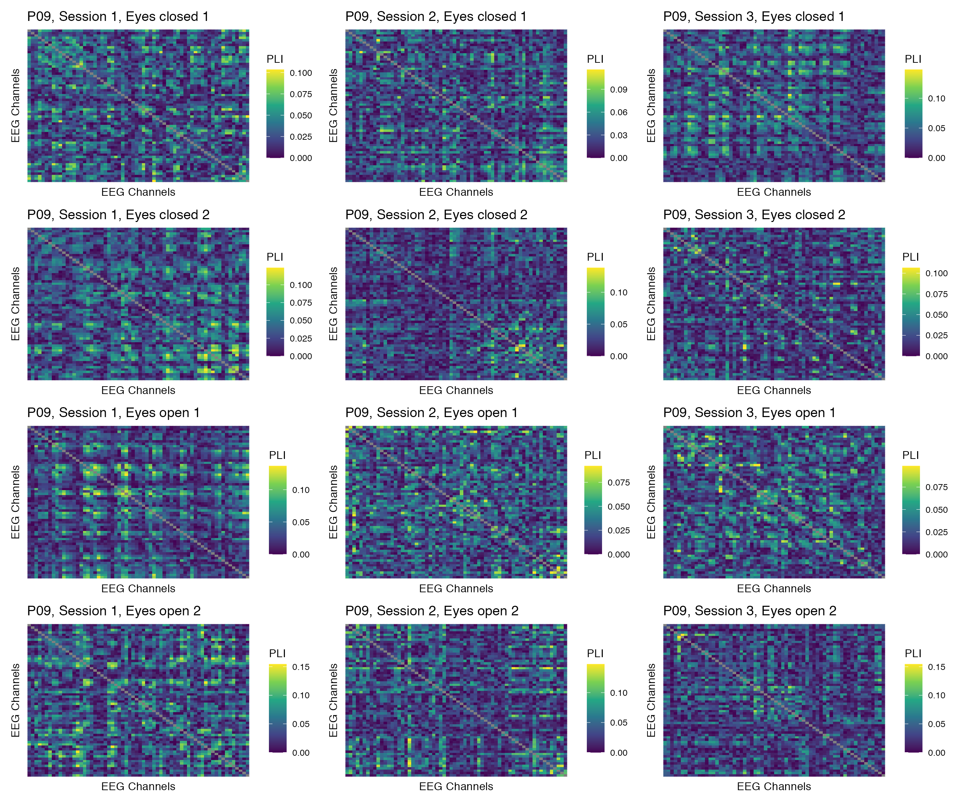

Figure 20: Phase coupling functional connectomes for participant P09 in the theta band. For each functional connectome, EEG channels are ordered as follows (from left to right, and from top to bottom): Fp1, Fp2, AF7, AF3, AFz, AF4, AF8, F7, F5, F3, F1, Fz, F2, F4, F6, F8, FT9, FT7, FC5, FC3, FC1, FCz, FC2, FC4, FC6, FT8, FT10, T7, C5, C3, C1, Cz, C2, C4, C6, T8, TP9, TP7, CP5, CP3, CP1, CPz, CP2, CP4, CP6, TP8, TP10, P7, P5, P3, P1, Pz, P2, P4, P6, P8, PO7, PO3, POz, PO4, PO8, O1, Oz, O2.

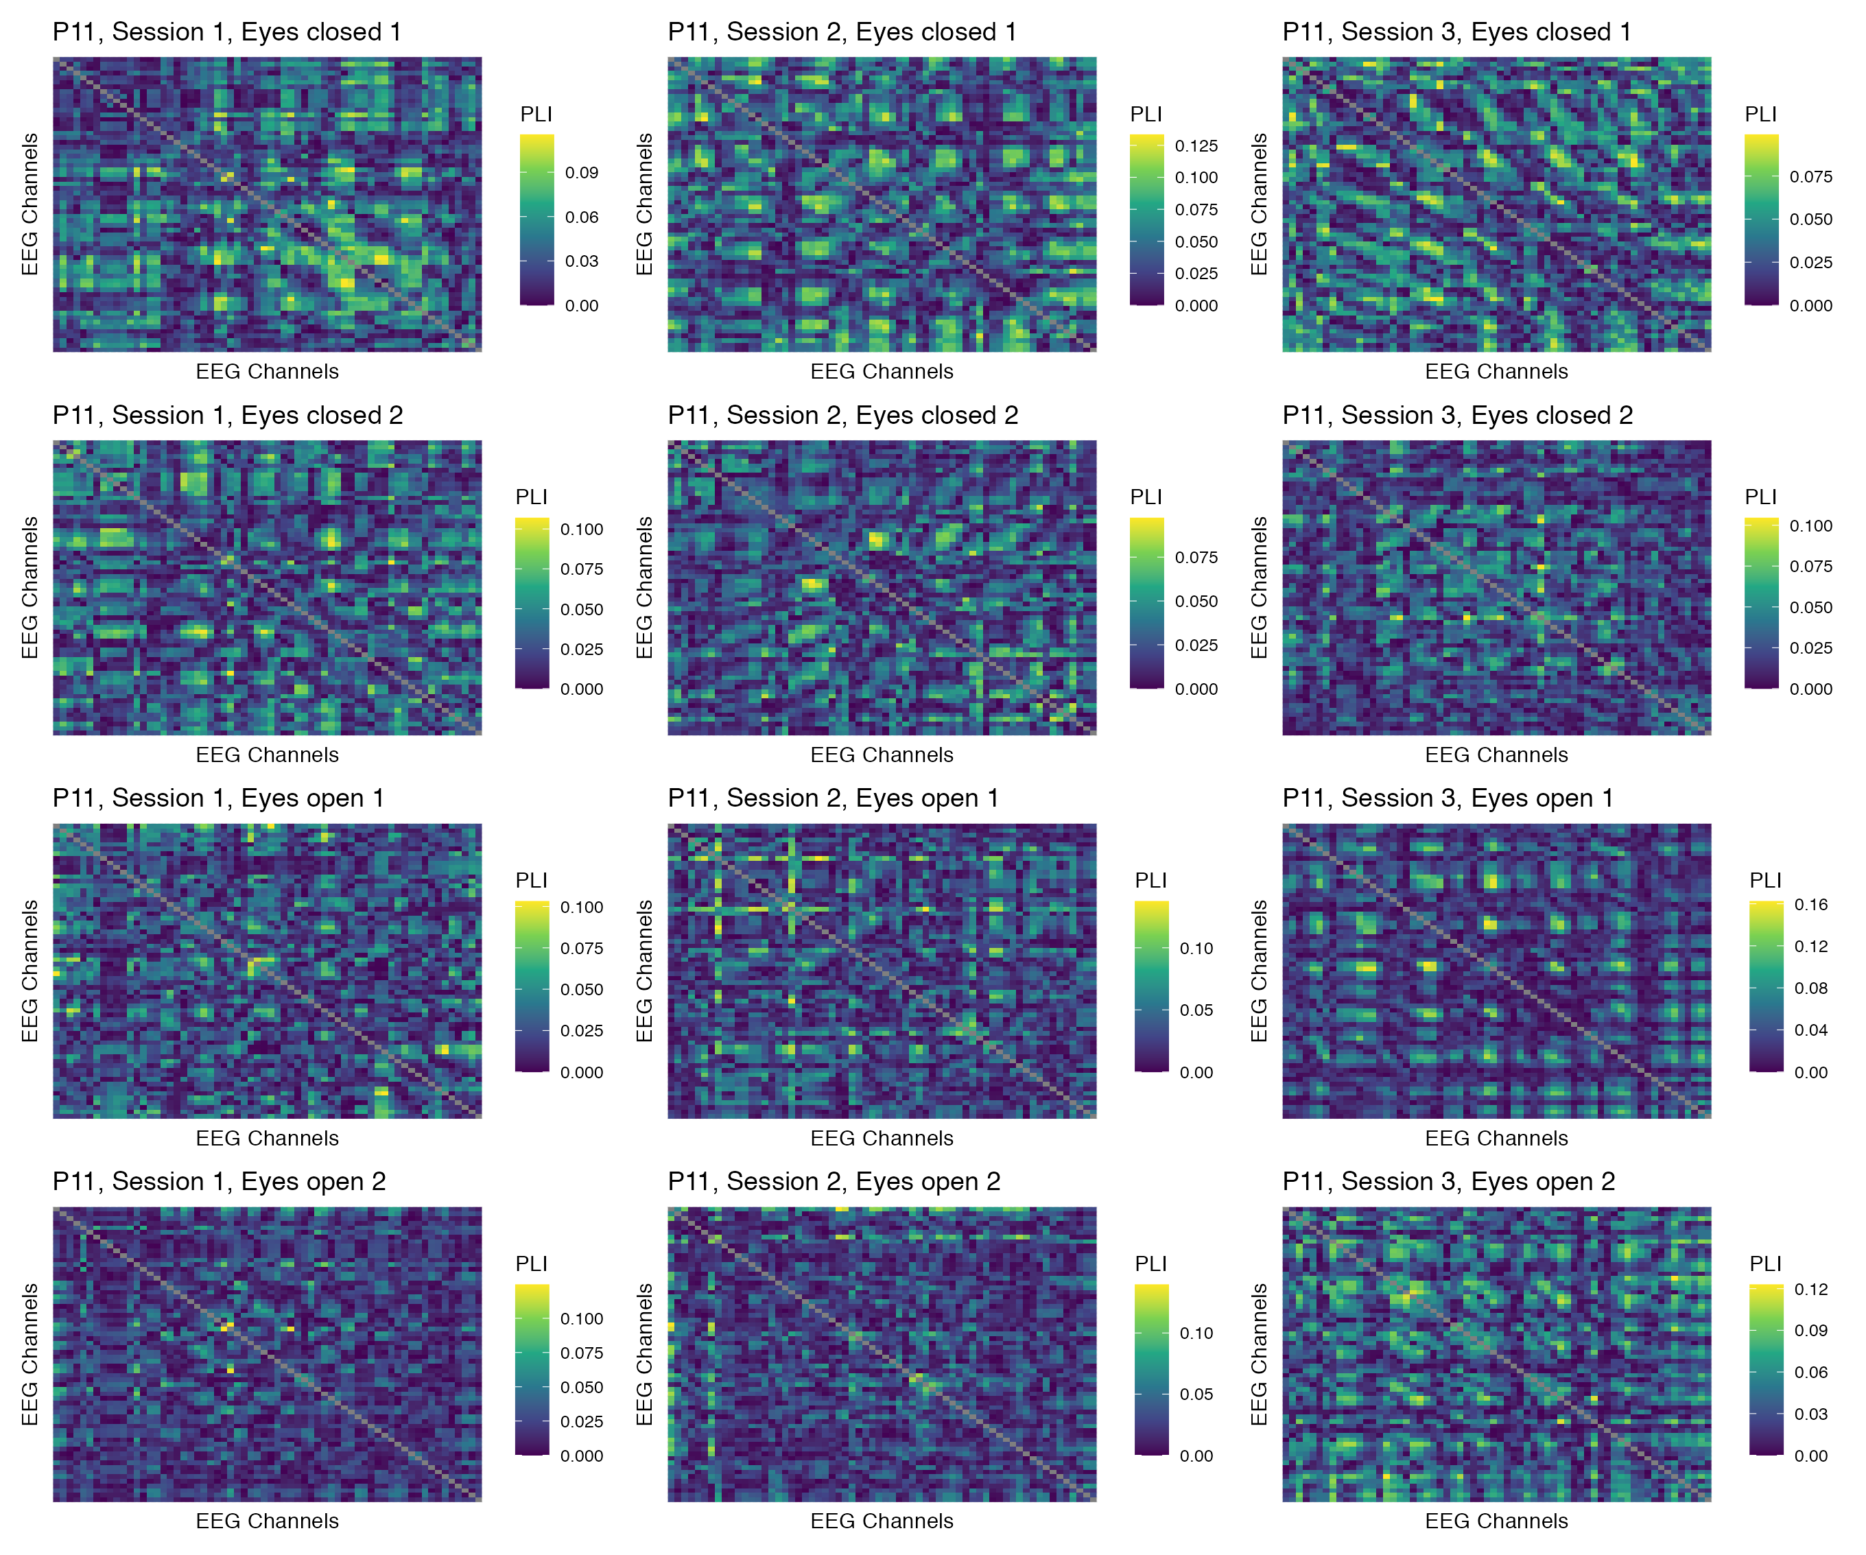

Figure 21: Phase coupling functional connectomes for participant P11 in the theta band. For each functional connectome, EEG channels are ordered as follows (from left to right, and from top to bottom): Fp1, Fp2, AF7, AF3, AFz, AF4, AF8, F7, F5, F3, F1, Fz, F2, F4, F6, F8, FT9, FT7, FC5, FC3, FC1, FCz, FC2, FC4, FC6, FT8, FT10, T7, C5, C3, C1, Cz, C2, C4, C6, T8, TP9, TP7, CP5, CP3, CP1, CPz, CP2, CP4, CP6, TP8, TP10, P7, P5, P3, P1, Pz, P2, P4, P6, P8, PO7, PO3, POz, PO4, PO8, O1, Oz, O2.

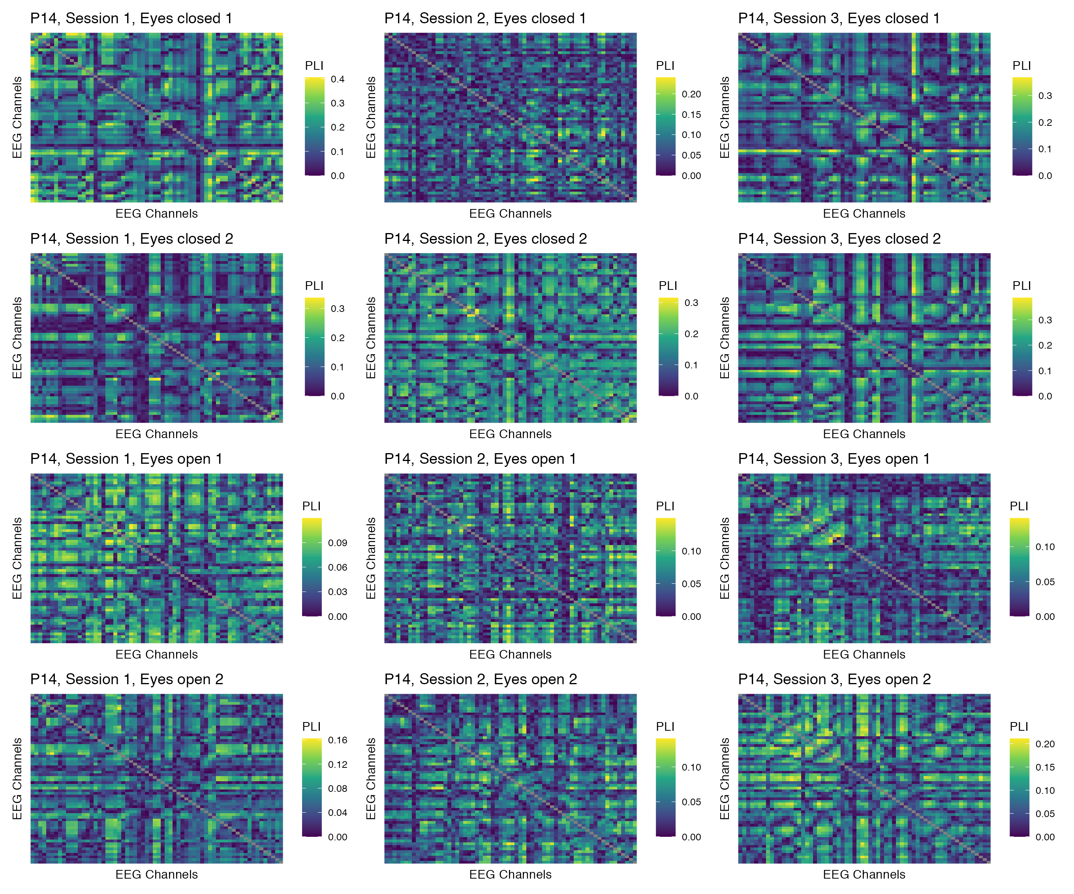

Figure 22: Phase coupling functional connectomes for participant P14 in the theta band. For each functional connectome, EEG channels are ordered as follows (from left to right, and from top to bottom): Fp1, Fp2, AF7, AF3, AFz, AF4, AF8, F7, F5, F3, F1, Fz, F2, F4, F6, F8, FT9, FT7, FC5, FC3, FC1, FCz, FC2, FC4, FC6, FT8, FT10, T7, C5, C3, C1, Cz, C2, C4, C6, T8, TP9, TP7, CP5, CP3, CP1, CPz, CP2, CP4, CP6, TP8, TP10, P7, P5, P3, P1, Pz, P2, P4, P6, P8, PO7, PO3, POz, PO4, PO8, O1, Oz, O2.

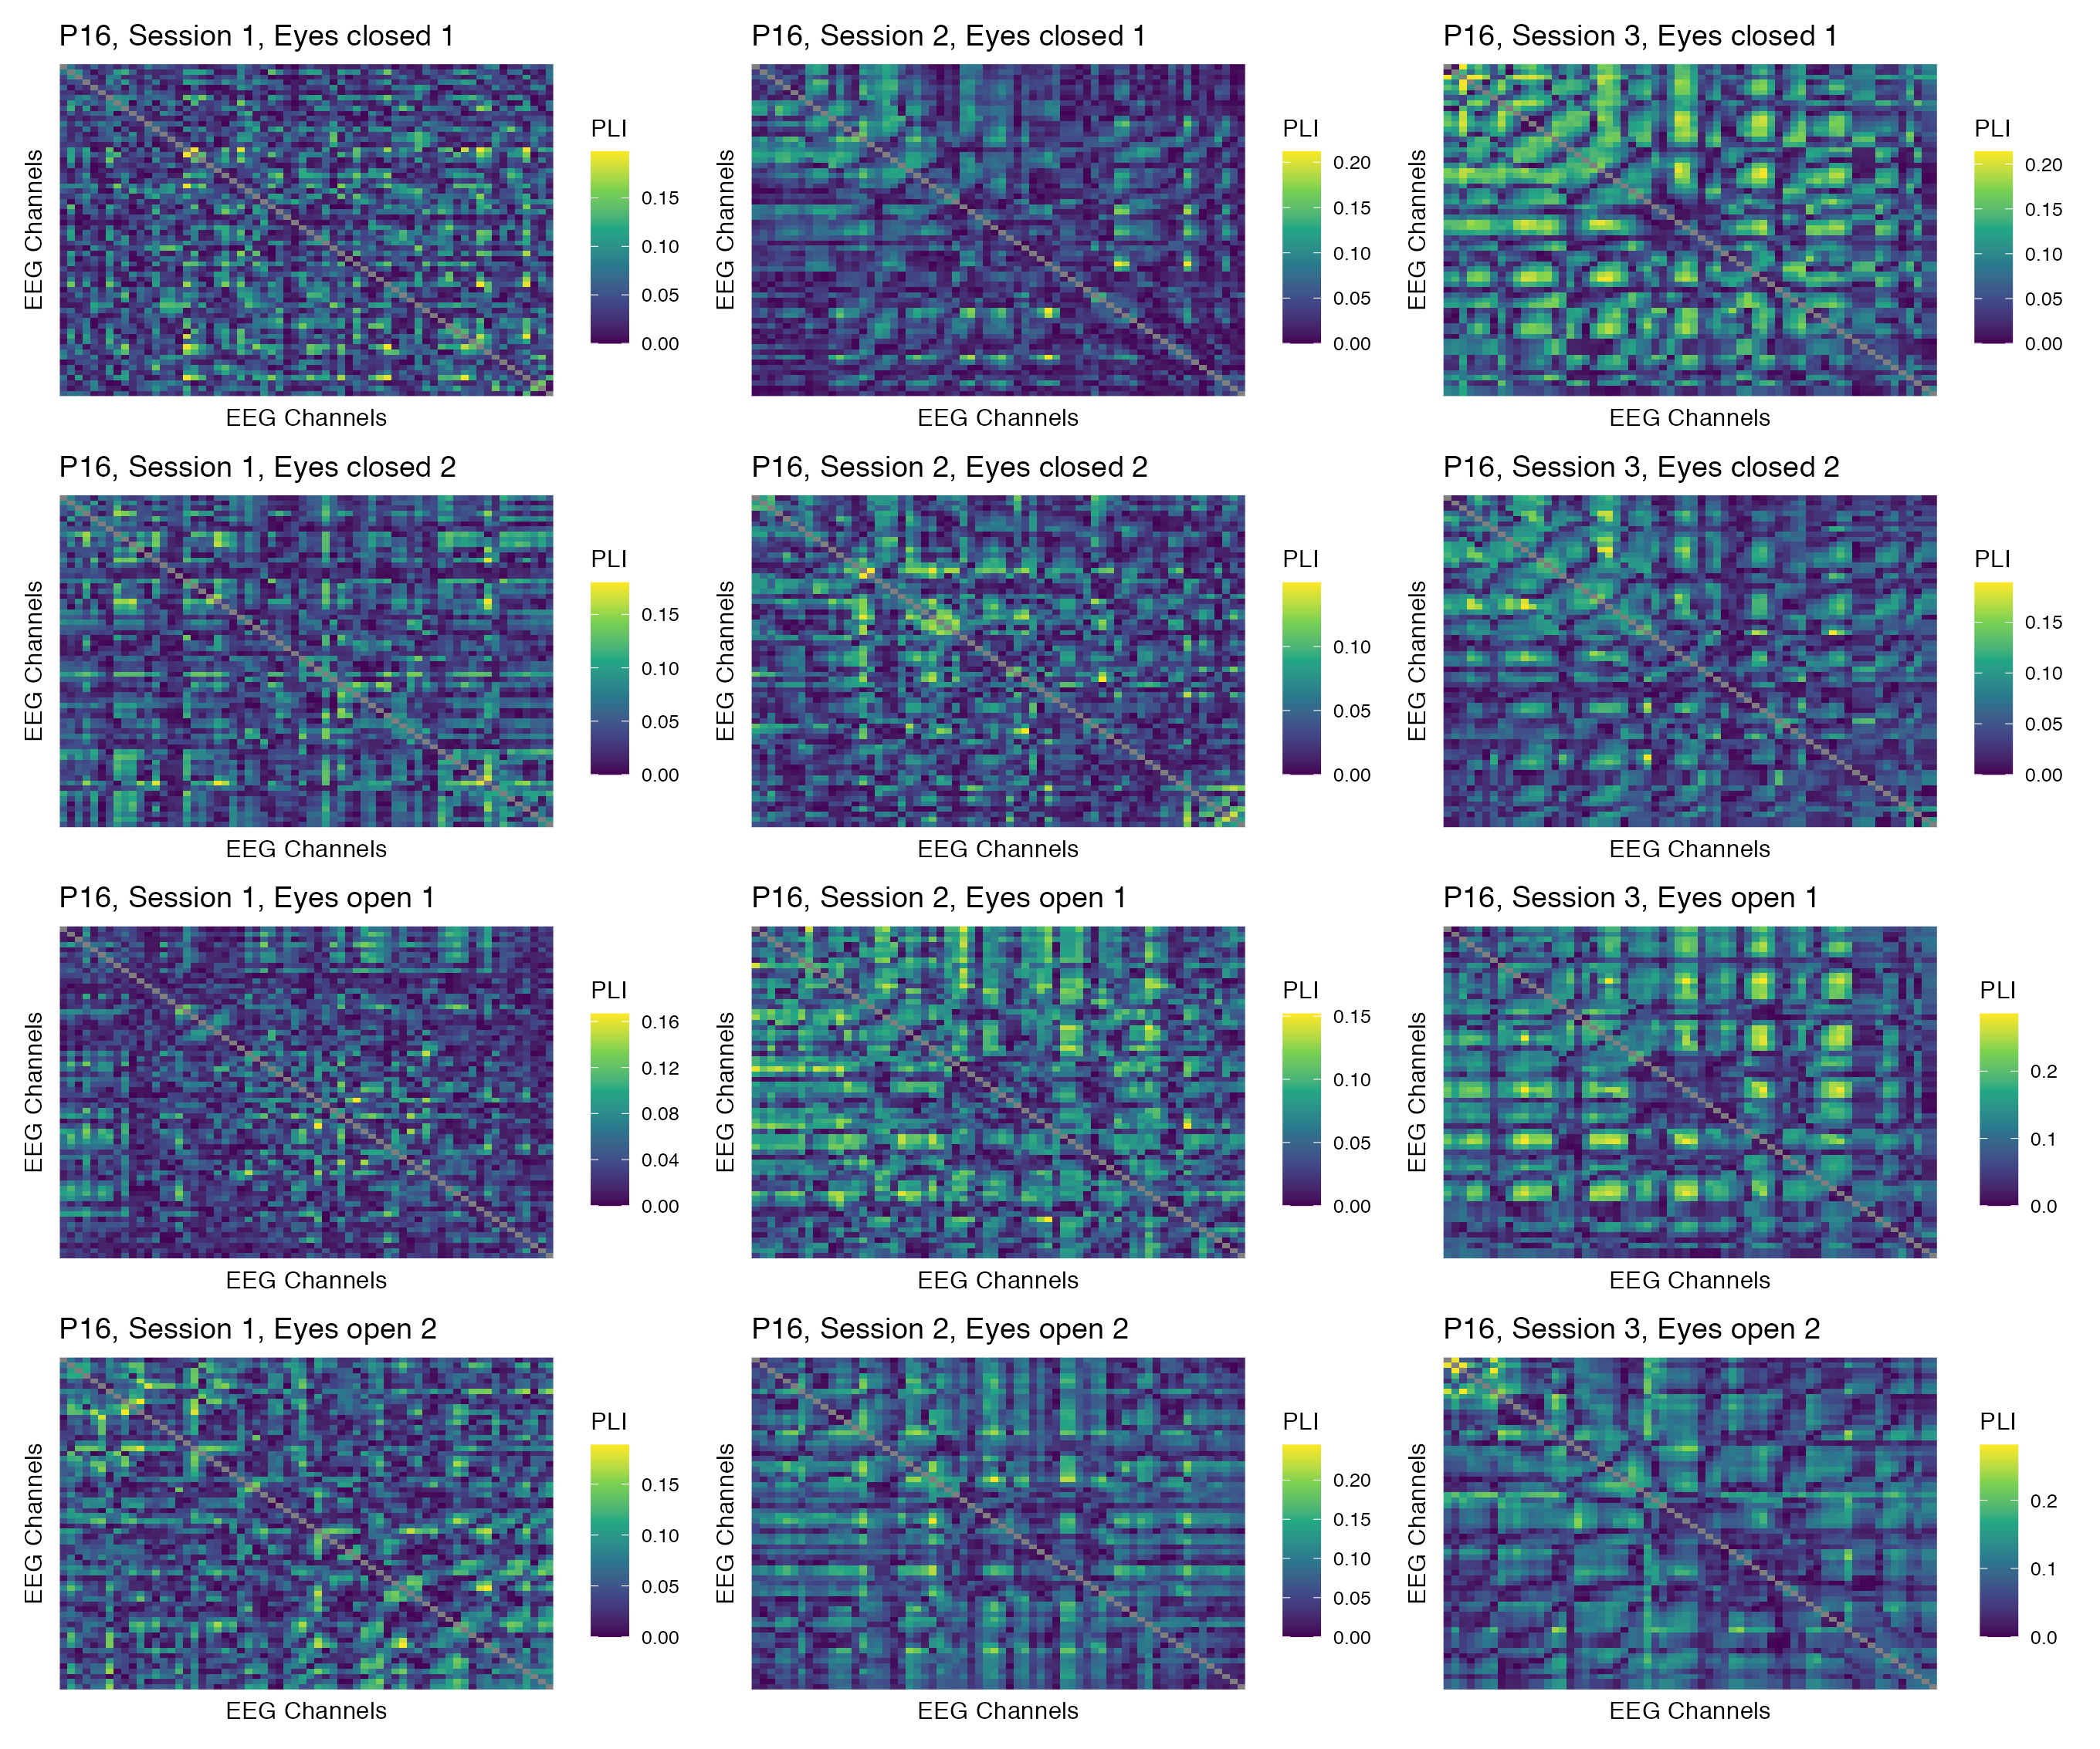

Figure 23: Phase coupling functional connectomes for participant P16 in the theta band. For each functional connectome, EEG channels are ordered as follows (from left to right, and from top to bottom): Fp1, Fp2, AF7, AF3, AFz, AF4, AF8, F7, F5, F3, F1, Fz, F2, F4, F6, F8, FT9, FT7, FC5, FC3, FC1, FCz, FC2, FC4, FC6, FT8, FT10, T7, C5, C3, C1, Cz, C2, C4, C6, T8, TP9, TP7, CP5, CP3, CP1, CPz, CP2, CP4, CP6, TP8, TP10, P7, P5, P3, P1, Pz, P2, P4, P6, P8, PO7, PO3, POz, PO4, PO8, O1, Oz, O2.

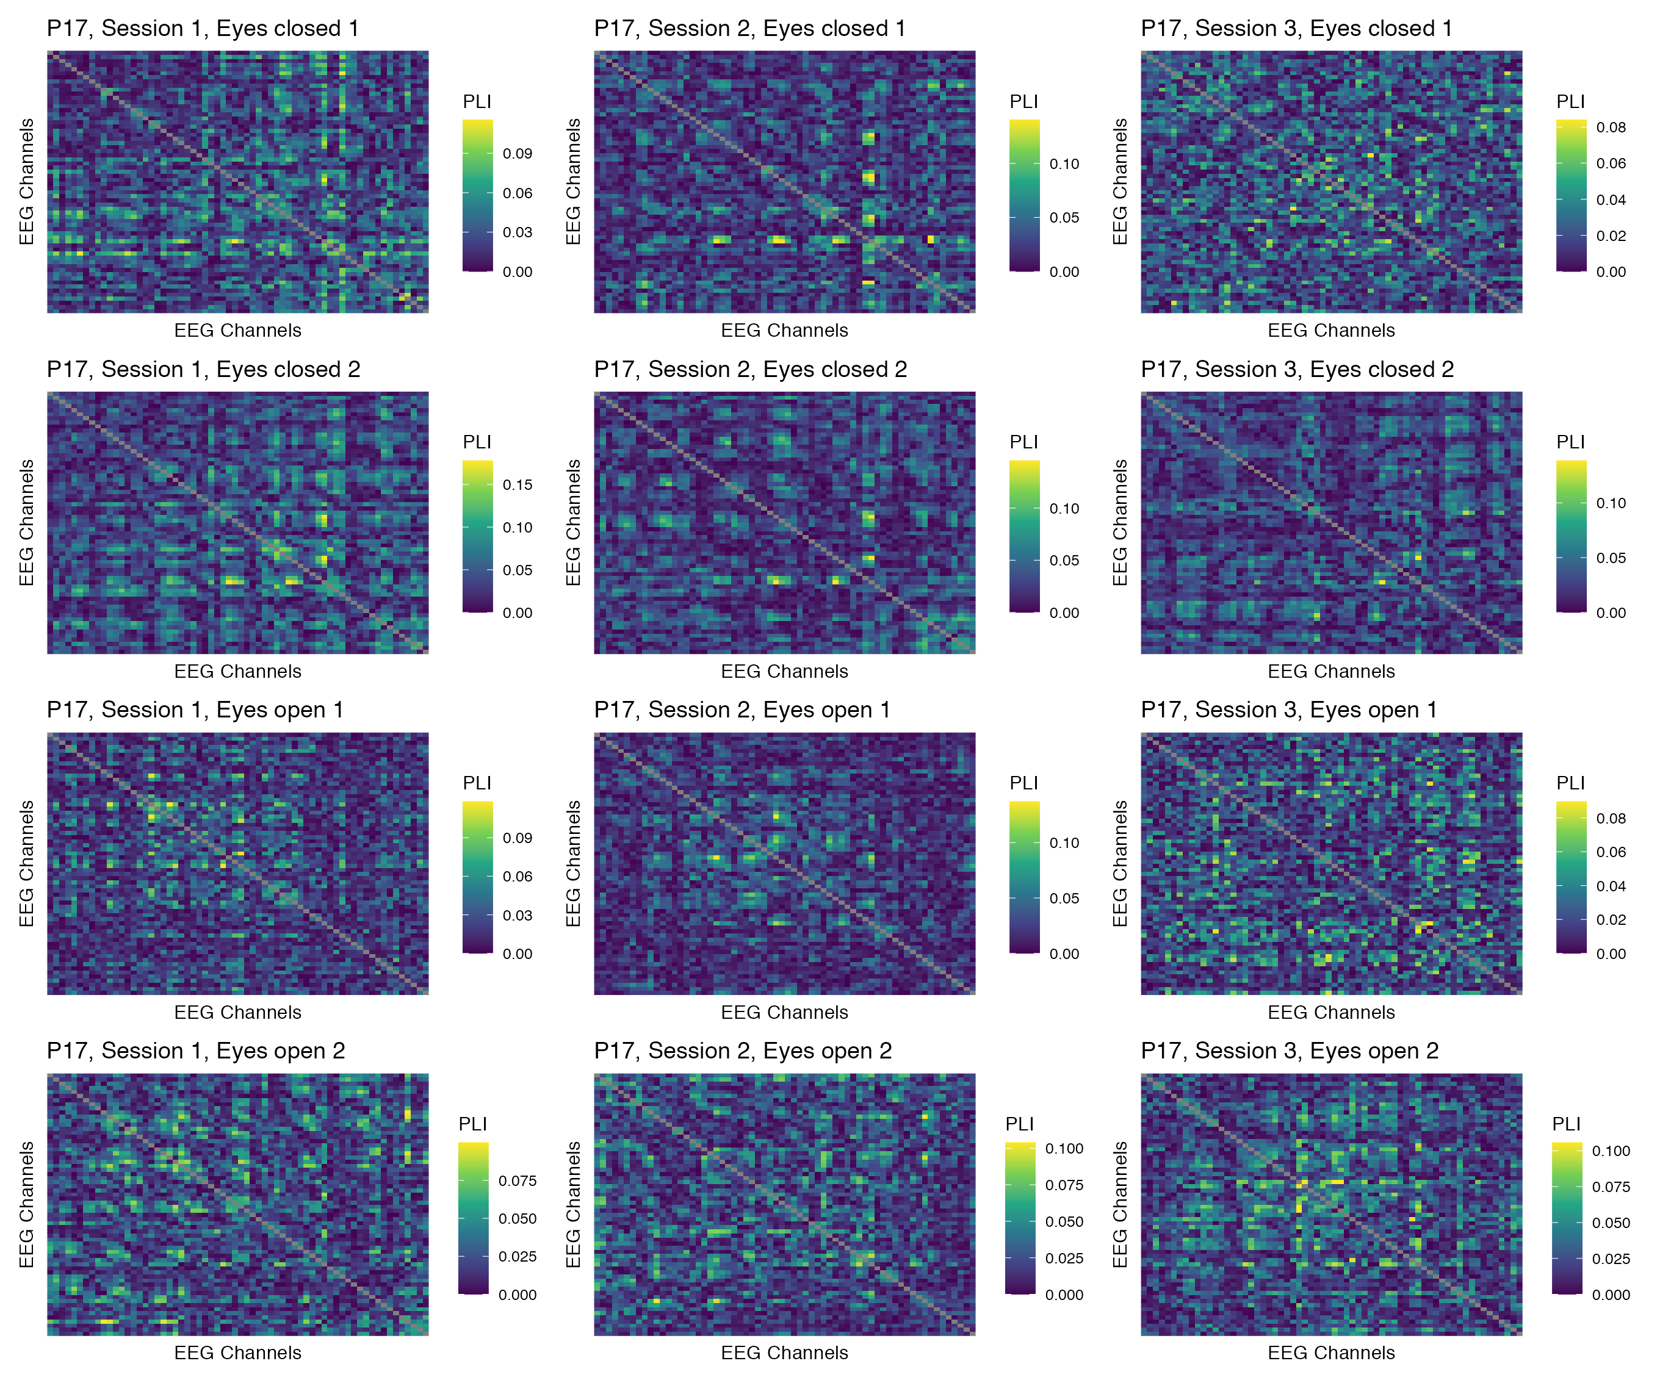

Figure 24: Phase coupling functional connectomes for participant P17 in the theta band. For each functional connectome, EEG channels are ordered as follows (from left to right, and from top to bottom): Fp1, Fp2, AF7, AF3, AFz, AF4, AF8, F7, F5, F3, F1, Fz, F2, F4, F6, F8, FT9, FT7, FC5, FC3, FC1, FCz, FC2, FC4, FC6, FT8, FT10, T7, C5, C3, C1, Cz, C2, C4, C6, T8, TP9, TP7, CP5, CP3, CP1, CPz, CP2, CP4, CP6, TP8, TP10, P7, P5, P3, P1, Pz, P2, P4, P6, P8, PO7, PO3, POz, PO4, PO8, O1, Oz, O2.

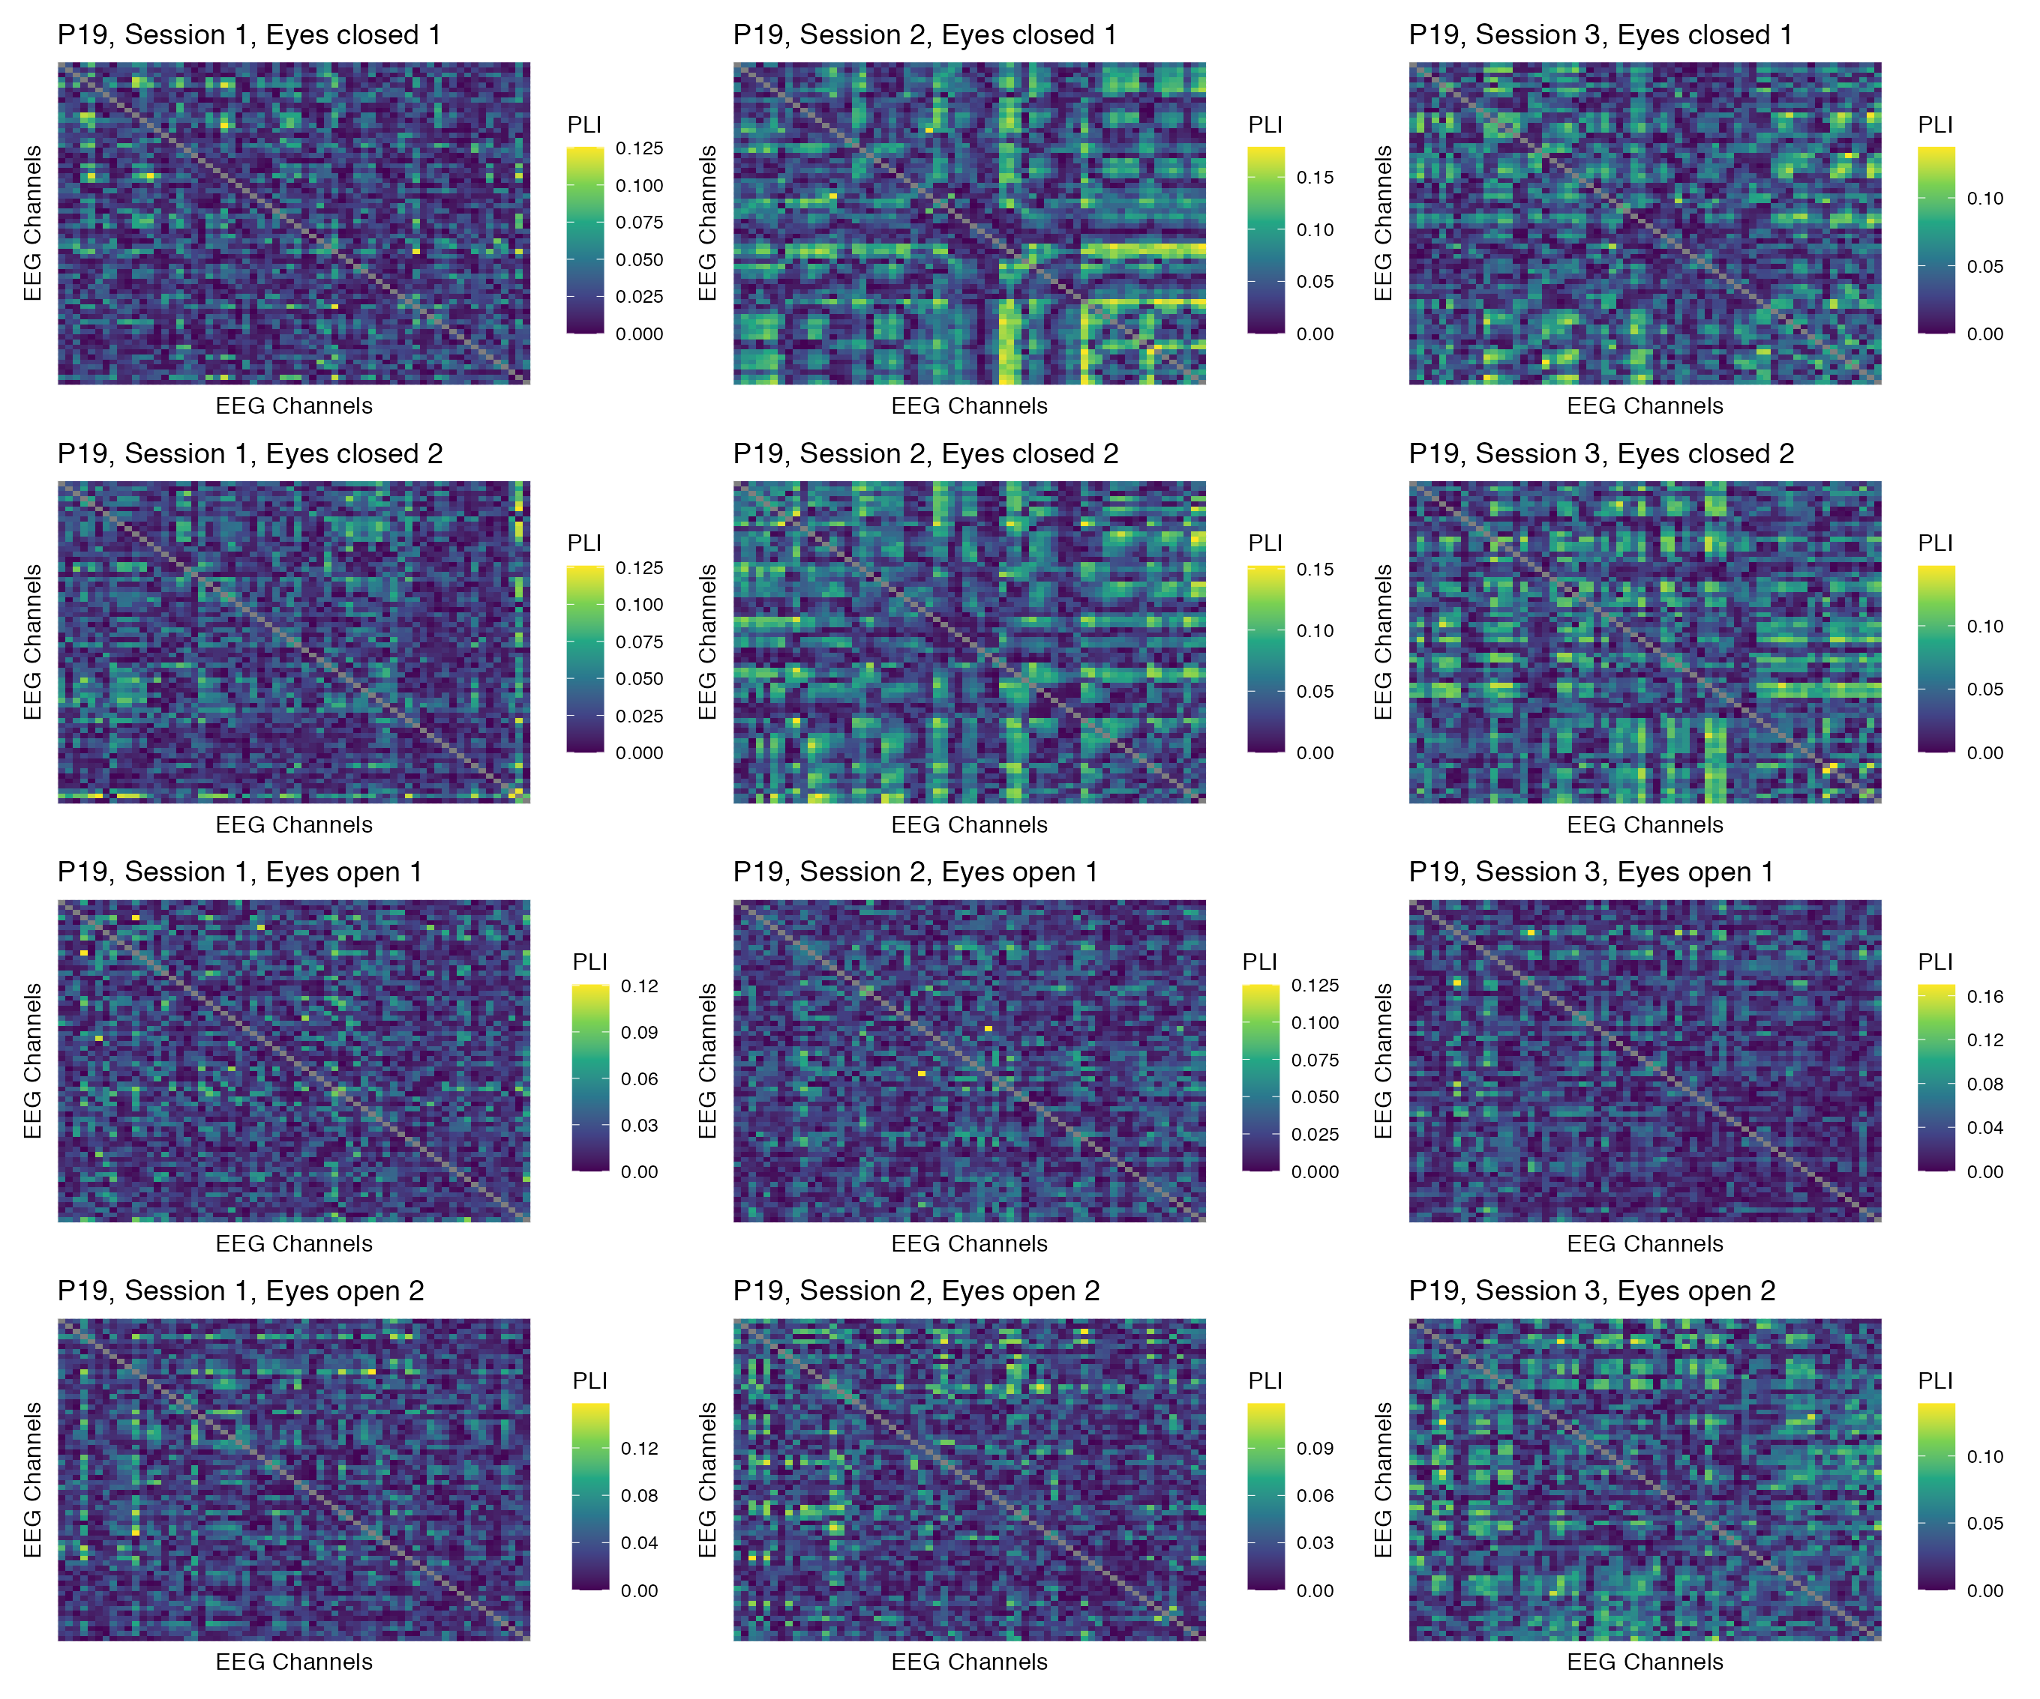

Figure 25: Phase coupling functional connectomes for participant P19 in the theta band. For each functional connectome, EEG channels are ordered as follows (from left to right, and from top to bottom): Fp1, Fp2, AF7, AF3, AFz, AF4, AF8, F7, F5, F3, F1, Fz, F2, F4, F6, F8, FT9, FT7, FC5, FC3, FC1, FCz, FC2, FC4, FC6, FT8, FT10, T7, C5, C3, C1, Cz, C2, C4, C6, T8, TP9, TP7, CP5, CP3, CP1, CPz, CP2, CP4, CP6, TP8, TP10, P7, P5, P3, P1, Pz, P2, P4, P6, P8, PO7, PO3, POz, PO4, PO8, O1, Oz, O2.

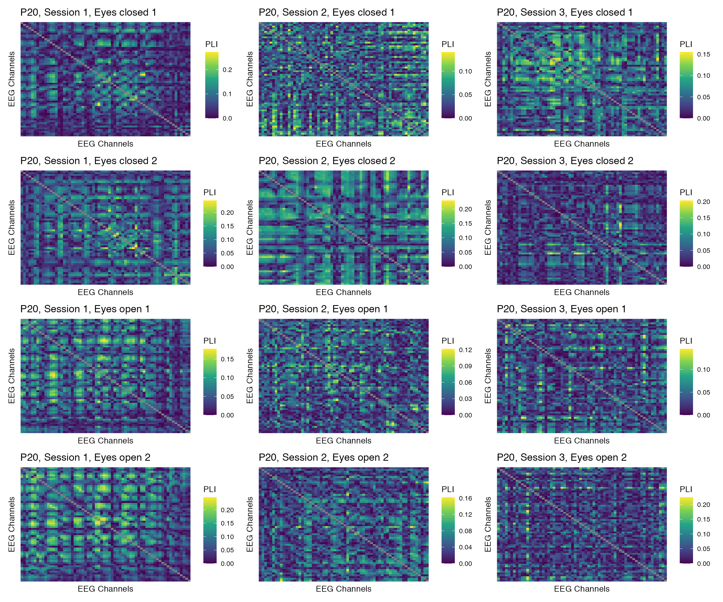

Figure 26: Phase coupling functional connectomes for participant P20 in the theta band. For each functional connectome, EEG channels are ordered as follows (from left to right, and from top to bottom): Fp1, Fp2, AF7, AF3, AFz, AF4, AF8, F7, F5, F3, F1, Fz, F2, F4, F6, F8, FT9, FT7, FC5, FC3, FC1, FCz, FC2, FC4, FC6, FT8, FT10, T7, C5, C3, C1, Cz, C2, C4, C6, T8, TP9, TP7, CP5, CP3, CP1, CPz, CP2, CP4, CP6, TP8, TP10, P7, P5, P3, P1, Pz, P2, P4, P6, P8, PO7, PO3, POz, PO4, PO8, O1, Oz, O2.

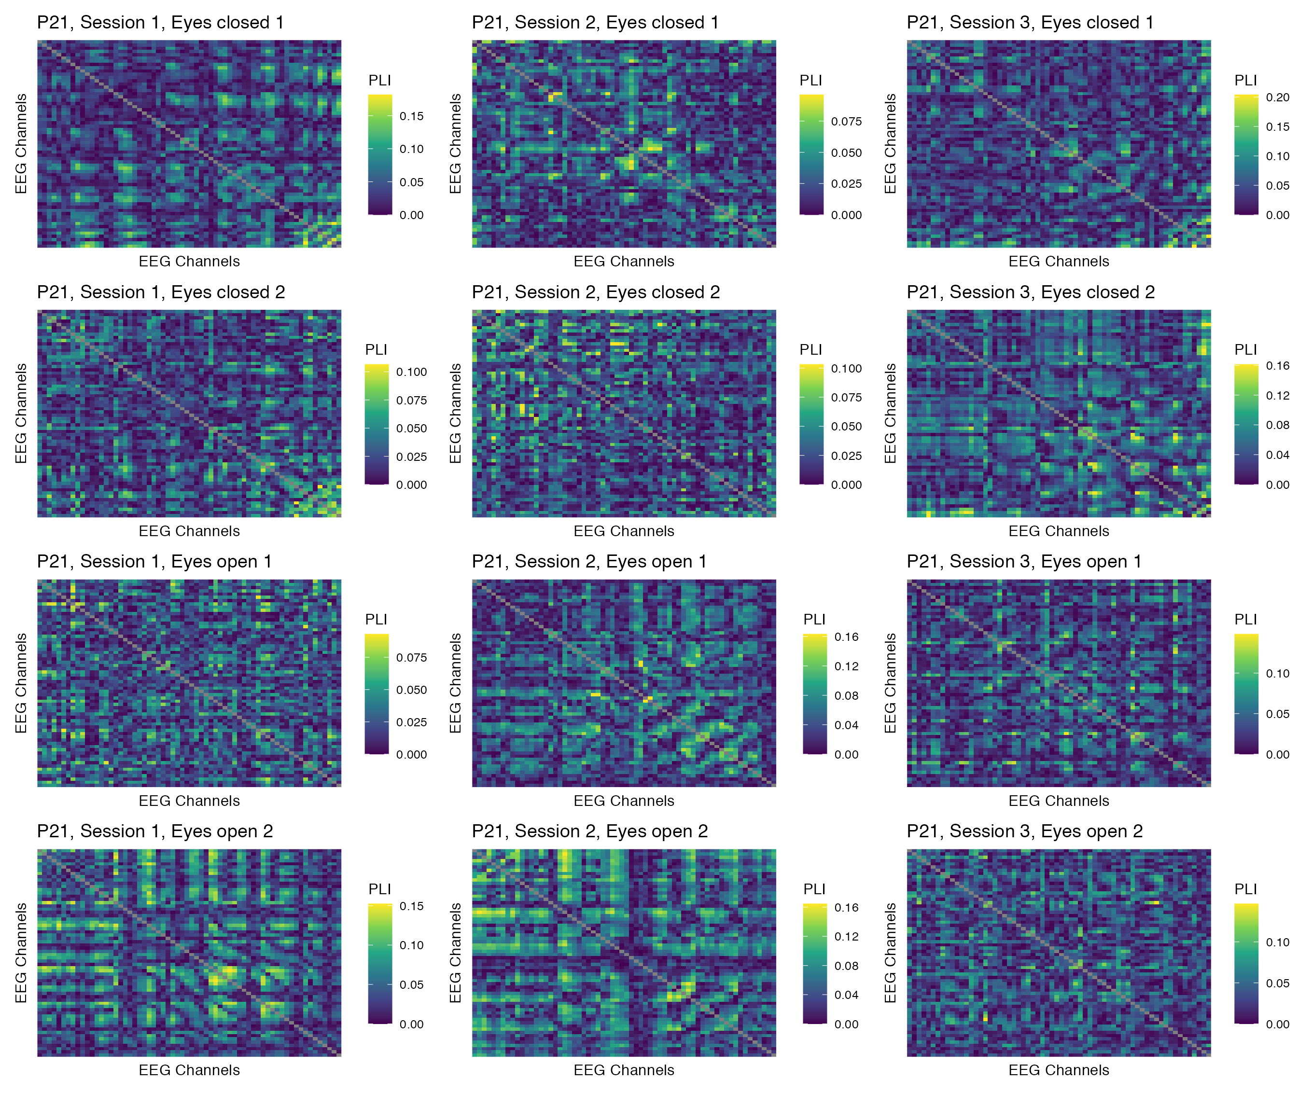

Figure 27: Phase coupling functional connectomes for participant P21 in the theta band. For each functional connectome, EEG channels are ordered as follows (from left to right, and from top to bottom): Fp1, Fp2, AF7, AF3, AFz, AF4, AF8, F7, F5, F3, F1, Fz, F2, F4, F6, F8, FT9, FT7, FC5, FC3, FC1, FCz, FC2, FC4, FC6, FT8, FT10, T7, C5, C3, C1, Cz, C2, C4, C6, T8, TP9, TP7, CP5, CP3, CP1, CPz, CP2, CP4, CP6, TP8, TP10, P7, P5, P3, P1, Pz, P2, P4, P6, P8, PO7, PO3, POz, PO4, PO8, O1, Oz, O2.

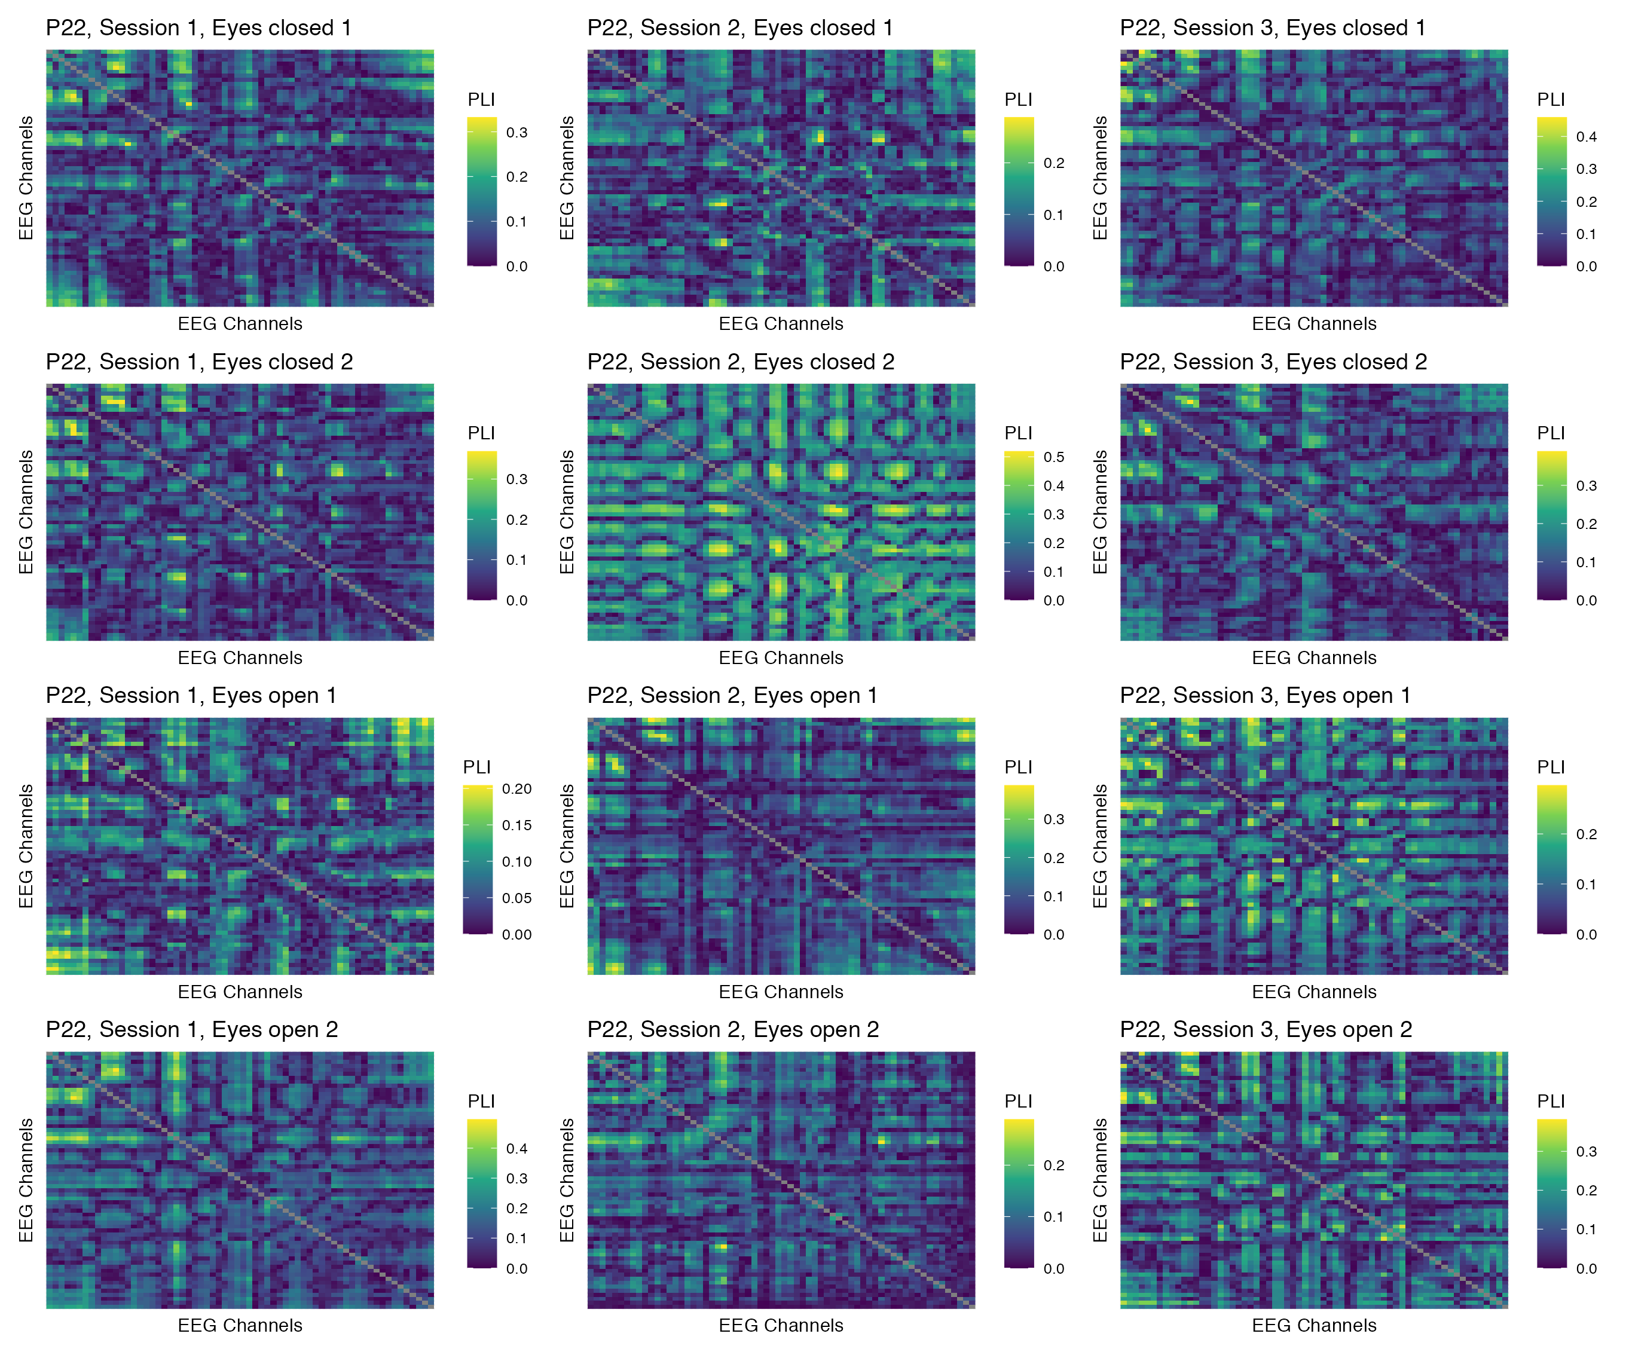

Figure 28: Phase coupling functional connectomes for participant P22 in the theta band. For each functional connectome, EEG channels are ordered as follows (from left to right, and from top to bottom): Fp1, Fp2, AF7, AF3, AFz, AF4, AF8, F7, F5, F3, F1, Fz, F2, F4, F6, F8, FT9, FT7, FC5, FC3, FC1, FCz, FC2, FC4, FC6, FT8, FT10, T7, C5, C3, C1, Cz, C2, C4, C6, T8, TP9, TP7, CP5, CP3, CP1, CPz, CP2, CP4, CP6, TP8, TP10, P7, P5, P3, P1, Pz, P2, P4, P6, P8, PO7, PO3, POz, PO4, PO8, O1, Oz, O2.

## Alpha band

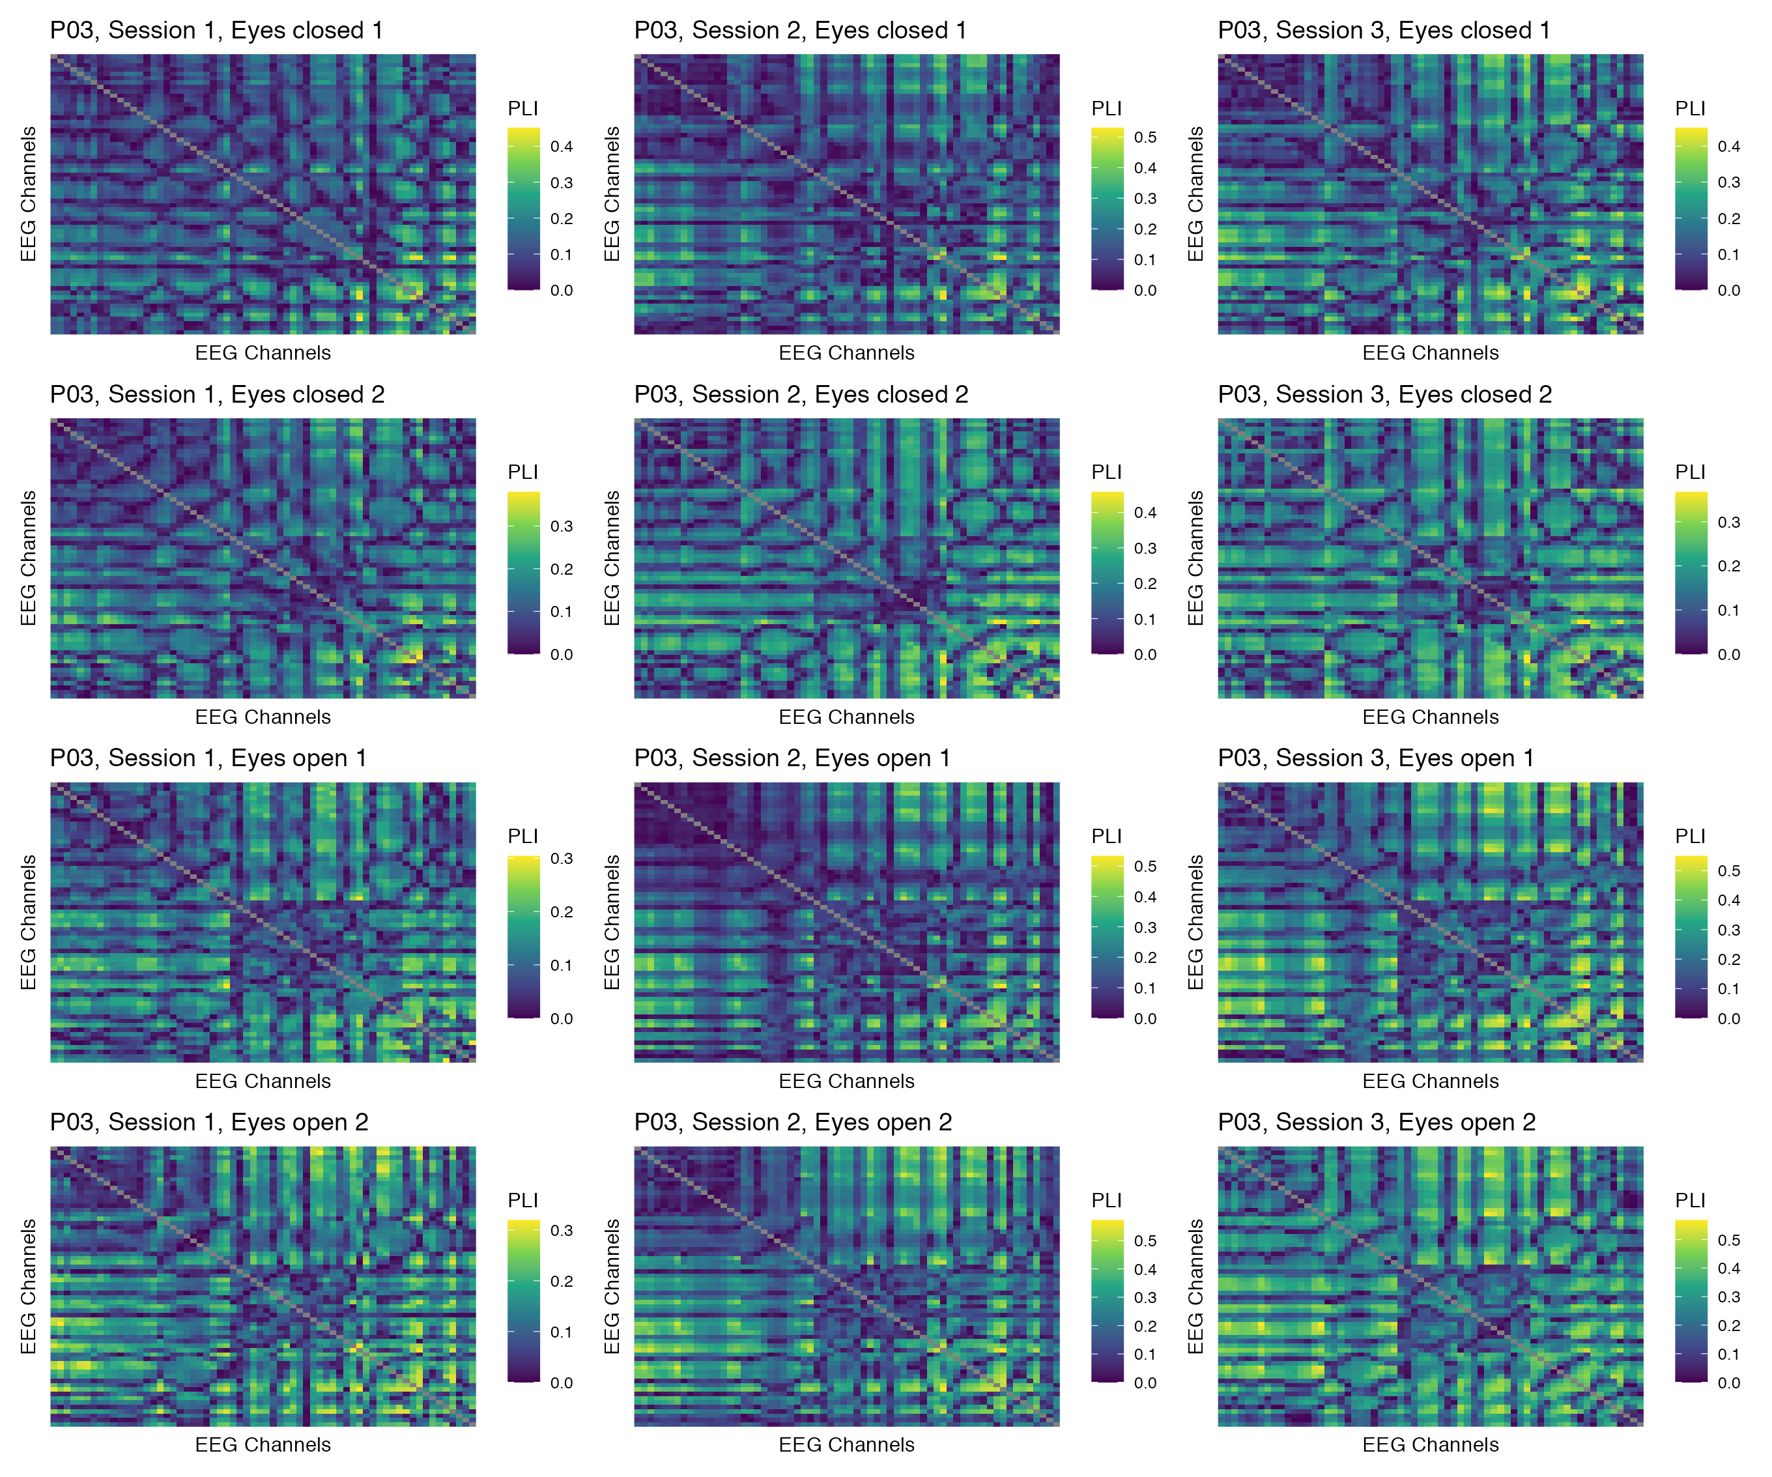

Figure 29: Phase coupling functional connectomes for participant P03 in the alpha band. For each functional connectome, EEG channels are ordered as follows (from left to right, and from top to bottom): Fp1, Fp2, AF7, AF3, AFz, AF4, AF8, F7, F5, F3, F1, Fz, F2, F4, F6, F8, FT9, FT7, FC5, FC3, FC1, FCz, FC2, FC4, FC6, FT8, FT10, T7, C5, C3, C1, Cz, C2, C4, C6, T8, TP9, TP7, CP5, CP3, CP1, CPz, CP2, CP4, CP6, TP8, TP10, P7, P5, P3, P1, Pz, P2, P4, P6, P8, PO7, PO3, POz, PO4, PO8, O1, Oz, O2.

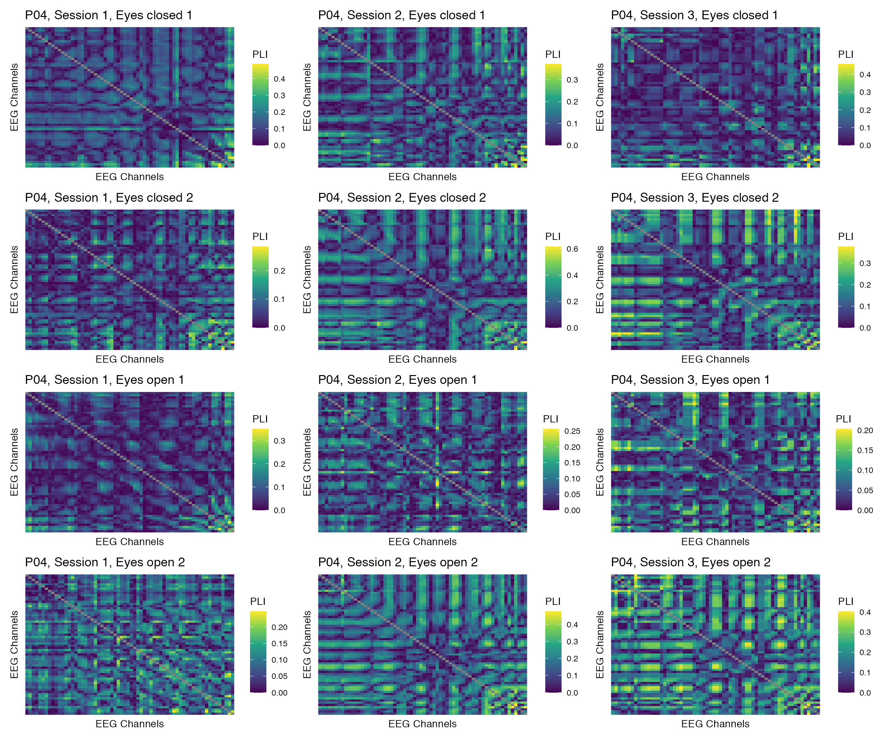

Figure 30: Phase coupling functional connectomes for participant P04 in the alpha band. For each functional connectome, EEG channels are ordered as follows (from left to right, and from top to bottom): Fp1, Fp2, AF7, AF3, AFz, AF4, AF8, F7, F5, F3, F1, Fz, F2, F4, F6, F8, FT9, FT7, FC5, FC3, FC1, FCz, FC2, FC4, FC6, FT8, FT10, T7, C5, C3, C1, Cz, C2, C4, C6, T8, TP9, TP7, CP5, CP3, CP1, CPz, CP2, CP4, CP6, TP8, TP10, P7, P5, P3, P1, Pz, P2, P4, P6, P8, PO7, PO3, POz, PO4, PO8, O1, Oz, O2.

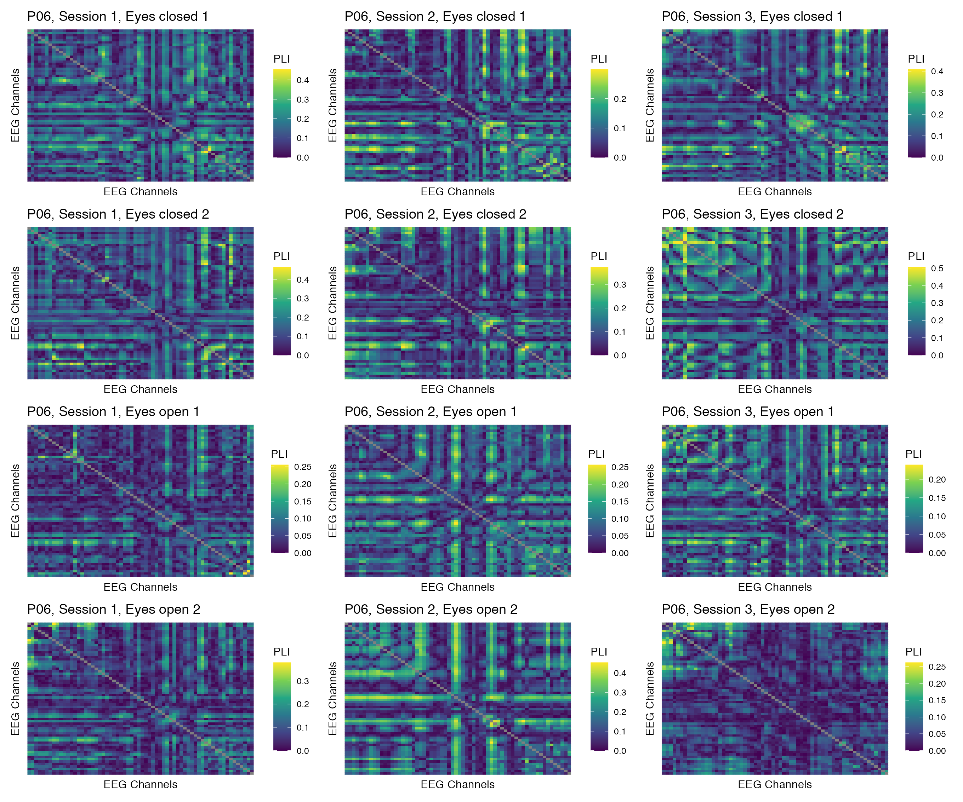

Figure 31: Phase coupling functional connectomes for participant P06 in the alpha band. For each functional connectome, EEG channels are ordered as follows (from left to right, and from top to bottom): Fp1, Fp2, AF7, AF3, AFz, AF4, AF8, F7, F5, F3, F1, Fz, F2, F4, F6, F8, FT9, FT7, FC5, FC3, FC1, FCz, FC2, FC4, FC6, FT8, FT10, T7, C5, C3, C1, Cz, C2, C4, C6, T8, TP9, TP7, CP5, CP3, CP1, CPz, CP2, CP4, CP6, TP8, TP10, P7, P5, P3, P1, Pz, P2, P4, P6, P8, PO7, PO3, POz, PO4, PO8, O1, Oz, O2.

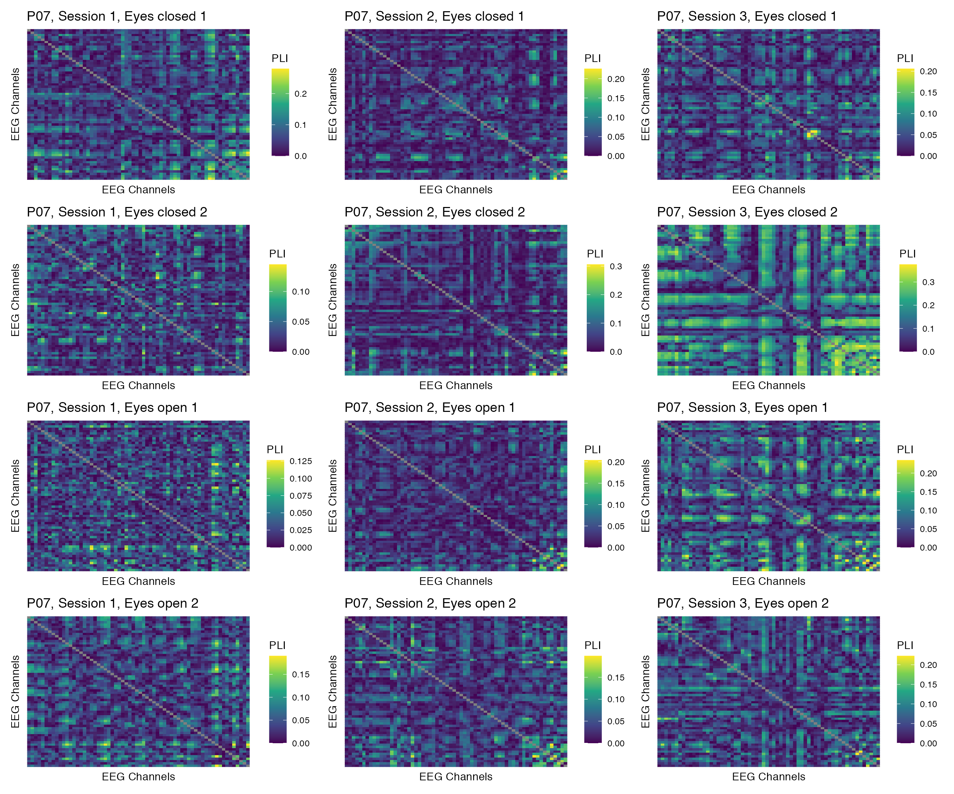

Figure 32: Phase coupling functional connectomes for participant P07 in the alpha band. For each functional connectome, EEG channels are ordered as follows (from left to right, and from top to bottom): Fp1, Fp2, AF7, AF3, AFz, AF4, AF8, F7, F5, F3, F1, Fz, F2, F4, F6, F8, FT9, FT7, FC5, FC3, FC1, FCz, FC2, FC4, FC6, FT8, FT10, T7, C5, C3, C1, Cz, C2, C4, C6, T8, TP9, TP7, CP5, CP3, CP1, CPz, CP2, CP4, CP6, TP8, TP10, P7, P5, P3, P1, Pz, P2, P4, P6, P8, PO7, PO3, POz, PO4, PO8, O1, Oz, O2.

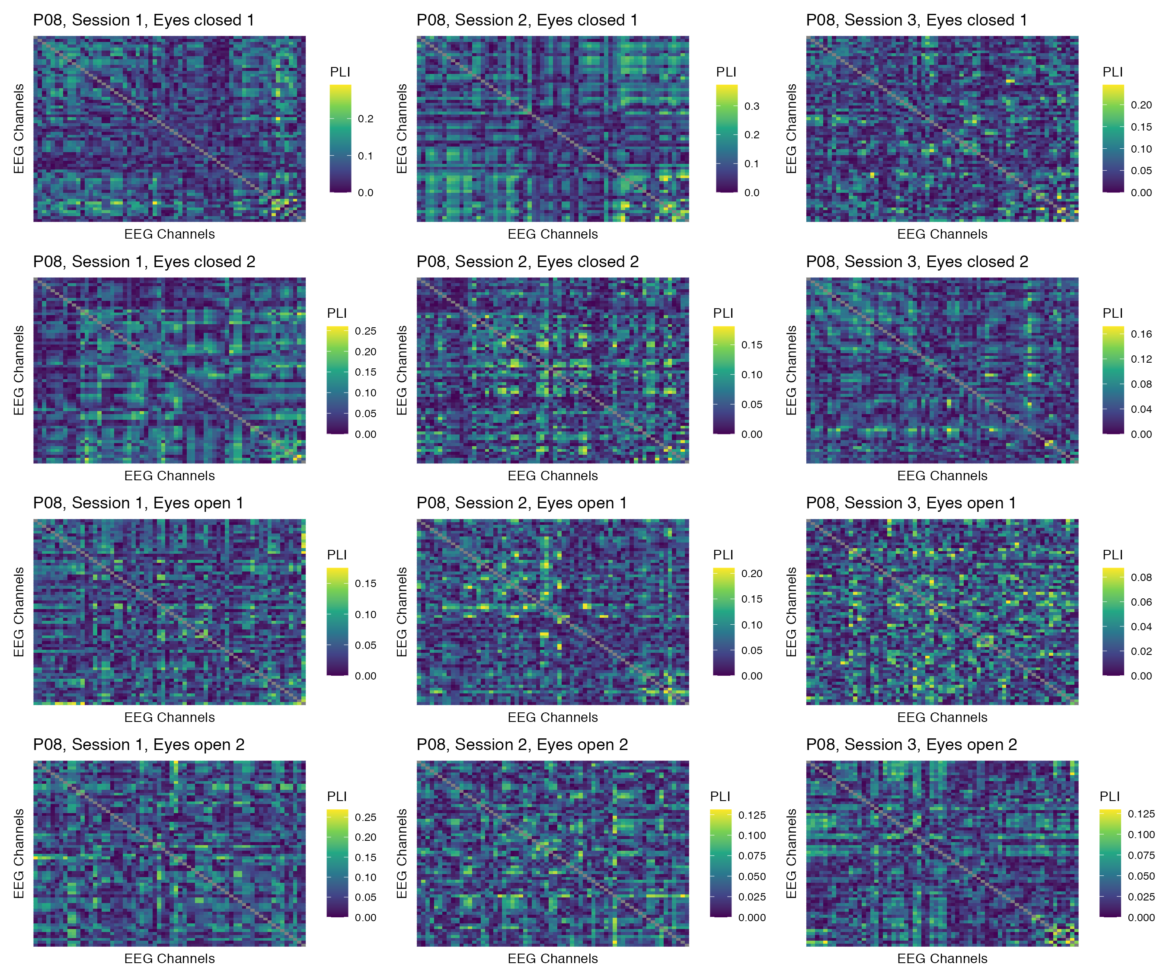

Figure 33: Phase coupling functional connectomes for participant P08 in the alpha band. For each functional connectome, EEG channels are ordered as follows (from left to right, and from top to bottom): Fp1, Fp2, AF7, AF3, AFz, AF4, AF8, F7, F5, F3, F1, Fz, F2, F4, F6, F8, FT9, FT7, FC5, FC3, FC1, FCz, FC2, FC4, FC6, FT8, FT10, T7, C5, C3, C1, Cz, C2, C4, C6, T8, TP9, TP7, CP5, CP3, CP1, CPz, CP2, CP4, CP6, TP8, TP10, P7, P5, P3, P1, Pz, P2, P4, P6, P8, PO7, PO3, POz, PO4, PO8, O1, Oz, O2.

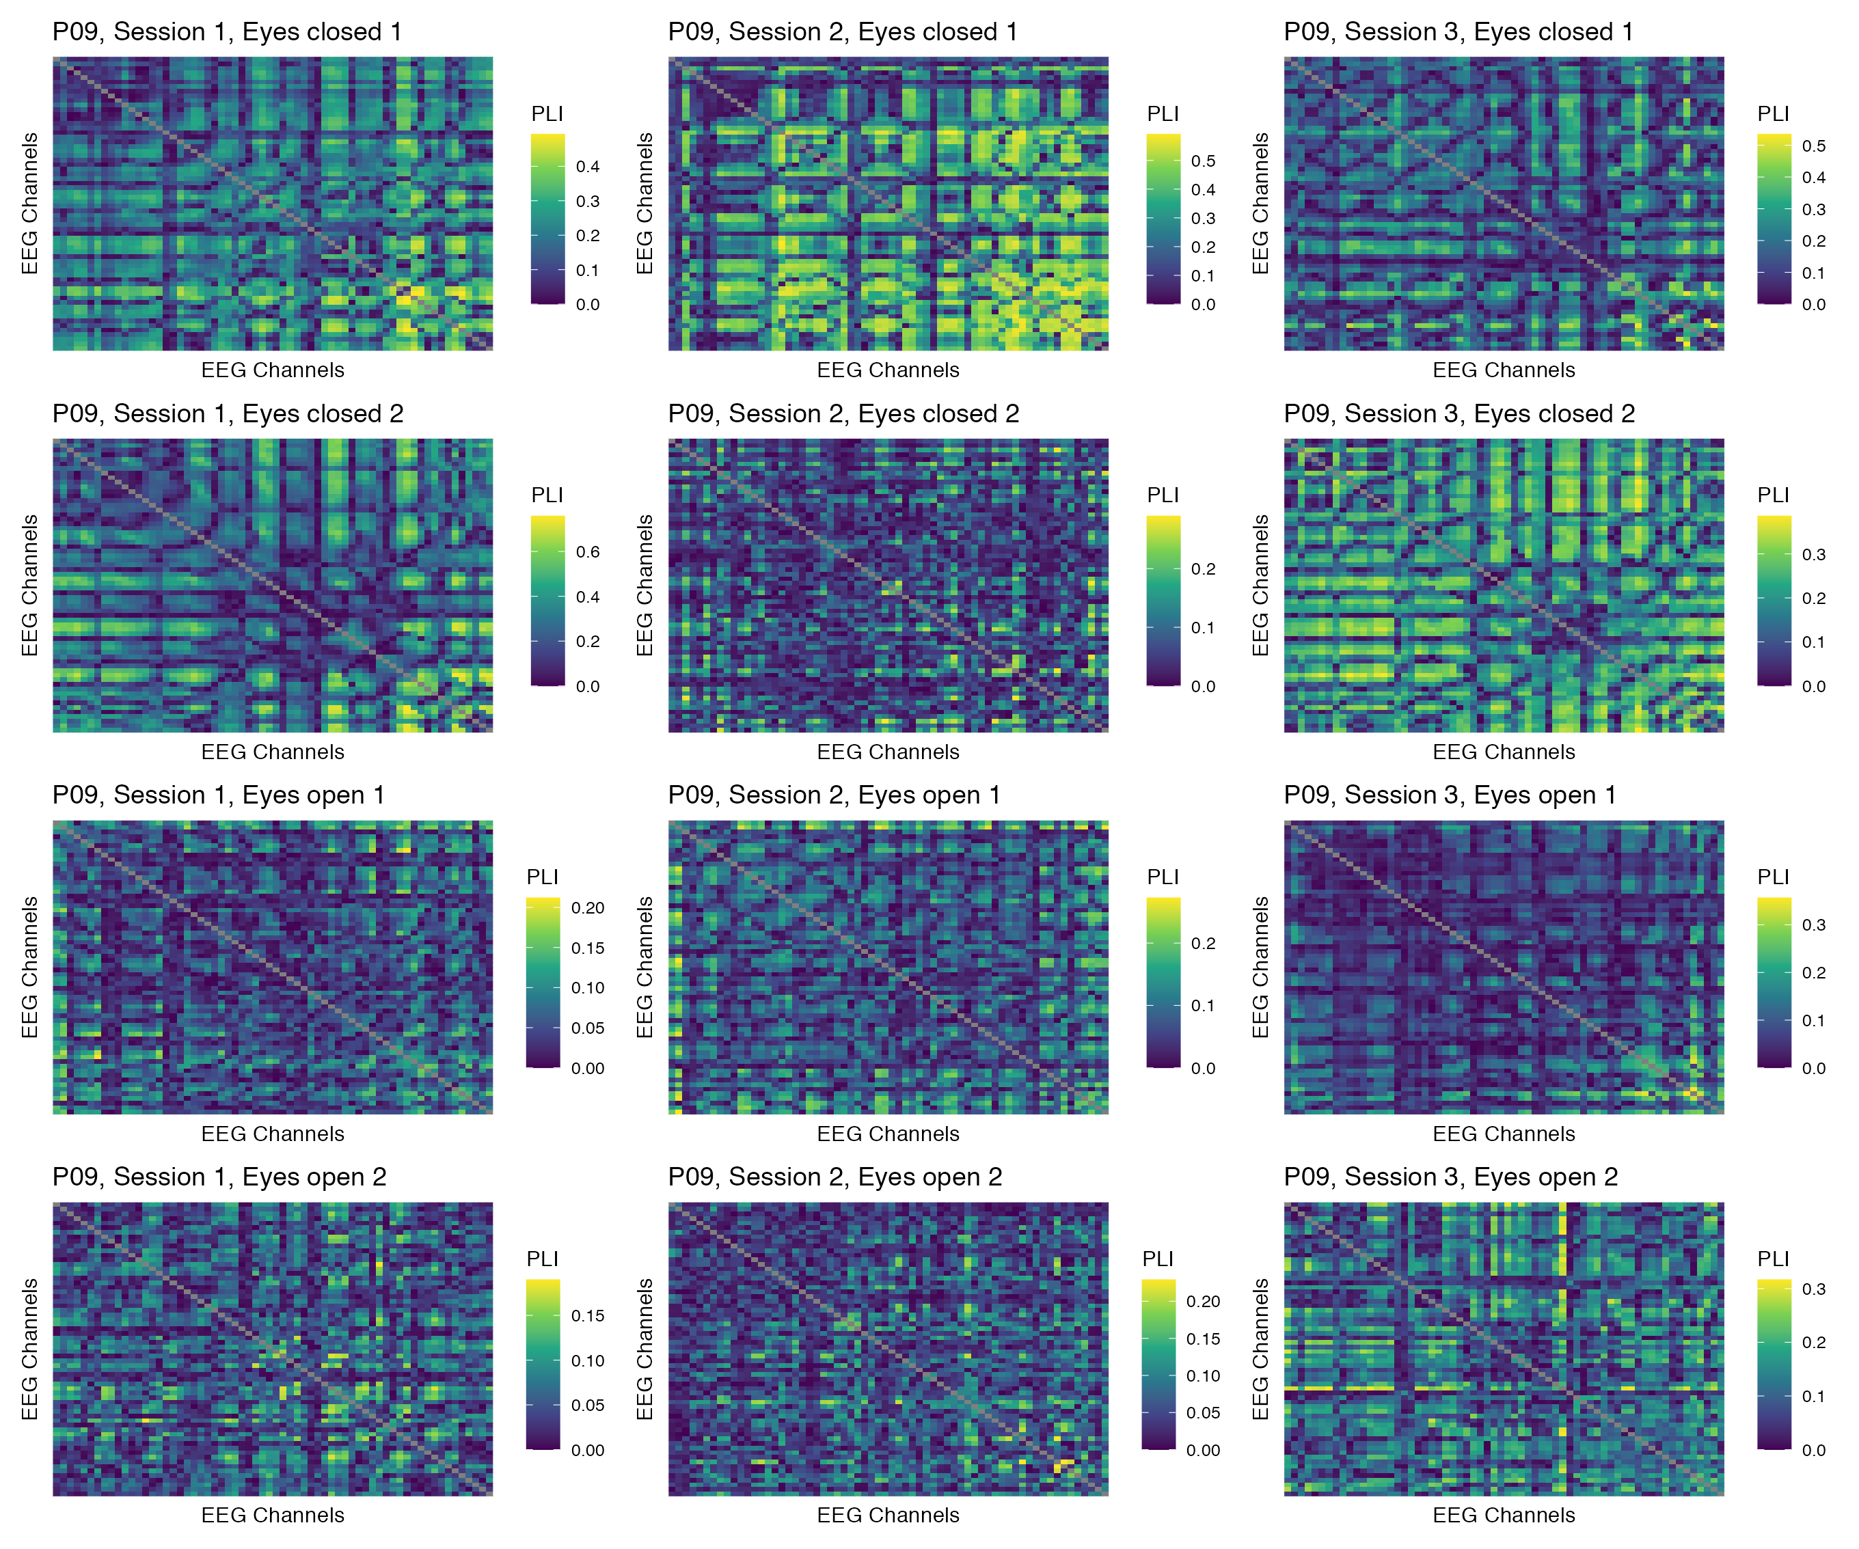

Figure 34: Phase coupling functional connectomes for participant P09 in the alpha band. For each functional connectome, EEG channels are ordered as follows (from left to right, and from top to bottom): Fp1, Fp2, AF7, AF3, AFz, AF4, AF8, F7, F5, F3, F1, Fz, F2, F4, F6, F8, FT9, FT7, FC5, FC3, FC1, FCz, FC2, FC4, FC6, FT8, FT10, T7, C5, C3, C1, Cz, C2, C4, C6, T8, TP9, TP7, CP5, CP3, CP1, CPz, CP2, CP4, CP6, TP8, TP10, P7, P5, P3, P1, Pz, P2, P4, P6, P8, PO7, PO3, POz, PO4, PO8, O1, Oz, O2.

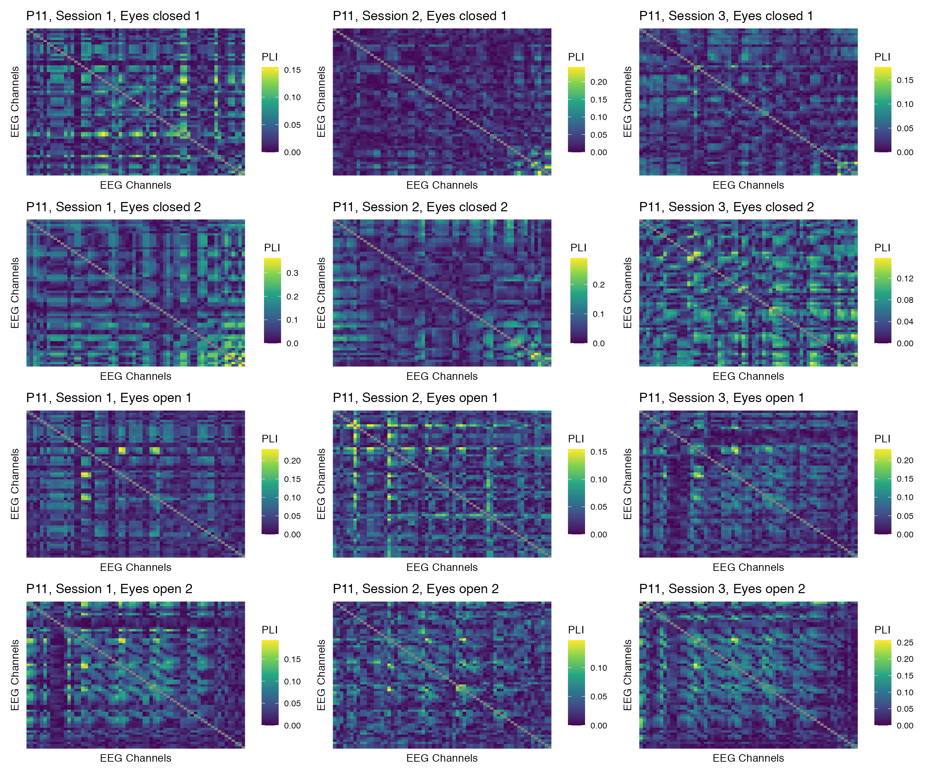

Figure 35: Phase coupling functional connectomes for participant P11 in the alpha band. For each functional connectome, EEG channels are ordered as follows (from left to right, and from top to bottom): Fp1, Fp2, AF7, AF3, AFz, AF4, AF8, F7, F5, F3, F1, Fz, F2, F4, F6, F8, FT9, FT7, FC5, FC3, FC1, FCz, FC2, FC4, FC6, FT8, FT10, T7, C5, C3, C1, Cz, C2, C4, C6, T8, TP9, TP7, CP5, CP3, CP1, CPz, CP2, CP4, CP6, TP8, TP10, P7, P5, P3, P1, Pz, P2, P4, P6, P8, PO7, PO3, POz, PO4, PO8, O1, Oz, O2.

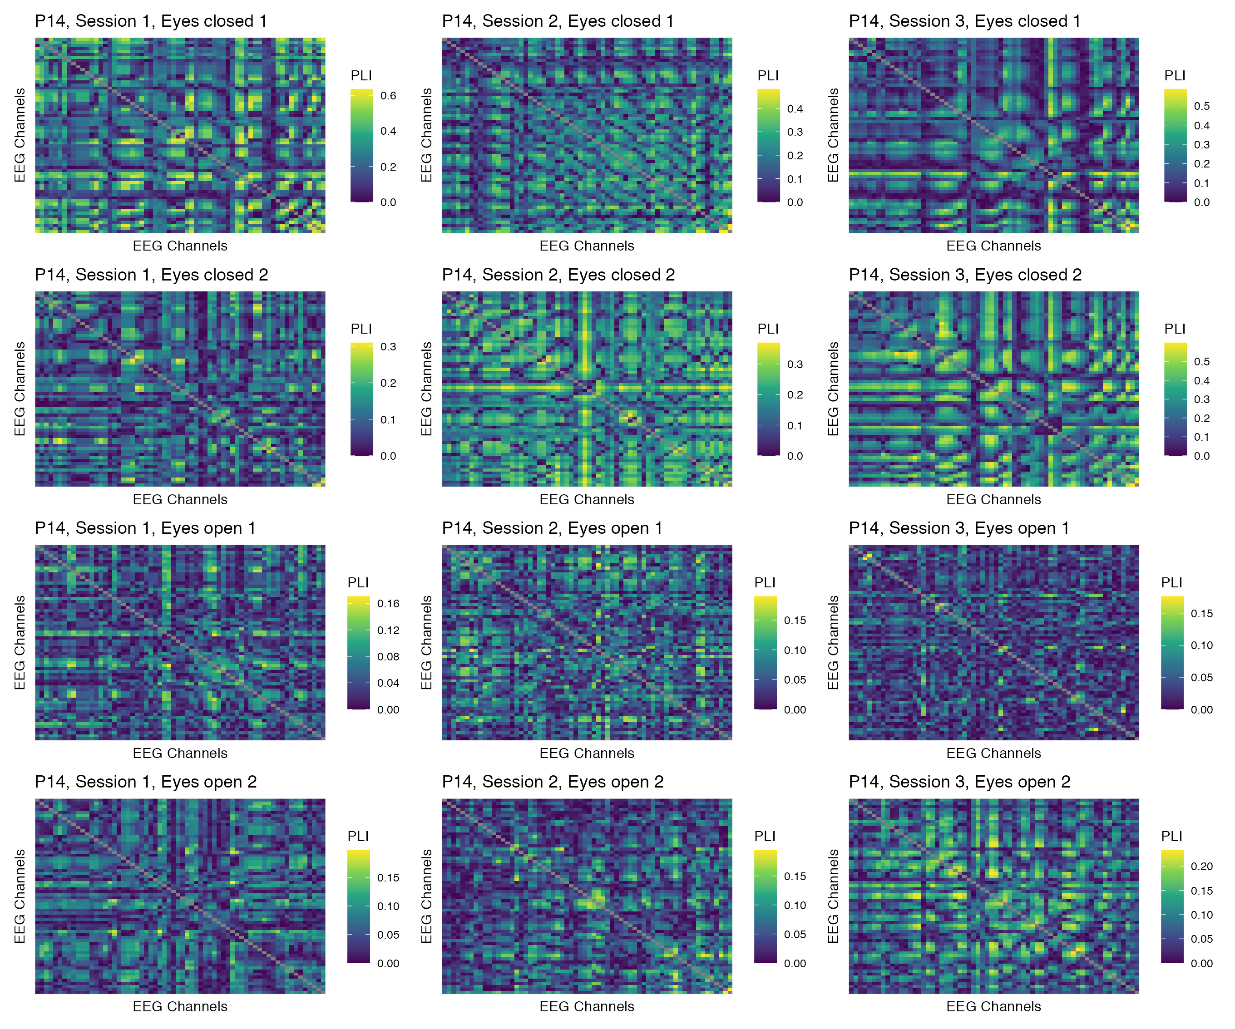

Figure 36: Phase coupling functional connectomes for participant P14 in the alpha band. For each functional connectome, EEG channels are ordered as follows (from left to right, and from top to bottom): Fp1, Fp2, AF7, AF3, AFz, AF4, AF8, F7, F5, F3, F1, Fz, F2, F4, F6, F8, FT9, FT7, FC5, FC3, FC1, FCz, FC2, FC4, FC6, FT8, FT10, T7, C5, C3, C1, Cz, C2, C4, C6, T8, TP9, TP7, CP5, CP3, CP1, CPz, CP2, CP4, CP6, TP8, TP10, P7, P5, P3, P1, Pz, P2, P4, P6, P8, PO7, PO3, POz, PO4, PO8, O1, Oz, O2.

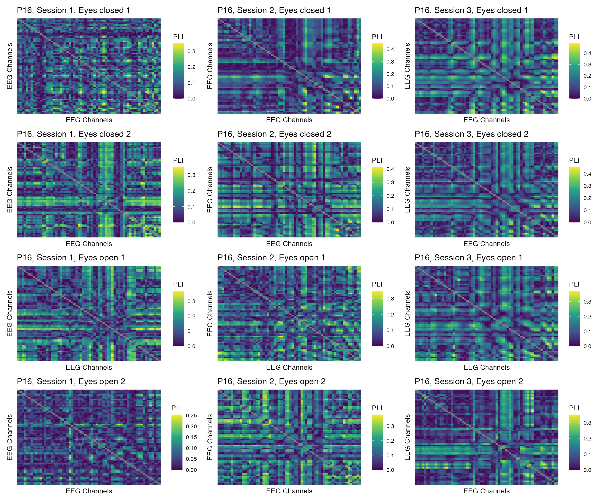

Figure 37: Phase coupling functional connectomes for participant P16 in the alpha band. For each functional connectome, EEG channels are ordered as follows (from left to right, and from top to bottom): Fp1, Fp2, AF7, AF3, AFz, AF4, AF8, F7, F5, F3, F1, Fz, F2, F4, F6, F8, FT9, FT7, FC5, FC3, FC1, FCz, FC2, FC4, FC6, FT8, FT10, T7, C5, C3, C1, Cz, C2, C4, C6, T8, TP9, TP7, CP5, CP3, CP1, CPz, CP2, CP4, CP6, TP8, TP10, P7, P5, P3, P1, Pz, P2, P4, P6, P8, PO7, PO3, POz, PO4, PO8, O1, Oz, O2.

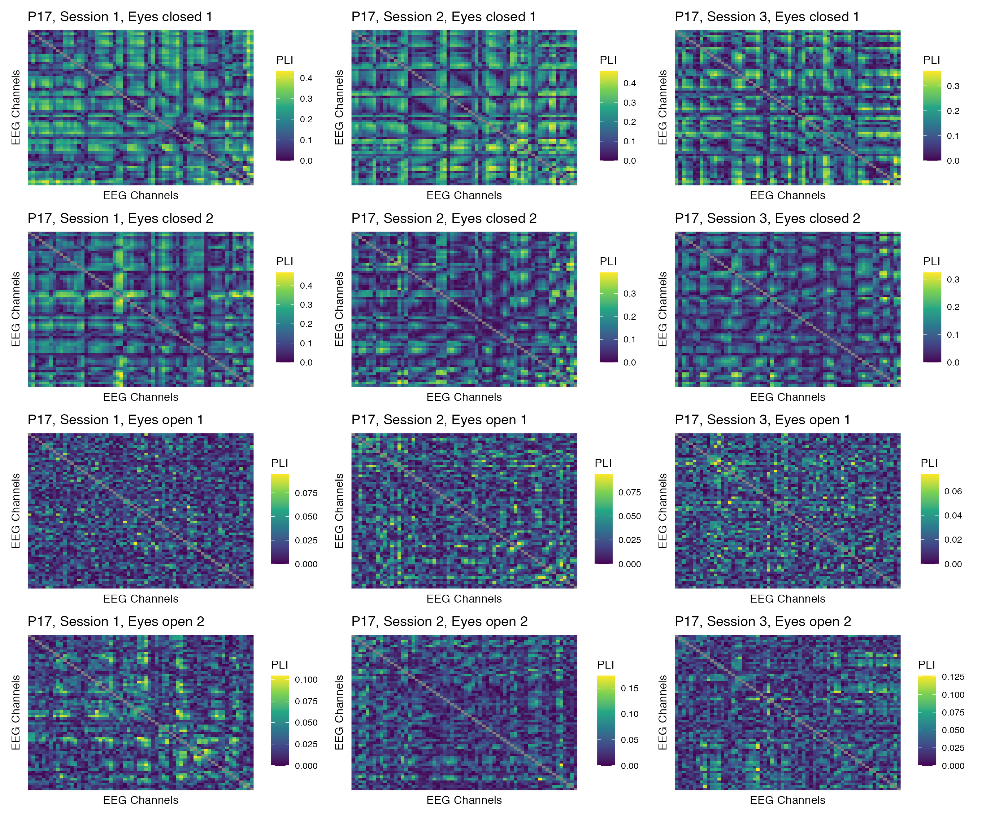

Figure 38: Phase coupling functional connectomes for participant P17 in the alpha band. For each functional connectome, EEG channels are ordered as follows (from left to right, and from top to bottom): Fp1, Fp2, AF7, AF3, AFz, AF4, AF8, F7, F5, F3, F1, Fz, F2, F4, F6, F8, FT9, FT7, FC5, FC3, FC1, FCz, FC2, FC4, FC6, FT8, FT10, T7, C5, C3, C1, Cz, C2, C4, C6, T8, TP9, TP7, CP5, CP3, CP1, CPz, CP2, CP4, CP6, TP8, TP10, P7, P5, P3, P1, Pz, P2, P4, P6, P8, PO7, PO3, POz, PO4, PO8, O1, Oz, O2.

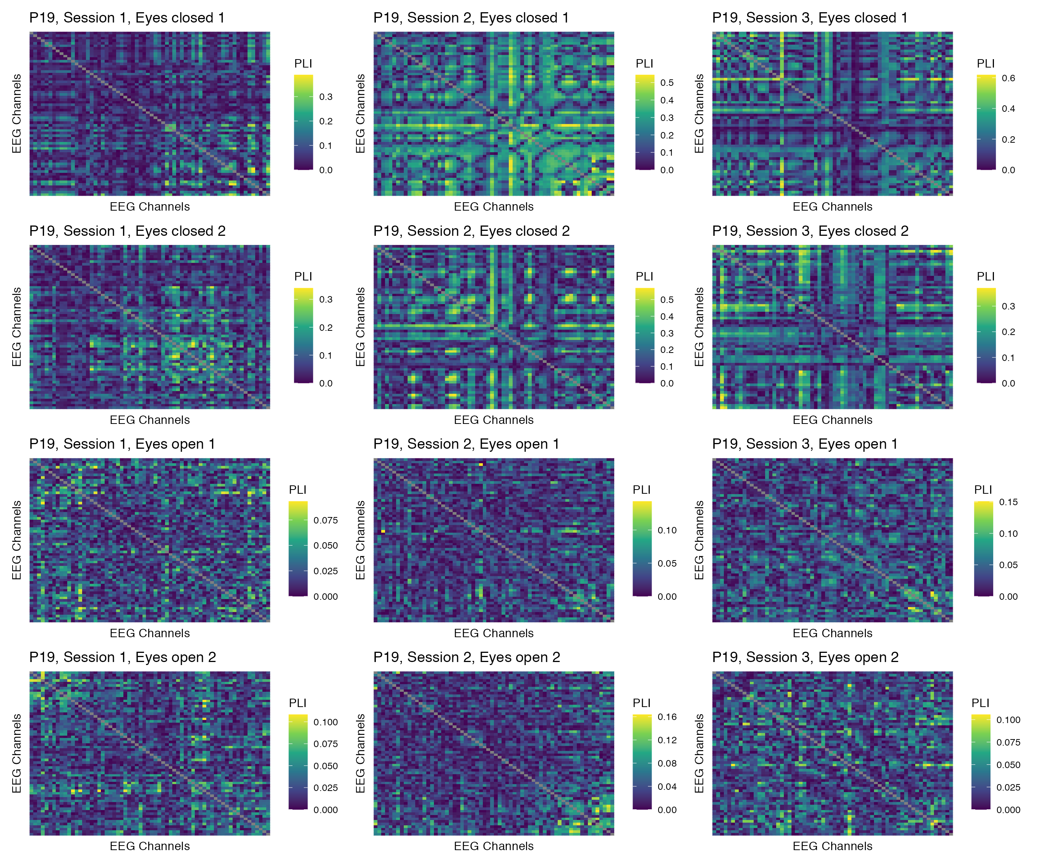

Figure 39: Phase coupling functional connectomes for participant P19 in the alpha band. For each functional connectome, EEG channels are ordered as follows (from left to right, and from top to bottom): Fp1, Fp2, AF7, AF3, AFz, AF4, AF8, F7, F5, F3, F1, Fz, F2, F4, F6, F8, FT9, FT7, FC5, FC3, FC1, FCz, FC2, FC4, FC6, FT8, FT10, T7, C5, C3, C1, Cz, C2, C4, C6, T8, TP9, TP7, CP5, CP3, CP1, CPz, CP2, CP4, CP6, TP8, TP10, P7, P5, P3, P1, Pz, P2, P4, P6, P8, PO7, PO3, POz, PO4, PO8, O1, Oz, O2.

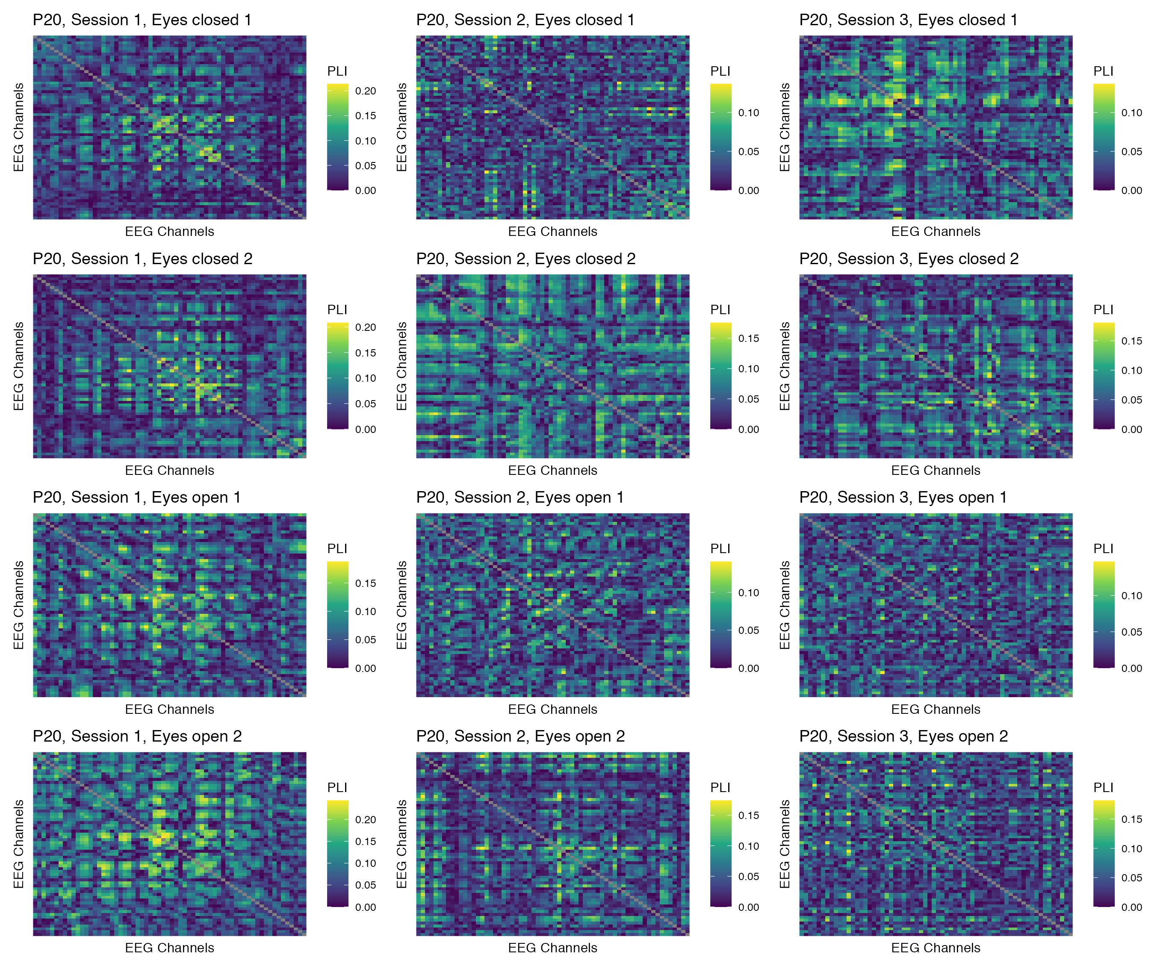

Figure 40: Phase coupling functional connectomes for participant P20 in the alpha band. For each functional connectome, EEG channels are ordered as follows (from left to right, and from top to bottom): Fp1, Fp2, AF7, AF3, AFz, AF4, AF8, F7, F5, F3, F1, Fz, F2, F4, F6, F8, FT9, FT7, FC5, FC3, FC1, FCz, FC2, FC4, FC6, FT8, FT10, T7, C5, C3, C1, Cz, C2, C4, C6, T8, TP9, TP7, CP5, CP3, CP1, CPz, CP2, CP4, CP6, TP8, TP10, P7, P5, P3, P1, Pz, P2, P4, P6, P8, PO7, PO3, POz, PO4, PO8, O1, Oz, O2.

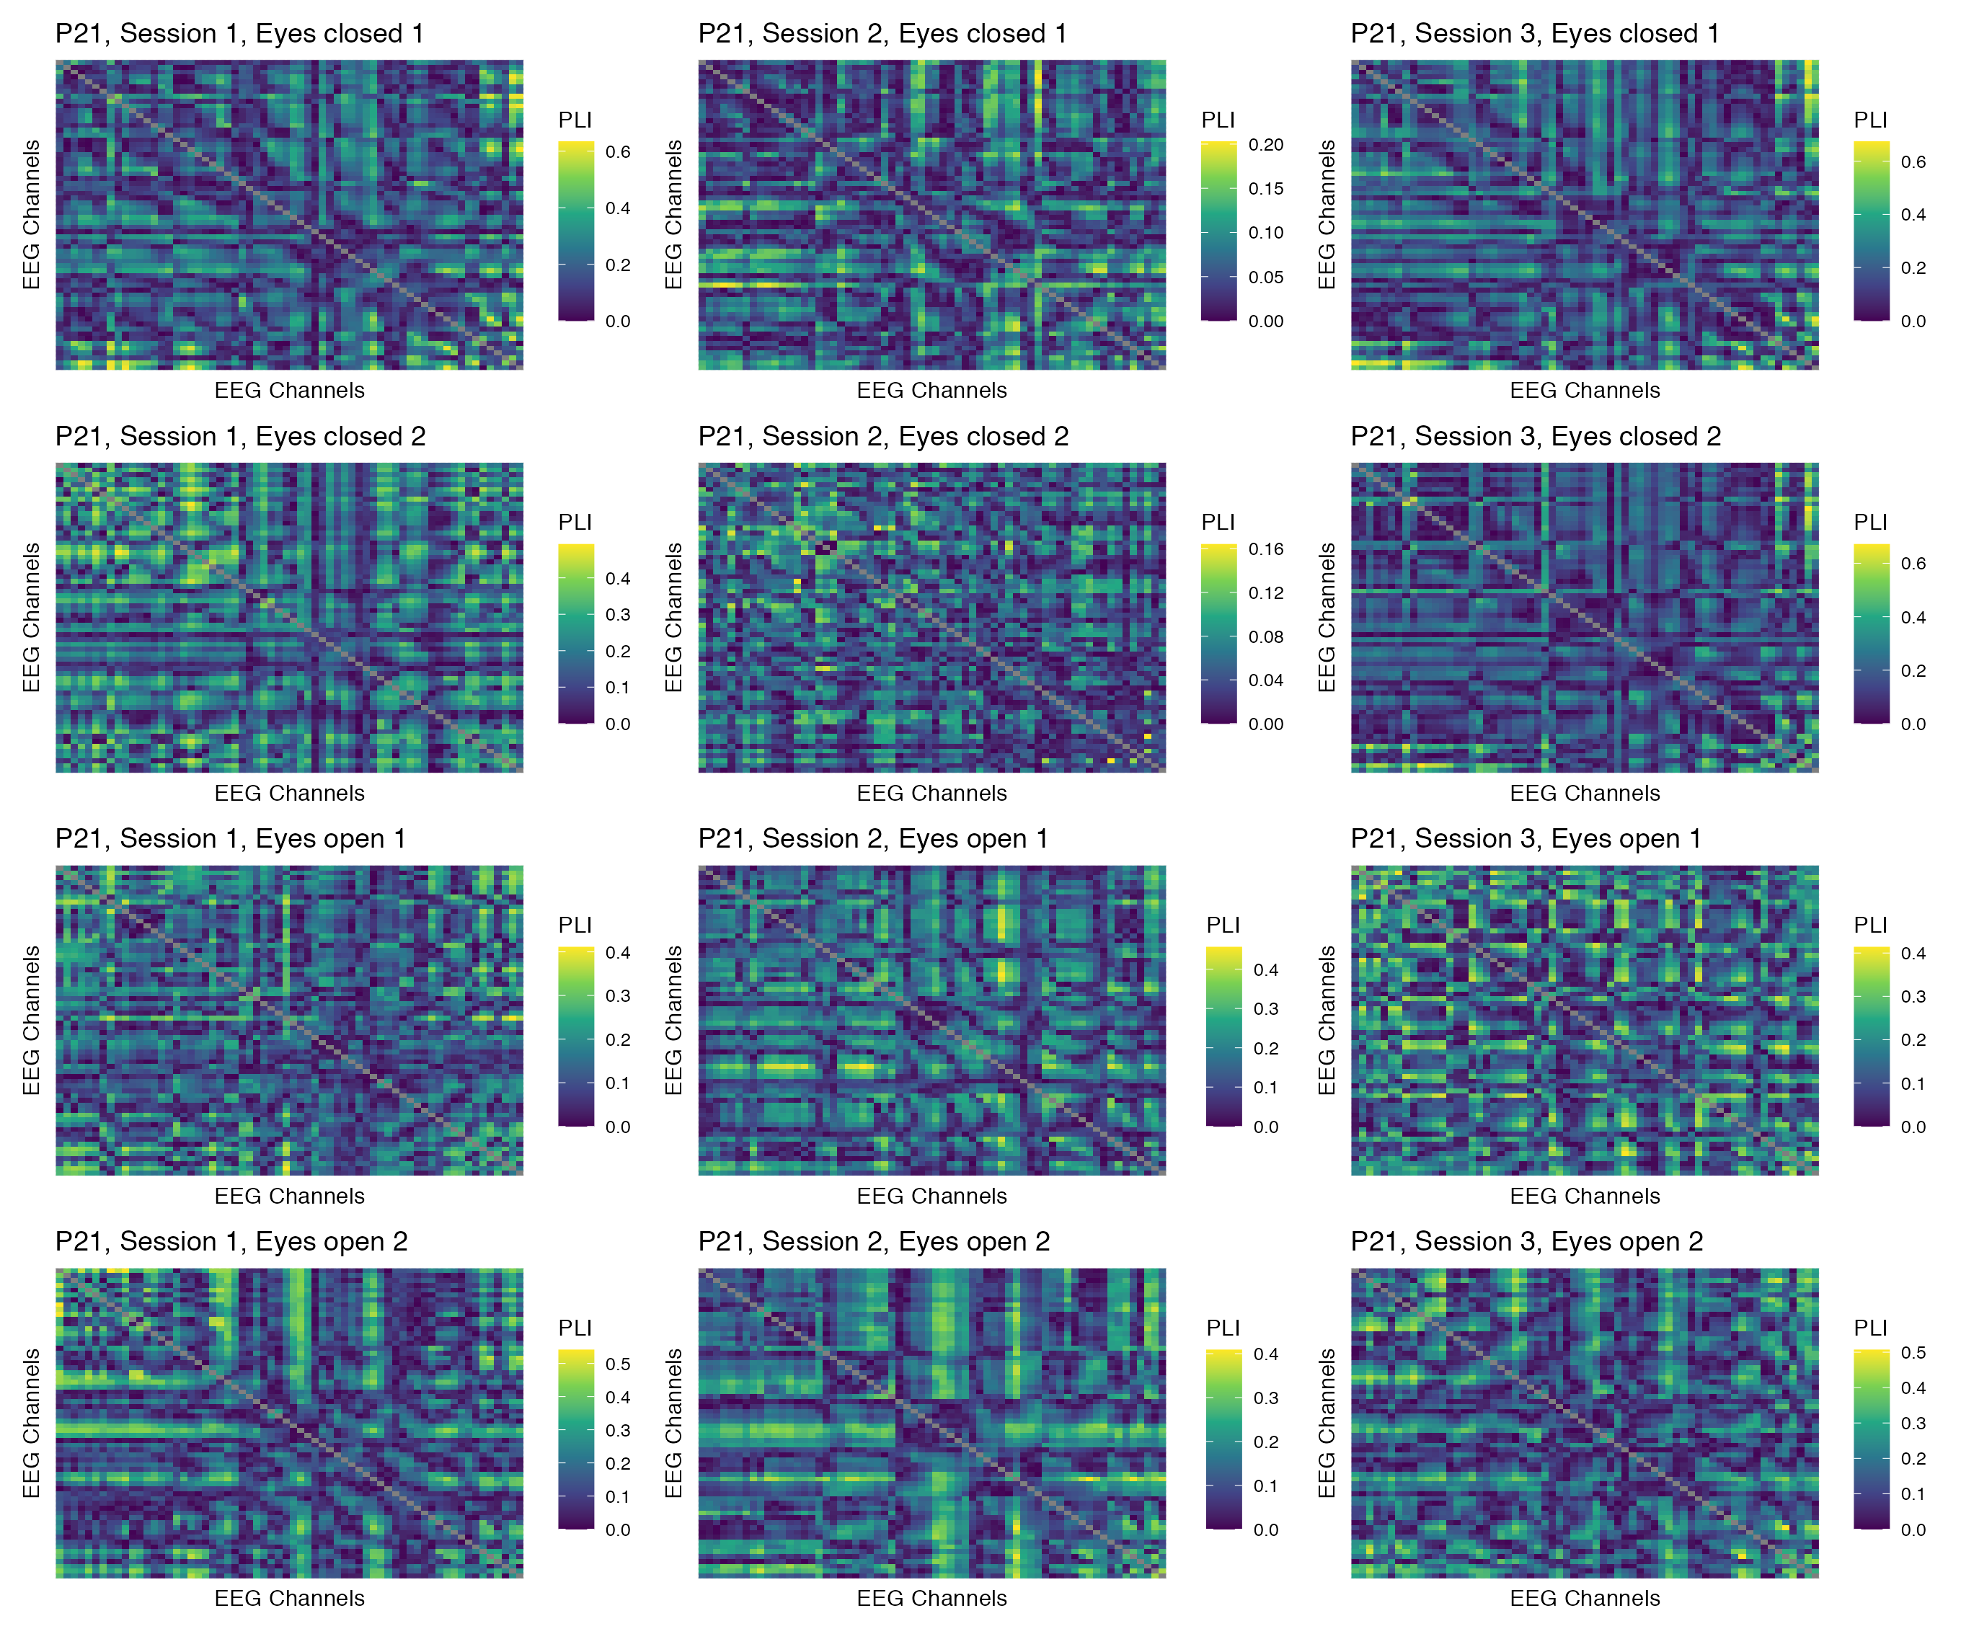

Figure 41: Phase coupling functional connectomes for participant P21 in the alpha band. For each functional connectome, EEG channels are ordered as follows (from left to right, and from top to bottom): Fp1, Fp2, AF7, AF3, AFz, AF4, AF8, F7, F5, F3, F1, Fz, F2, F4, F6, F8, FT9, FT7, FC5, FC3, FC1, FCz, FC2, FC4, FC6, FT8, FT10, T7, C5, C3, C1, Cz, C2, C4, C6, T8, TP9, TP7, CP5, CP3, CP1, CPz, CP2, CP4, CP6, TP8, TP10, P7, P5, P3, P1, Pz, P2, P4, P6, P8, PO7, PO3, POz, PO4, PO8, O1, Oz, O2.

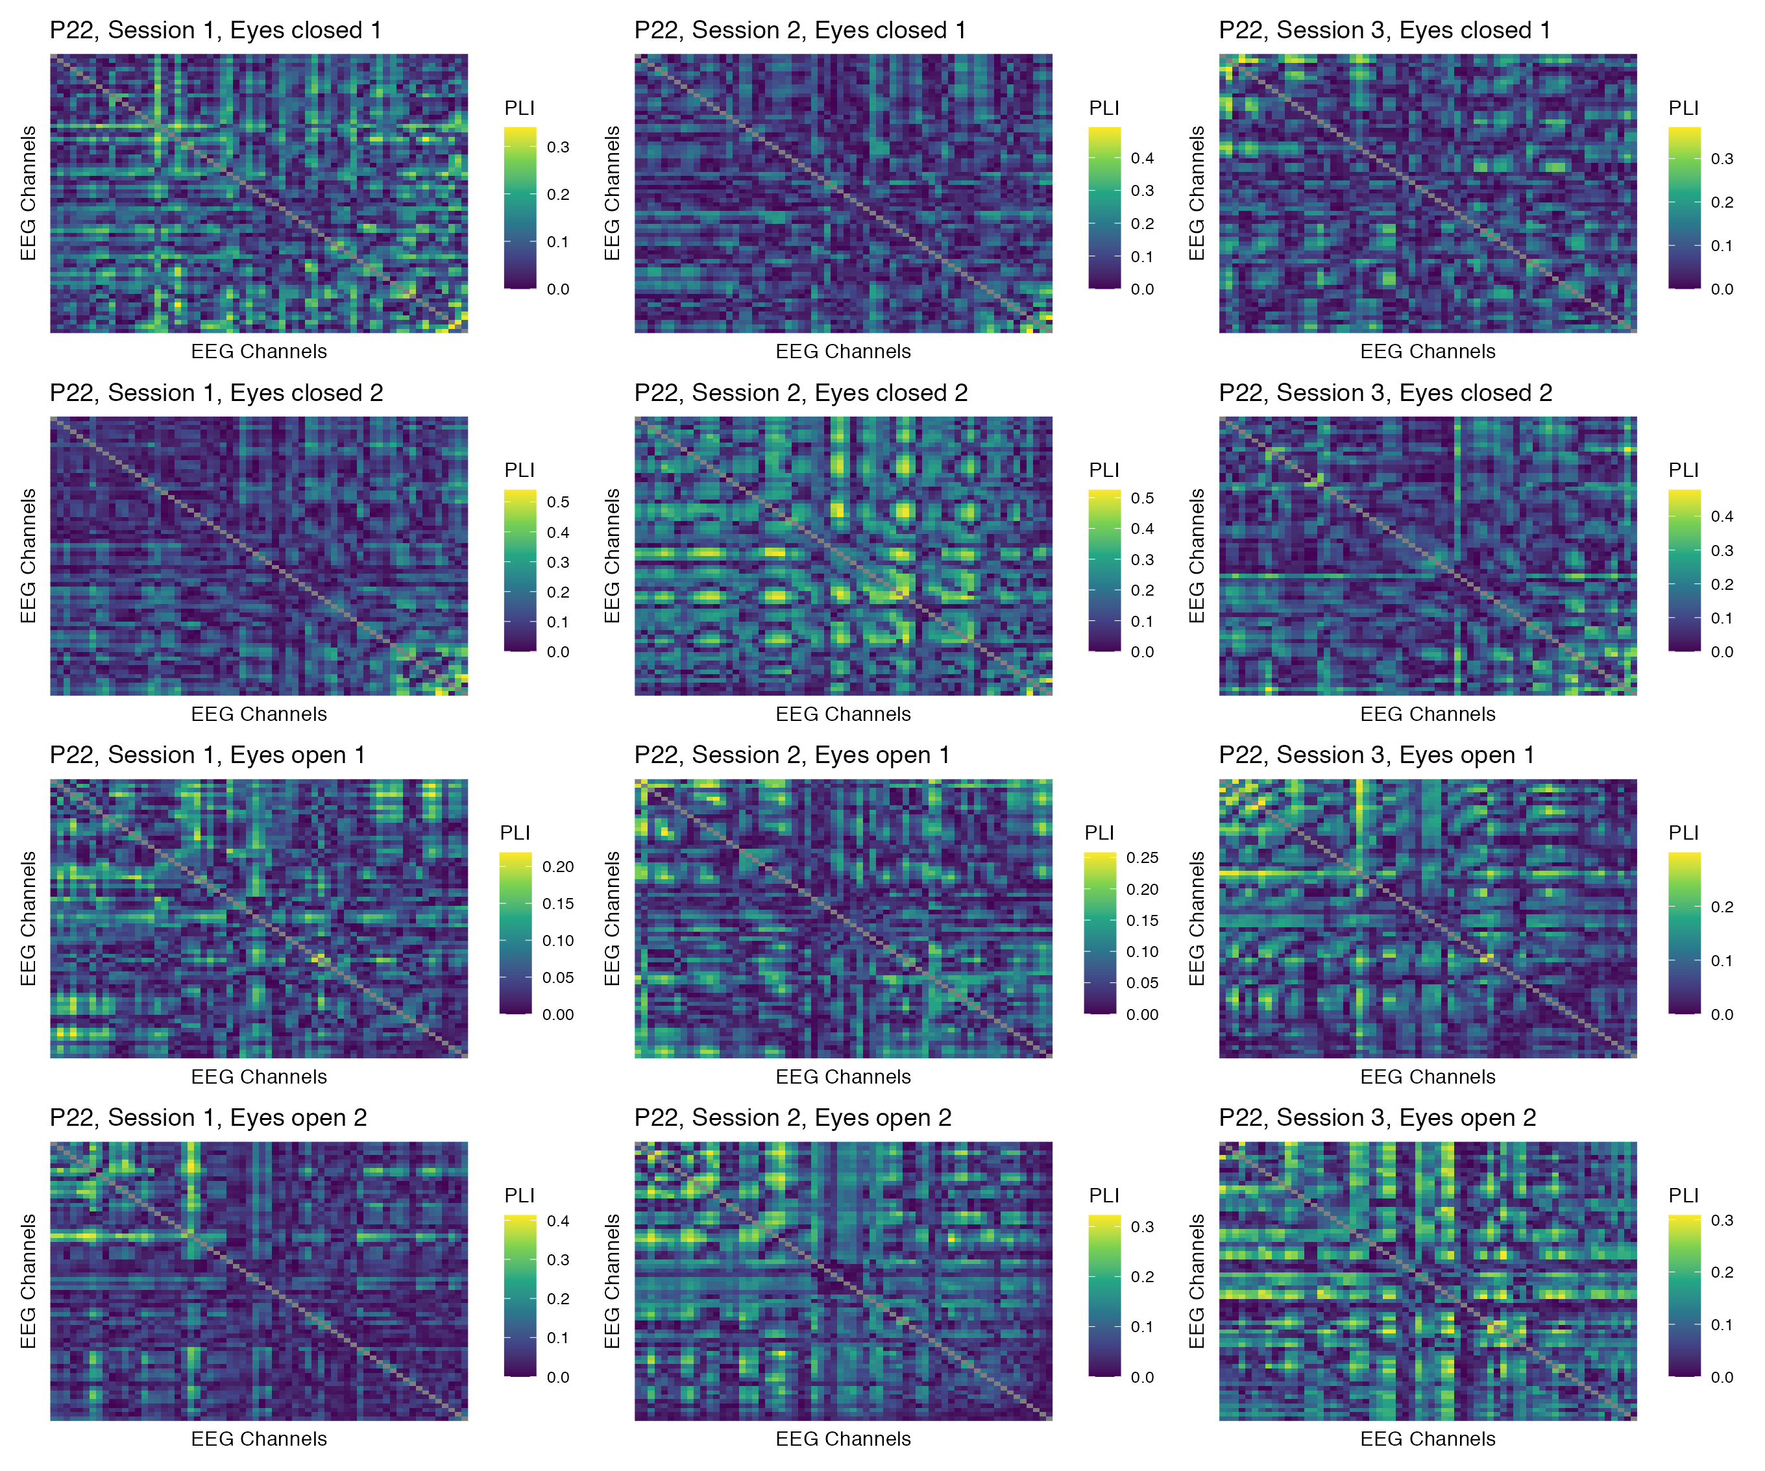

Figure 42: Phase coupling functional connectomes for participant P22 in the alpha band. For each functional connectome, EEG channels are ordered as follows (from left to right, and from top to bottom): Fp1, Fp2, AF7, AF3, AFz, AF4, AF8, F7, F5, F3, F1, Fz, F2, F4, F6, F8, FT9, FT7, FC5, FC3, FC1, FCz, FC2, FC4, FC6, FT8, FT10, T7, C5, C3, C1, Cz, C2, C4, C6, T8, TP9, TP7, CP5, CP3, CP1, CPz, CP2, CP4, CP6, TP8, TP10, P7, P5, P3, P1, Pz, P2, P4, P6, P8, PO7, PO3, POz, PO4, PO8, O1, Oz, O2.

## Beta band

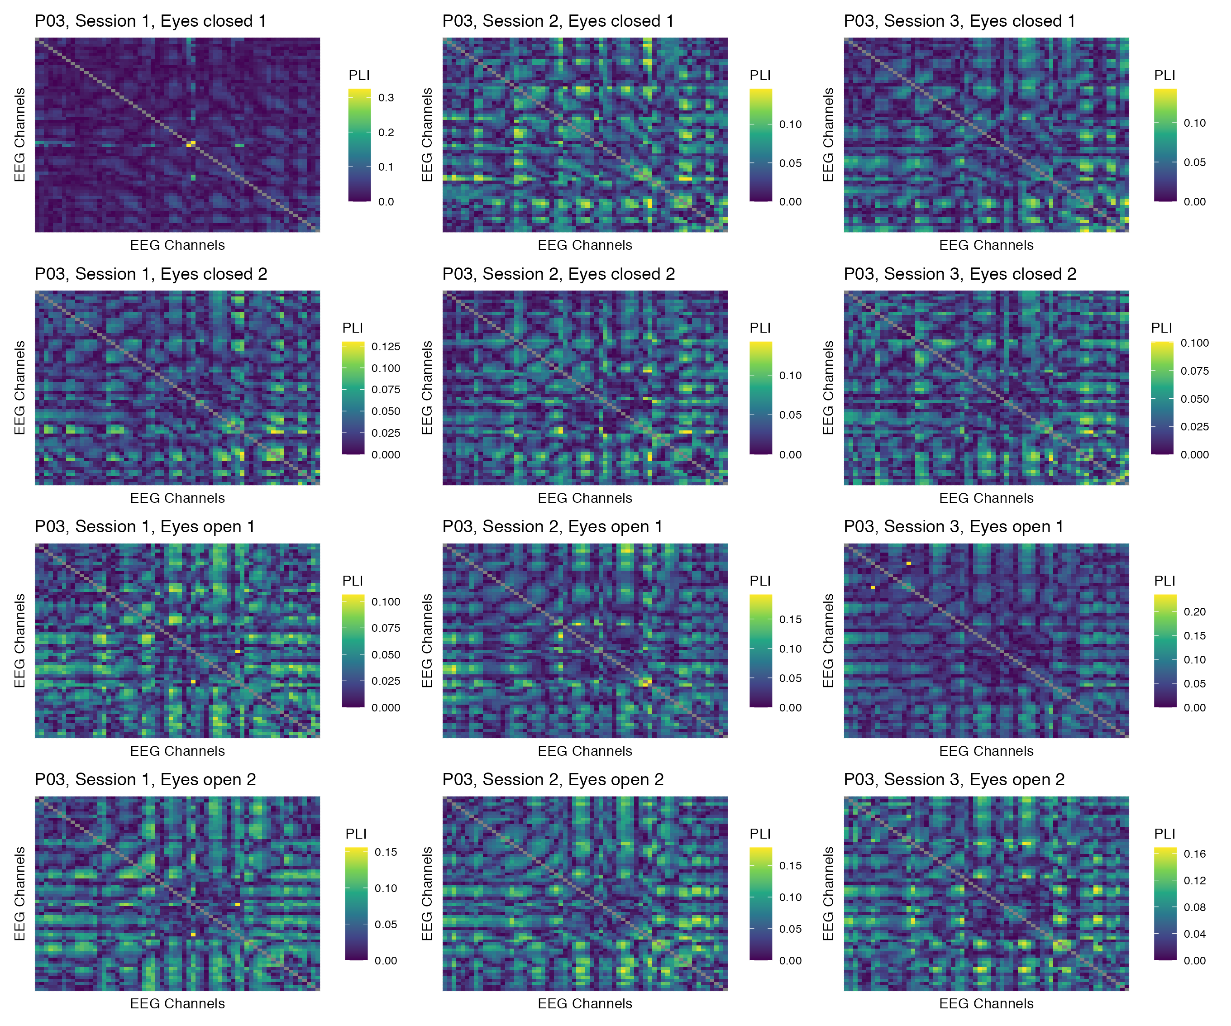

Figure 43: Phase coupling functional connectomes for participant P03 in the beta band. For each functional connectome, EEG channels are ordered as follows (from left to right, and from top to bottom): Fp1, Fp2, AF7, AF3, AFz, AF4, AF8, F7, F5, F3, F1, Fz, F2, F4, F6, F8, FT9, FT7, FC5, FC3, FC1, FCz, FC2, FC4, FC6, FT8, FT10, T7, C5, C3, C1, Cz, C2, C4, C6, T8, TP9, TP7, CP5, CP3, CP1, CPz, CP2, CP4, CP6, TP8, TP10, P7, P5, P3, P1, Pz, P2, P4, P6, P8, PO7, PO3, POz, PO4, PO8, O1, Oz, O2.

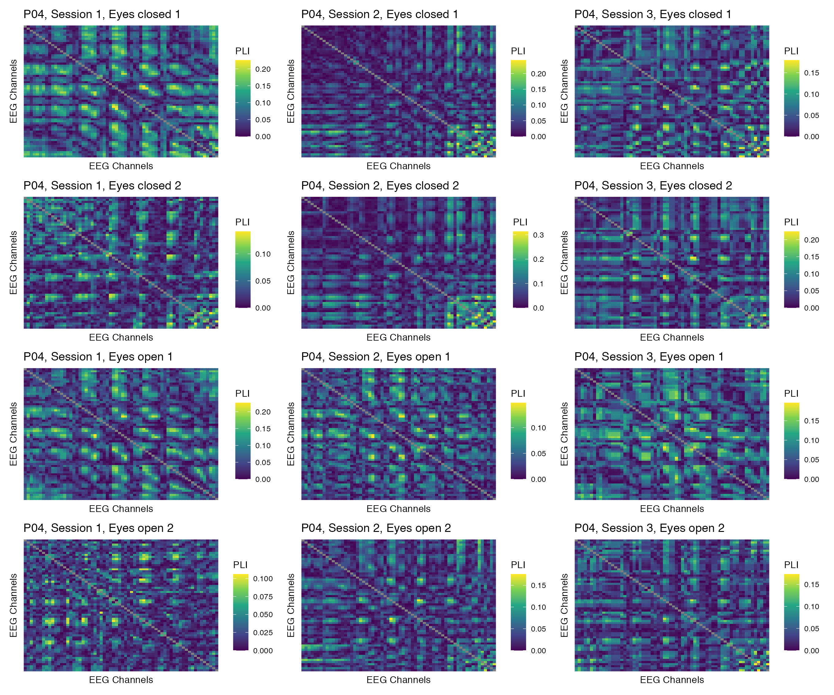

Figure 44: Phase coupling functional connectomes for participant P04 in the beta band. For each functional connectome, EEG channels are ordered as follows (from left to right, and from top to bottom): Fp1, Fp2, AF7, AF3, AFz, AF4, AF8, F7, F5, F3, F1, Fz, F2, F4, F6, F8, FT9, FT7, FC5, FC3, FC1, FCz, FC2, FC4, FC6, FT8, FT10, T7, C5, C3, C1, Cz, C2, C4, C6, T8, TP9, TP7, CP5, CP3, CP1, CPz, CP2, CP4, CP6, TP8, TP10, P7, P5, P3, P1, Pz, P2, P4, P6, P8, PO7, PO3, POz, PO4, PO8, O1, Oz, O2.

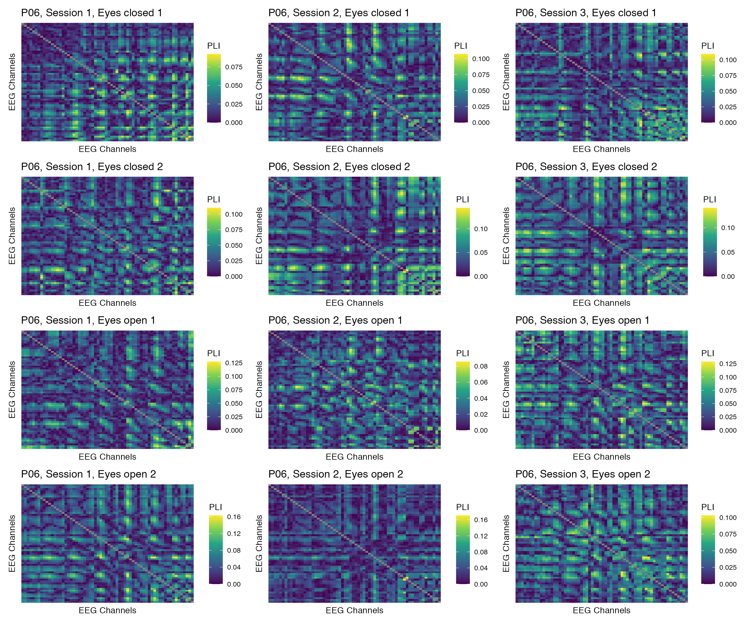

Figure 45: Phase coupling functional connectomes for participant P06 in the beta band. For each functional connectome, EEG channels are ordered as follows (from left to right, and from top to bottom): Fp1, Fp2, AF7, AF3, AFz, AF4, AF8, F7, F5, F3, F1, Fz, F2, F4, F6, F8, FT9, FT7, FC5, FC3, FC1, FCz, FC2, FC4, FC6, FT8, FT10, T7, C5, C3, C1, Cz, C2, C4, C6, T8, TP9, TP7, CP5, CP3, CP1, CPz, CP2, CP4, CP6, TP8, TP10, P7, P5, P3, P1, Pz, P2, P4, P6, P8, PO7, PO3, POz, PO4, PO8, O1, Oz, O2.

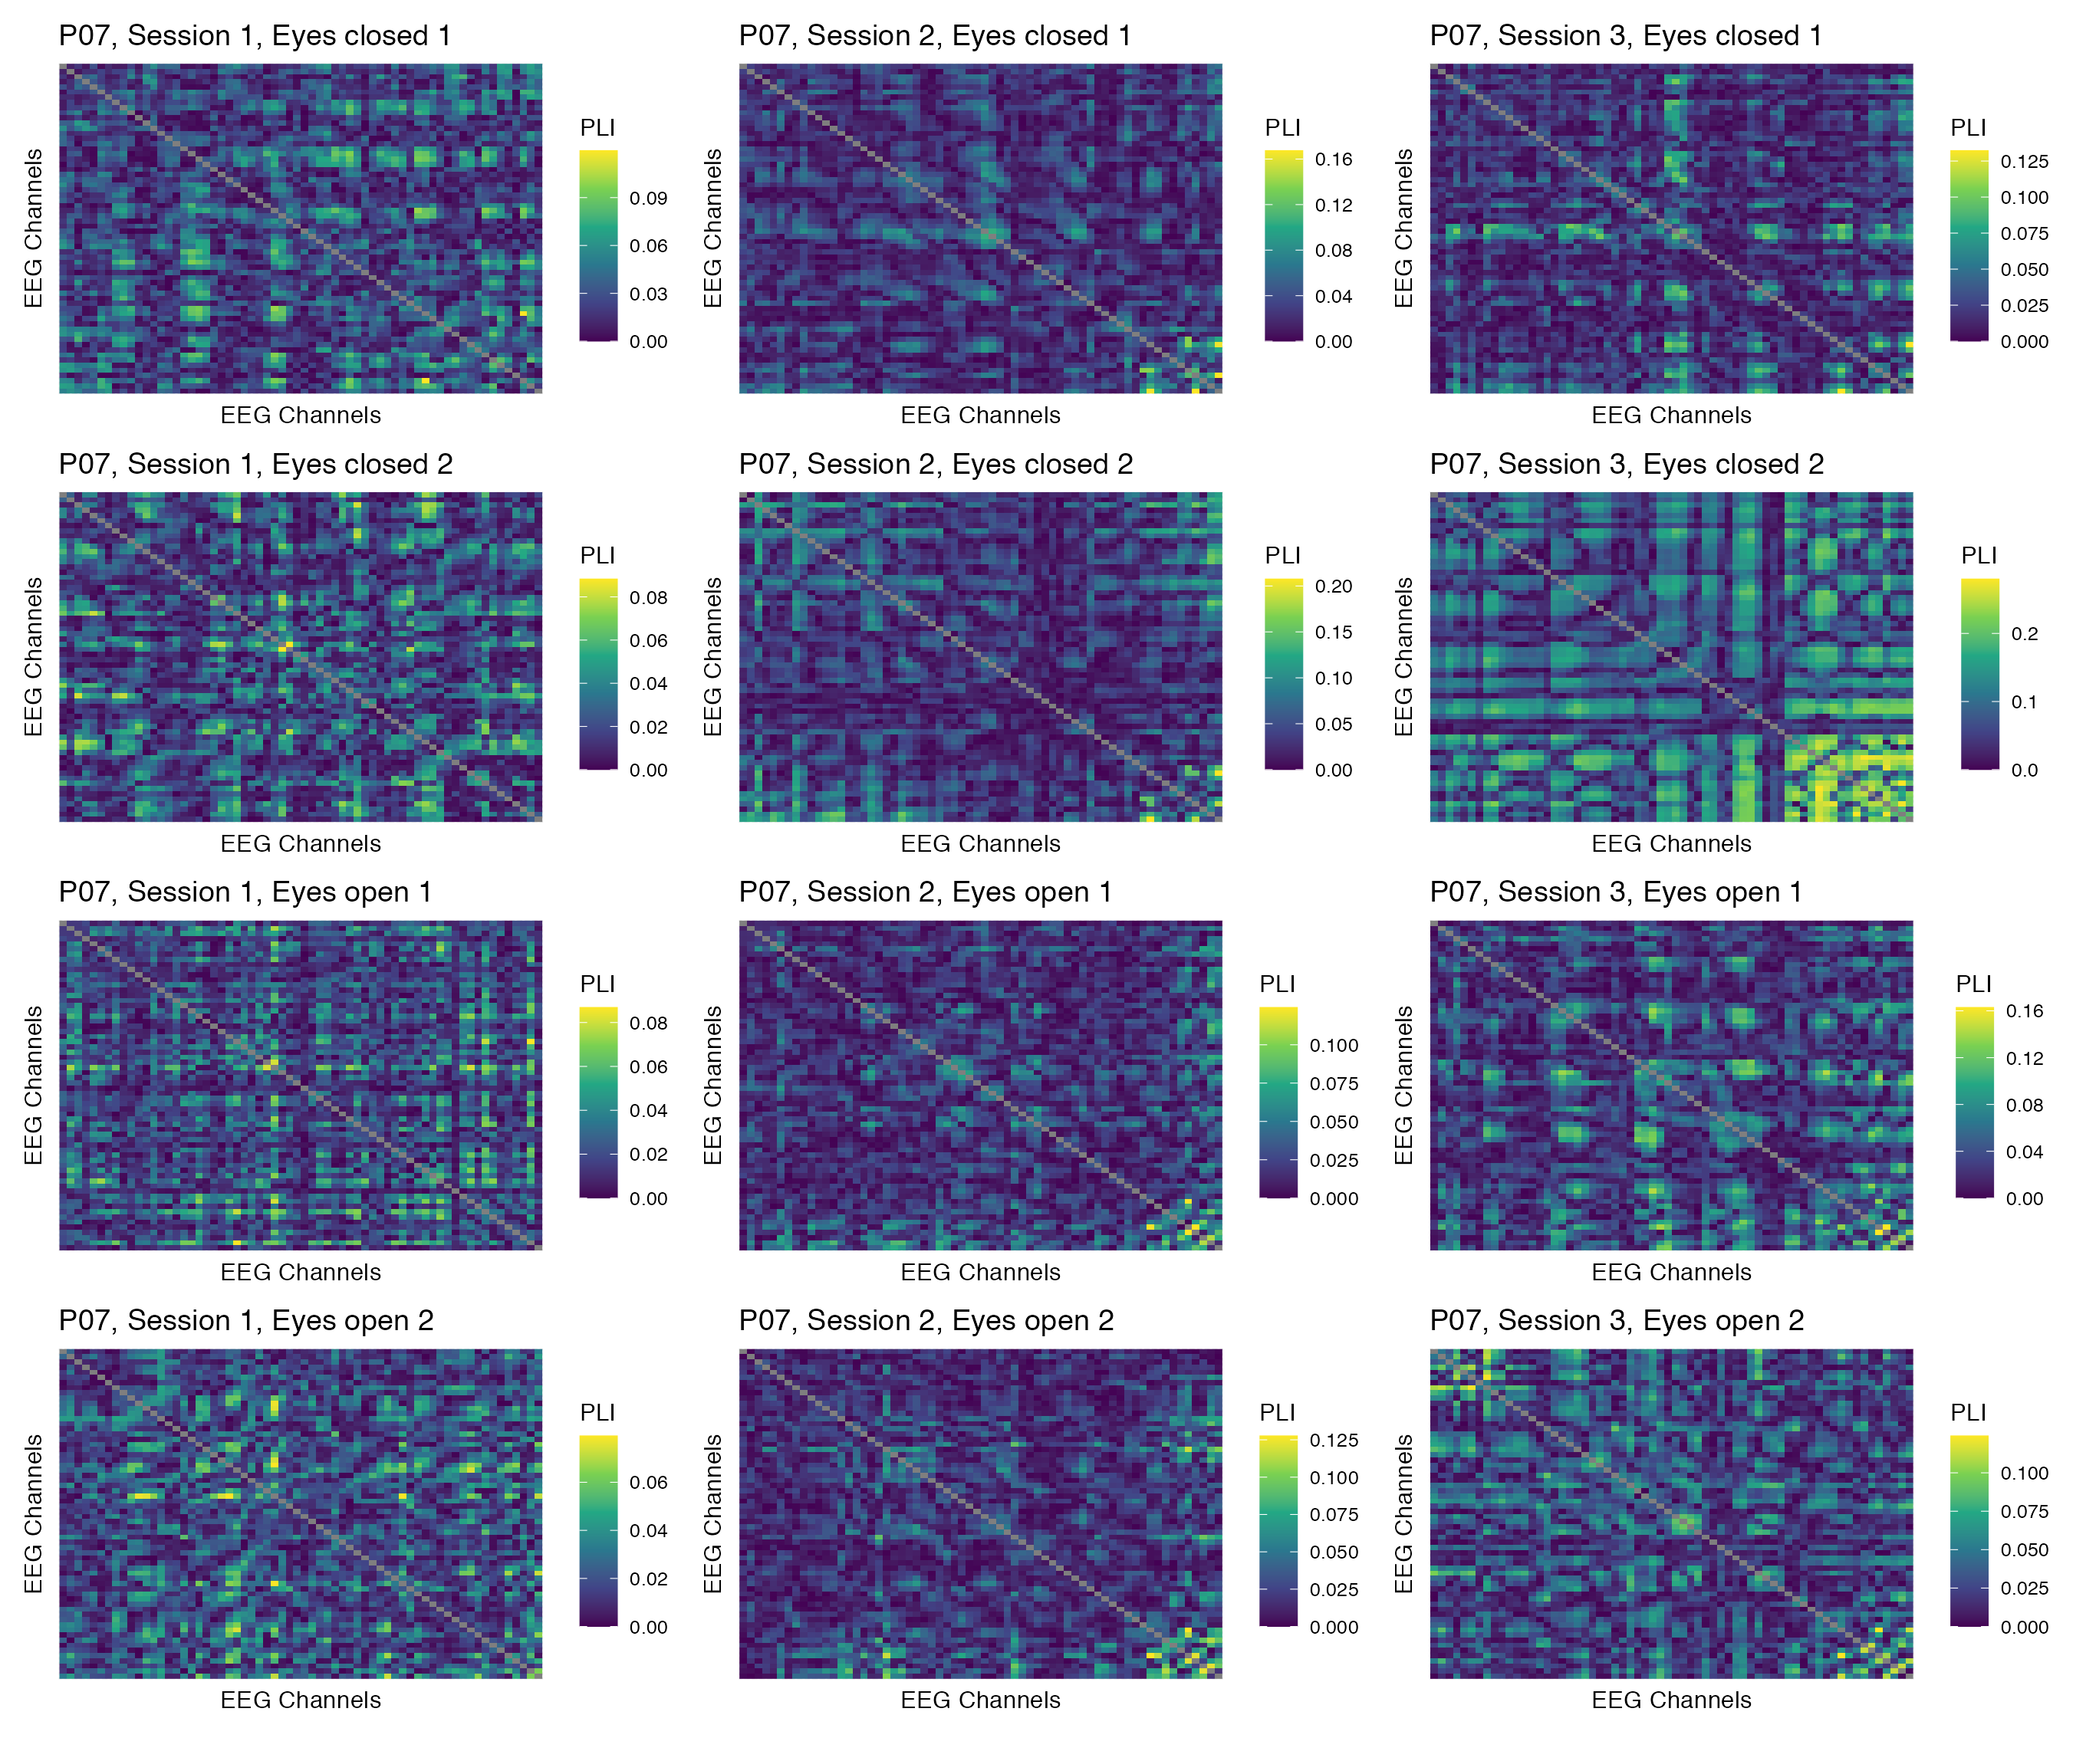

Figure 46: Phase coupling functional connectomes for participant P07 in the beta band. For each functional connectome, EEG channels are ordered as follows (from left to right, and from top to bottom): Fp1, Fp2, AF7, AF3, AFz, AF4, AF8, F7, F5, F3, F1, Fz, F2, F4, F6, F8, FT9, FT7, FC5, FC3, FC1, FCz, FC2, FC4, FC6, FT8, FT10, T7, C5, C3, C1, Cz, C2, C4, C6, T8, TP9, TP7, CP5, CP3, CP1, CPz, CP2, CP4, CP6, TP8, TP10, P7, P5, P3, P1, Pz, P2, P4, P6, P8, PO7, PO3, POz, PO4, PO8, O1, Oz, O2.

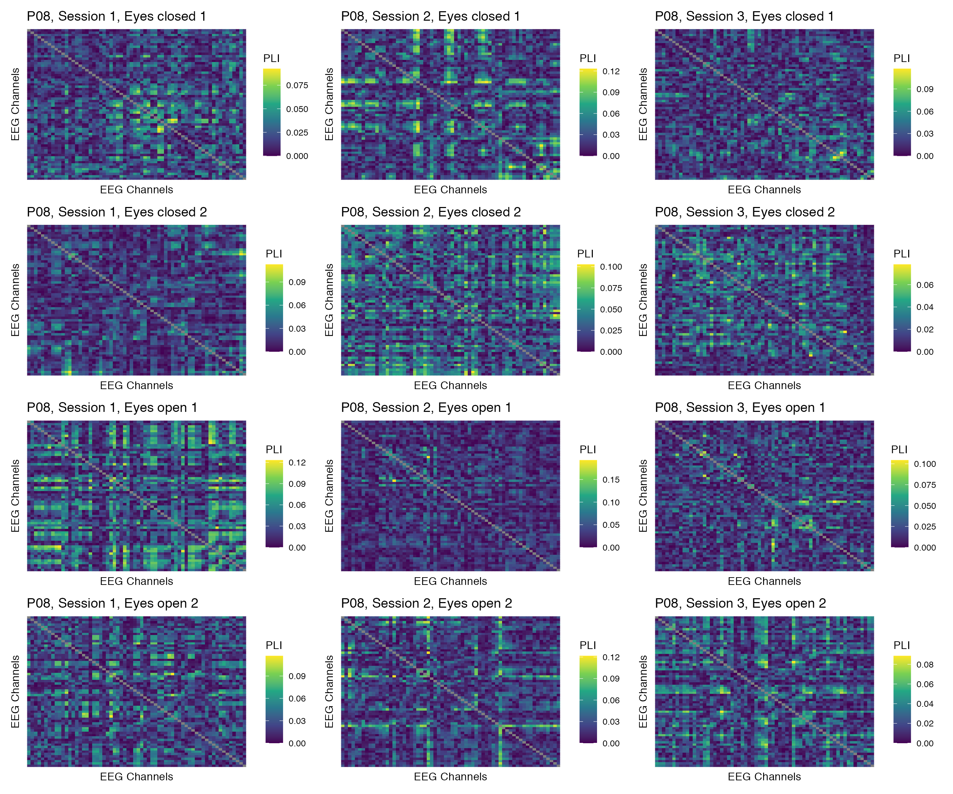

Figure 47: Phase coupling functional connectomes for participant P08 in the beta band. For each functional connectome, EEG channels are ordered as follows (from left to right, and from top to bottom): Fp1, Fp2, AF7, AF3, AFz, AF4, AF8, F7, F5, F3, F1, Fz, F2, F4, F6, F8, FT9, FT7, FC5, FC3, FC1, FCz, FC2, FC4, FC6, FT8, FT10, T7, C5, C3, C1, Cz, C2, C4, C6, T8, TP9, TP7, CP5, CP3, CP1, CPz, CP2, CP4, CP6, TP8, TP10, P7, P5, P3, P1, Pz, P2, P4, P6, P8, PO7, PO3, POz, PO4, PO8, O1, Oz, O2.

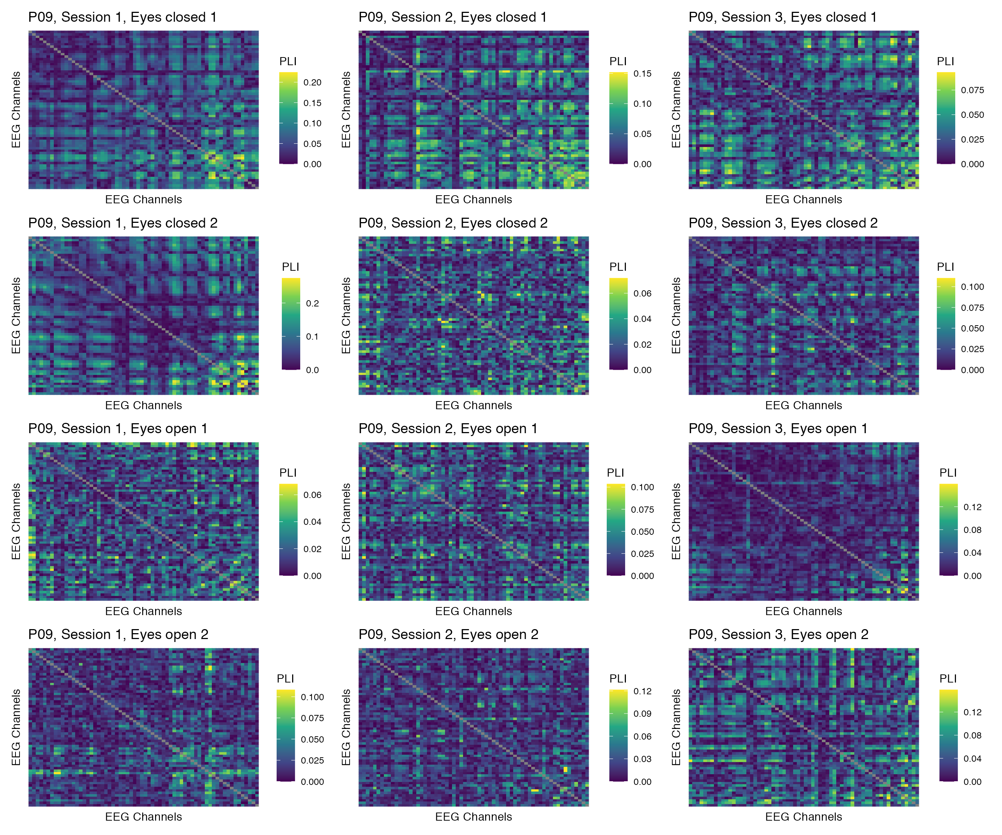

Figure 48: Phase coupling functional connectomes for participant P09 in the beta band. For each functional connectome, EEG channels are ordered as follows (from left to right, and from top to bottom): Fp1, Fp2, AF7, AF3, AFz, AF4, AF8, F7, F5, F3, F1, Fz, F2, F4, F6, F8, FT9, FT7, FC5, FC3, FC1, FCz, FC2, FC4, FC6, FT8, FT10, T7, C5, C3, C1, Cz, C2, C4, C6, T8, TP9, TP7, CP5, CP3, CP1, CPz, CP2, CP4, CP6, TP8, TP10, P7, P5, P3, P1, Pz, P2, P4, P6, P8, PO7, PO3, POz, PO4, PO8, O1, Oz, O2.

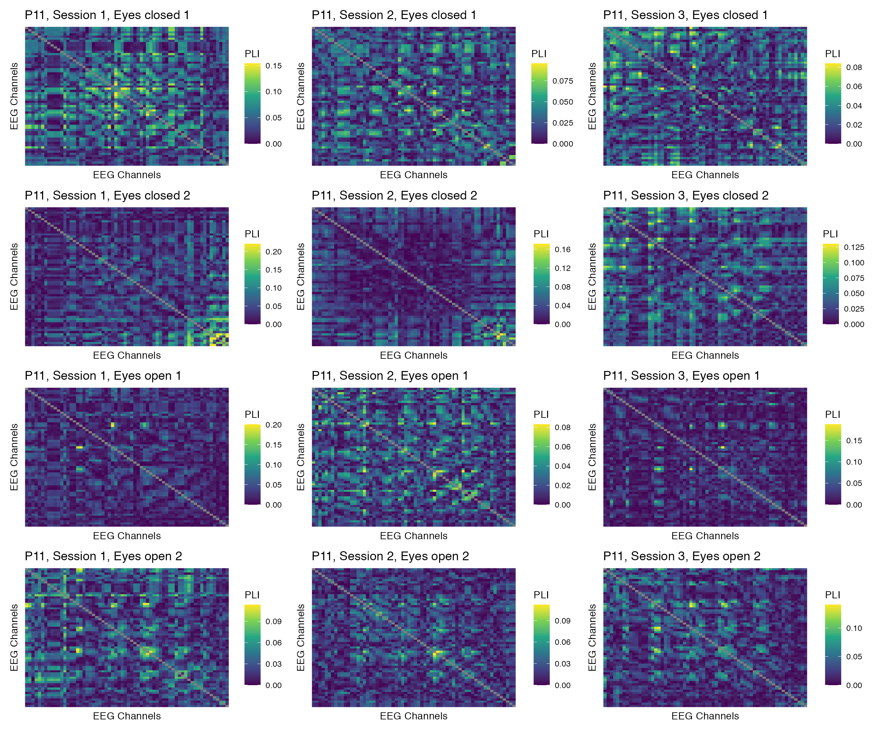

Figure 49: Phase coupling functional connectomes for participant P11 in the beta band. For each functional connectome, EEG channels are ordered as follows (from left to right, and from top to bottom): Fp1, Fp2, AF7, AF3, AFz, AF4, AF8, F7, F5, F3, F1, Fz, F2, F4, F6, F8, FT9, FT7, FC5, FC3, FC1, FCz, FC2, FC4, FC6, FT8, FT10, T7, C5, C3, C1, Cz, C2, C4, C6, T8, TP9, TP7, CP5, CP3, CP1, CPz, CP2, CP4, CP6, TP8, TP10, P7, P5, P3, P1, Pz, P2, P4, P6, P8, PO7, PO3, POz, PO4, PO8, O1, Oz, O2.

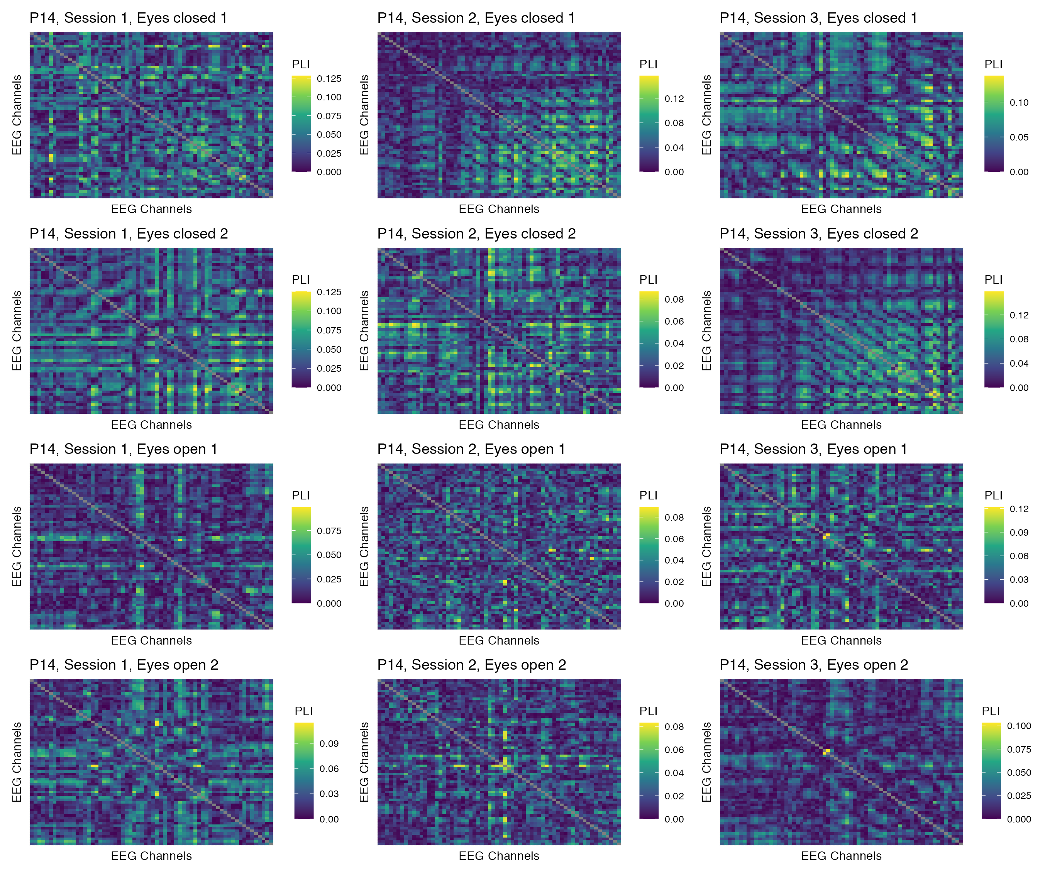

Figure 50: Phase coupling functional connectomes for participant P14 in the beta band. For each functional connectome, EEG channels are ordered as follows (from left to right, and from top to bottom): Fp1, Fp2, AF7, AF3, AFz, AF4, AF8, F7, F5, F3, F1, Fz, F2, F4, F6, F8, FT9, FT7, FC5, FC3, FC1, FCz, FC2, FC4, FC6, FT8, FT10, T7, C5, C3, C1, Cz, C2, C4, C6, T8, TP9, TP7, CP5, CP3, CP1, CPz, CP2, CP4, CP6, TP8, TP10, P7, P5, P3, P1, Pz, P2, P4, P6, P8, PO7, PO3, POz, PO4, PO8, O1, Oz, O2.

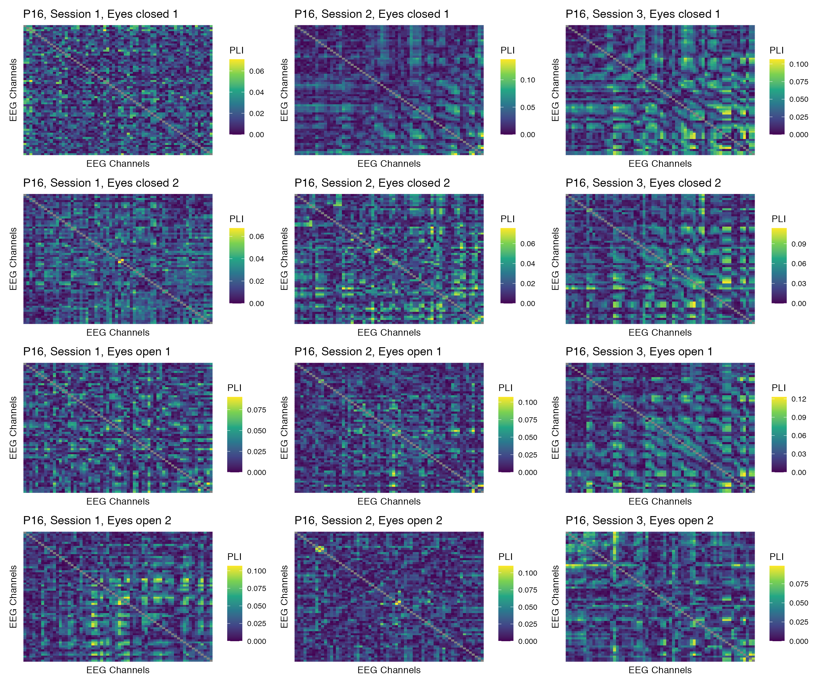

Figure 51: Phase coupling functional connectomes for participant P16 in the beta band. For each functional connectome, EEG channels are ordered as follows (from left to right, and from top to bottom): Fp1, Fp2, AF7, AF3, AFz, AF4, AF8, F7, F5, F3, F1, Fz, F2, F4, F6, F8, FT9, FT7, FC5, FC3, FC1, FCz, FC2, FC4, FC6, FT8, FT10, T7, C5, C3, C1, Cz, C2, C4, C6, T8, TP9, TP7, CP5, CP3, CP1, CPz, CP2, CP4, CP6, TP8, TP10, P7, P5, P3, P1, Pz, P2, P4, P6, P8, PO7, PO3, POz, PO4, PO8, O1, Oz, O2.

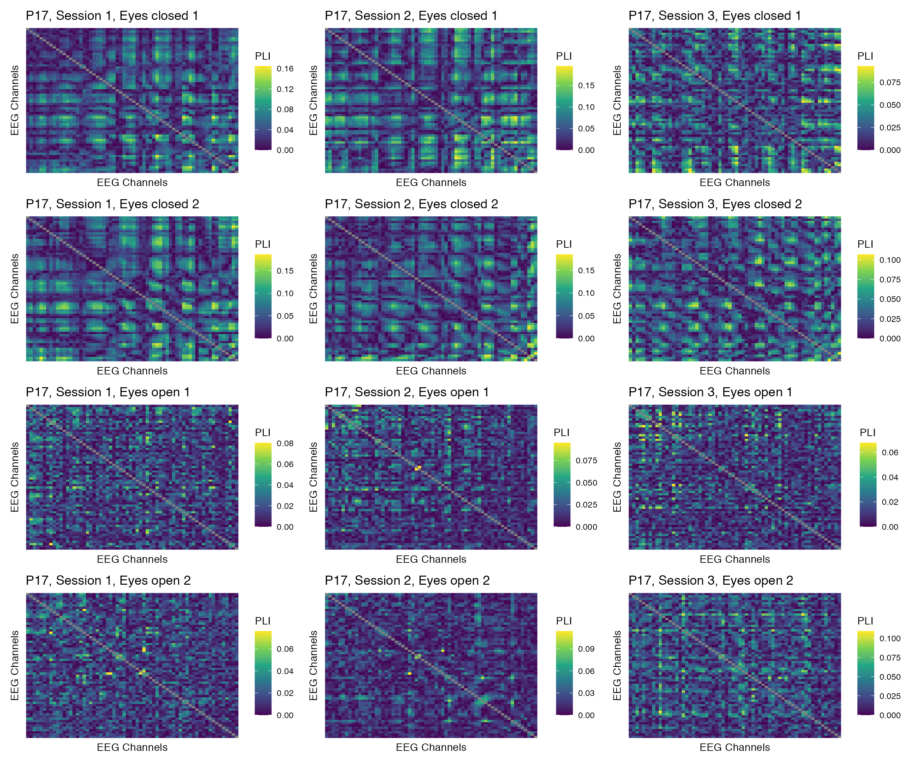

Figure 52: Phase coupling functional connectomes for participant P17 in the beta band. For each functional connectome, EEG channels are ordered as follows (from left to right, and from top to bottom): Fp1, Fp2, AF7, AF3, AFz, AF4, AF8, F7, F5, F3, F1, Fz, F2, F4, F6, F8, FT9, FT7, FC5, FC3, FC1, FCz, FC2, FC4, FC6, FT8, FT10, T7, C5, C3, C1, Cz, C2, C4, C6, T8, TP9, TP7, CP5, CP3, CP1, CPz, CP2, CP4, CP6, TP8, TP10, P7, P5, P3, P1, Pz, P2, P4, P6, P8, PO7, PO3, POz, PO4, PO8, O1, Oz, O2.

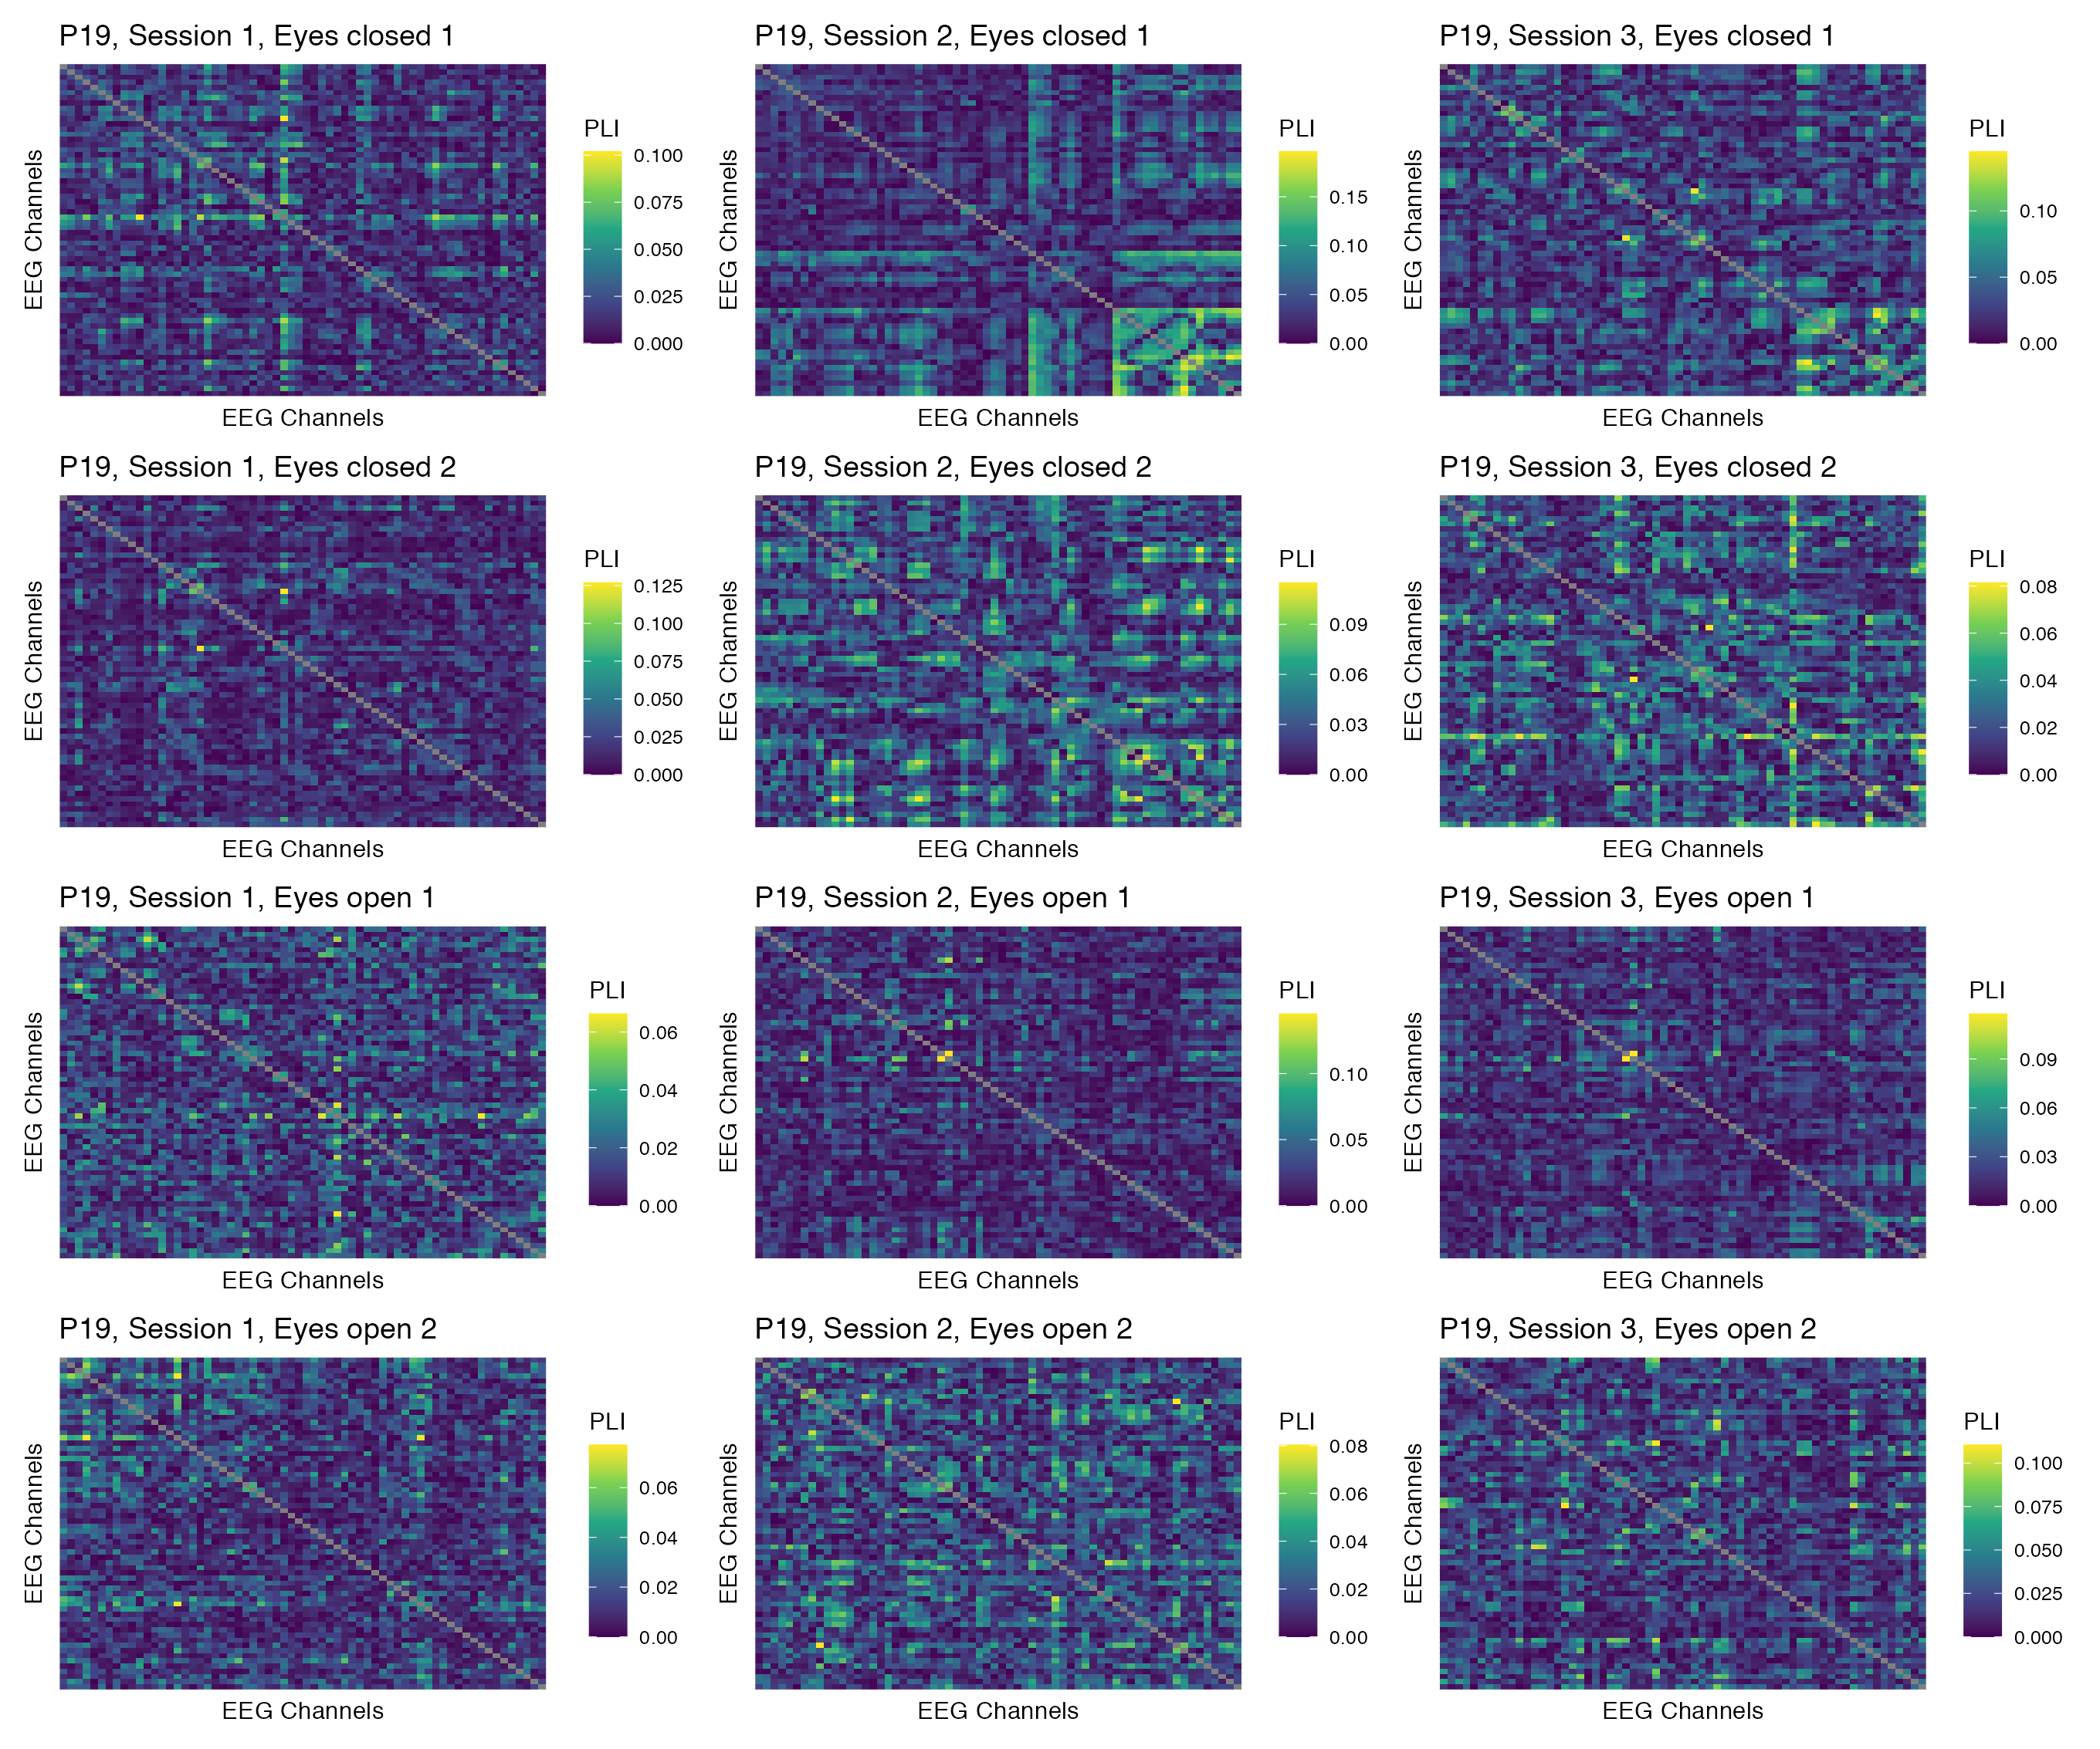

Figure 53: Phase coupling functional connectomes for participant P19 in the beta band. For each functional connectome, EEG channels are ordered as follows (from left to right, and from top to bottom): Fp1, Fp2, AF7, AF3, AFz, AF4, AF8, F7, F5, F3, F1, Fz, F2, F4, F6, F8, FT9, FT7, FC5, FC3, FC1, FCz, FC2, FC4, FC6, FT8, FT10, T7, C5, C3, C1, Cz, C2, C4, C6, T8, TP9, TP7, CP5, CP3, CP1, CPz, CP2, CP4, CP6, TP8, TP10, P7, P5, P3, P1, Pz, P2, P4, P6, P8, PO7, PO3, POz, PO4, PO8, O1, Oz, O2.

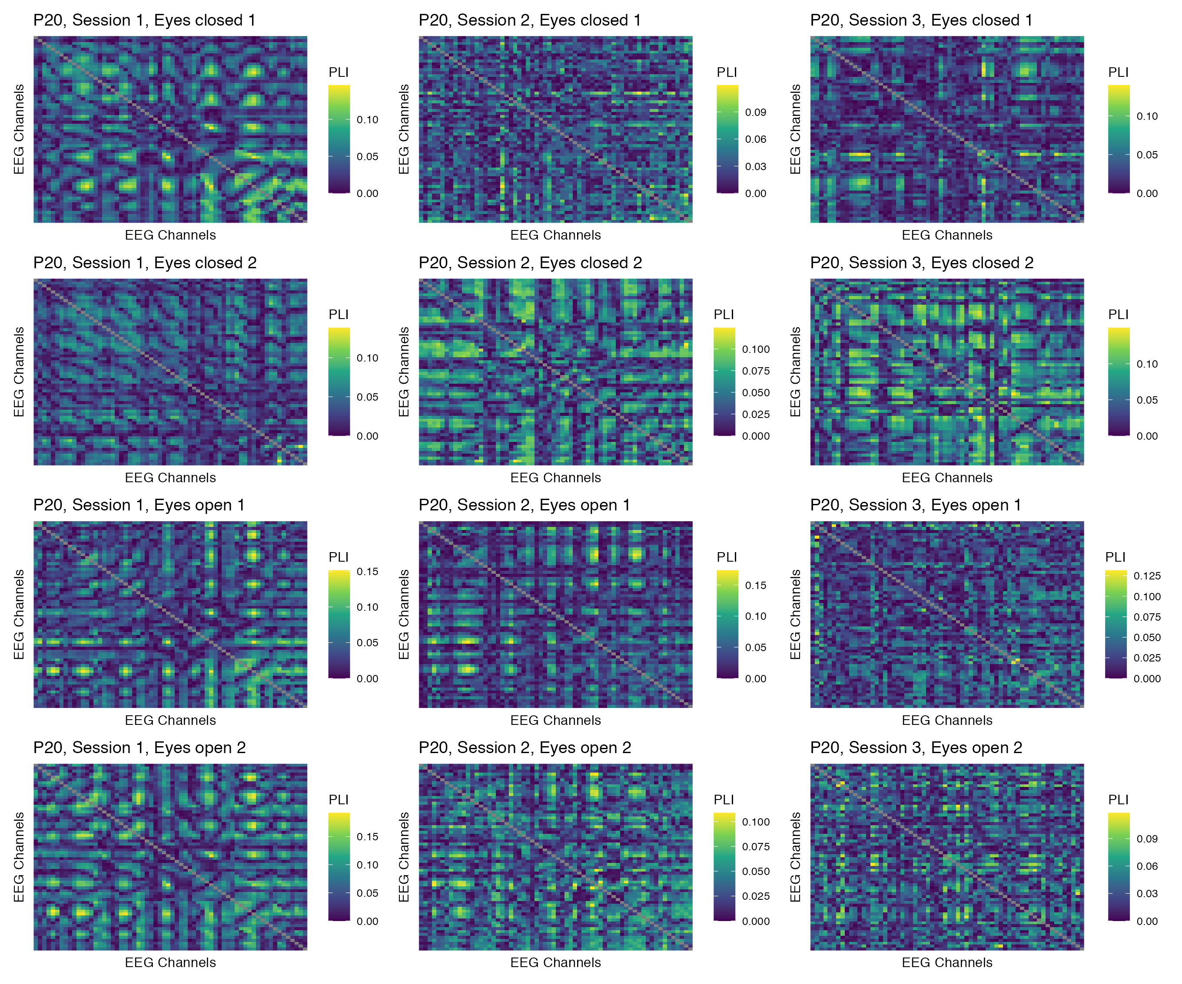

Figure 54: Phase coupling functional connectomes for participant P20 in the beta band. For each functional connectome, EEG channels are ordered as follows (from left to right, and from top to bottom): Fp1, Fp2, AF7, AF3, AFz, AF4, AF8, F7, F5, F3, F1, Fz, F2, F4, F6, F8, FT9, FT7, FC5, FC3, FC1, FCz, FC2, FC4, FC6, FT8, FT10, T7, C5, C3, C1, Cz, C2, C4, C6, T8, TP9, TP7, CP5, CP3, CP1, CPz, CP2, CP4, CP6, TP8, TP10, P7, P5, P3, P1, Pz, P2, P4, P6, P8, PO7, PO3, POz, PO4, PO8, O1, Oz, O2.

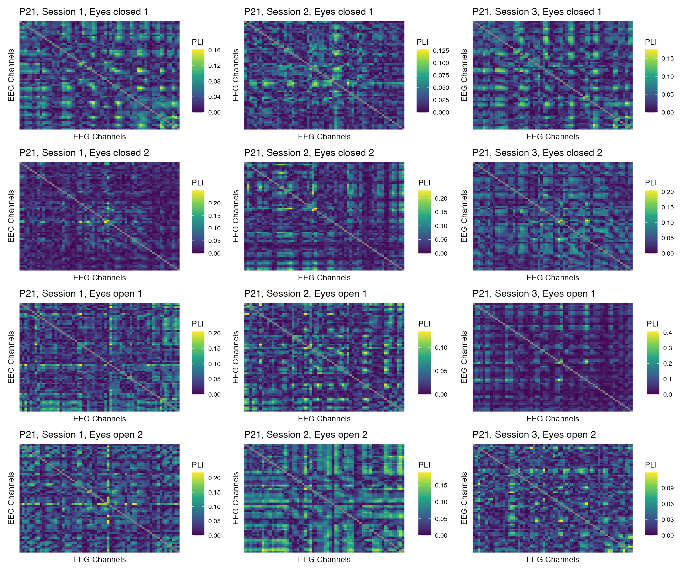

Figure 55: Phase coupling functional connectomes for participant P21 in the beta band. For each functional connectome, EEG channels are ordered as follows (from left to right, and from top to bottom): Fp1, Fp2, AF7, AF3, AFz, AF4, AF8, F7, F5, F3, F1, Fz, F2, F4, F6, F8, FT9, FT7, FC5, FC3, FC1, FCz, FC2, FC4, FC6, FT8, FT10, T7, C5, C3, C1, Cz, C2, C4, C6, T8, TP9, TP7, CP5, CP3, CP1, CPz, CP2, CP4, CP6, TP8, TP10, P7, P5, P3, P1, Pz, P2, P4, P6, P8, PO7, PO3, POz, PO4, PO8, O1, Oz, O2.

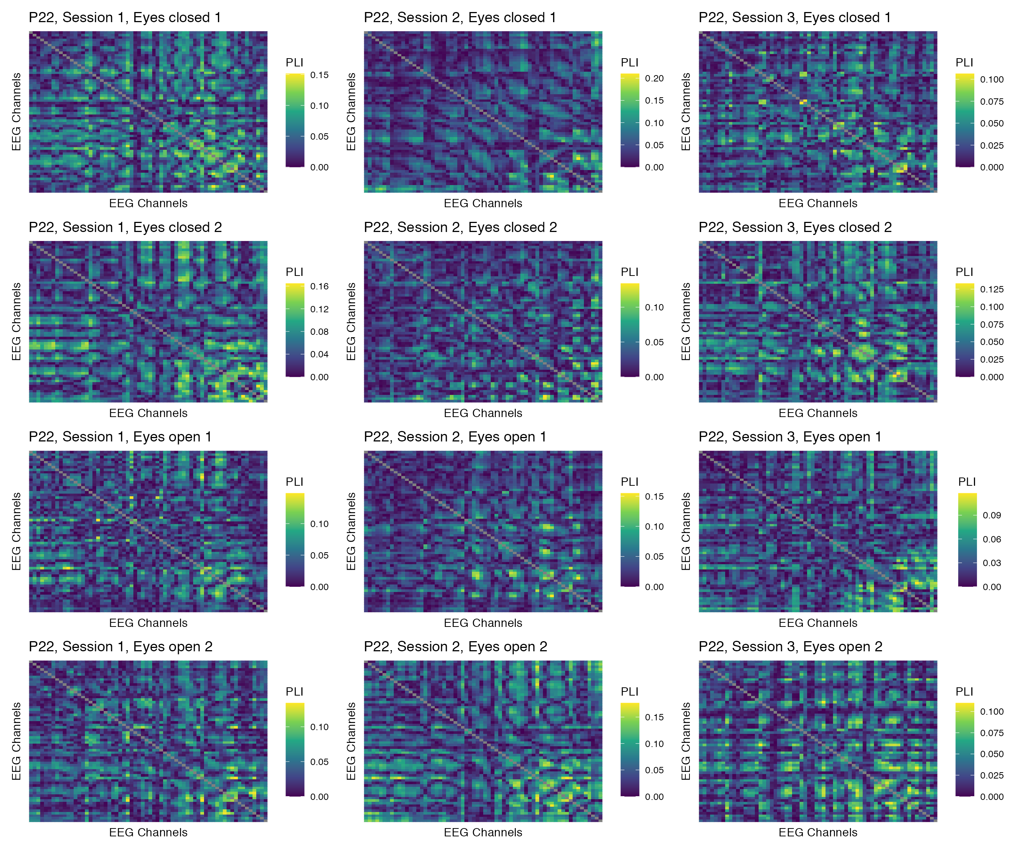

Figure 56: Phase coupling functional connectomes for participant P22 in the beta band. For each functional connectome, EEG channels are ordered as follows (from left to right, and from top to bottom): Fp1, Fp2, AF7, AF3, AFz, AF4, AF8, F7, F5, F3, F1, Fz, F2, F4, F6, F8, FT9, FT7, FC5, FC3, FC1, FCz, FC2, FC4, FC6, FT8, FT10, T7, C5, C3, C1, Cz, C2, C4, C6, T8, TP9, TP7, CP5, CP3, CP1, CPz, CP2, CP4, CP6, TP8, TP10, P7, P5, P3, P1, Pz, P2, P4, P6, P8, PO7, PO3, POz, PO4, PO8, O1, Oz, O2.

## Gamma band

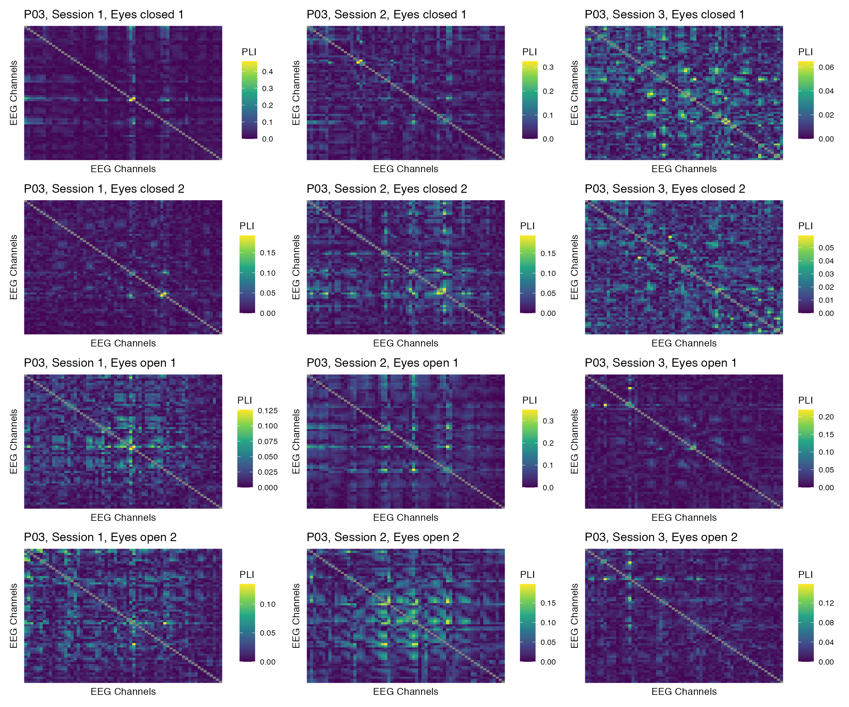

Figure 57: Phase coupling functional connectomes for participant P03 in the gamma band. For each functional connectome, EEG channels are ordered as follows (from left to right, and from top to bottom): Fp1, Fp2, AF7, AF3, AFz, AF4, AF8, F7, F5, F3, F1, Fz, F2, F4, F6, F8, FT9, FT7, FC5, FC3, FC1, FCz, FC2, FC4, FC6, FT8, FT10, T7, C5, C3, C1, Cz, C2, C4, C6, T8, TP9, TP7, CP5, CP3, CP1, CPz, CP2, CP4, CP6, TP8, TP10, P7, P5, P3, P1, Pz, P2, P4, P6, P8, PO7, PO3, POz, PO4, PO8, O1, Oz, O2.

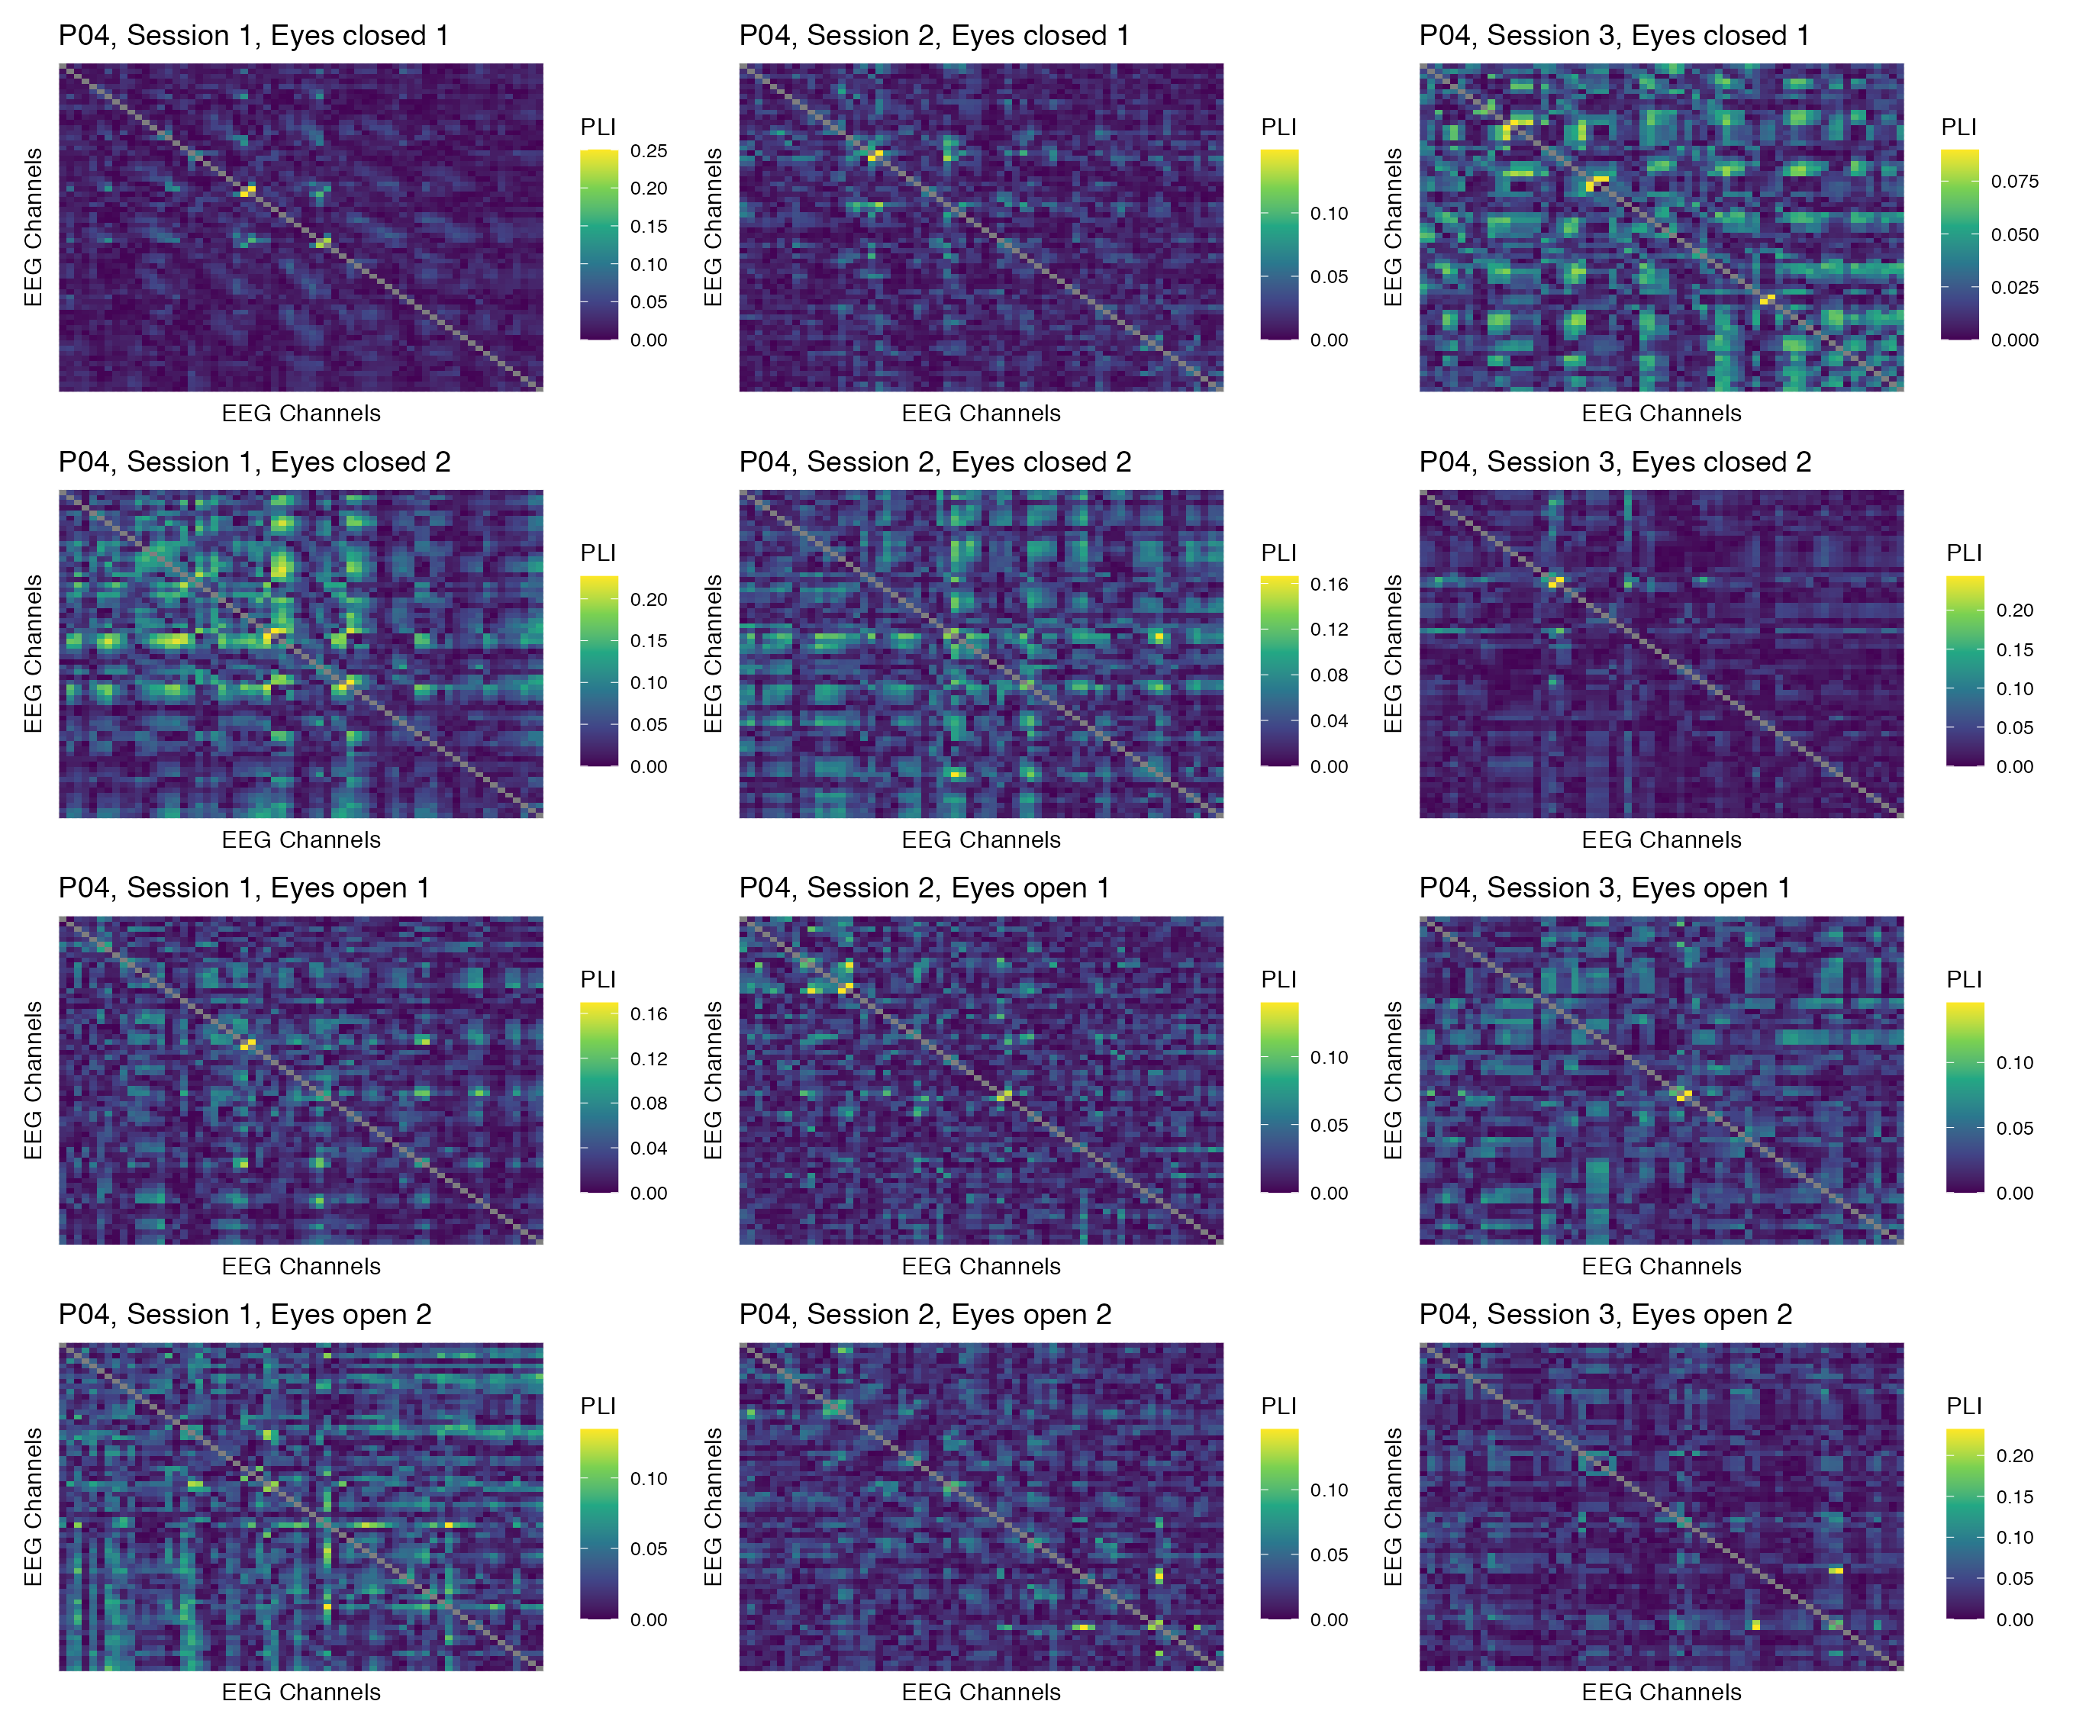

Figure 58: Phase coupling functional connectomes for participant P04 in the gamma band. For each functional connectome, EEG channels are ordered as follows (from left to right, and from top to bottom): Fp1, Fp2, AF7, AF3, AFz, AF4, AF8, F7, F5, F3, F1, Fz, F2, F4, F6, F8, FT9, FT7, FC5, FC3, FC1, FCz, FC2, FC4, FC6, FT8, FT10, T7, C5, C3, C1, Cz, C2, C4, C6, T8, TP9, TP7, CP5, CP3, CP1, CPz, CP2, CP4, CP6, TP8, TP10, P7, P5, P3, P1, Pz, P2, P4, P6, P8, PO7, PO3, POz, PO4, PO8, O1, Oz, O2.

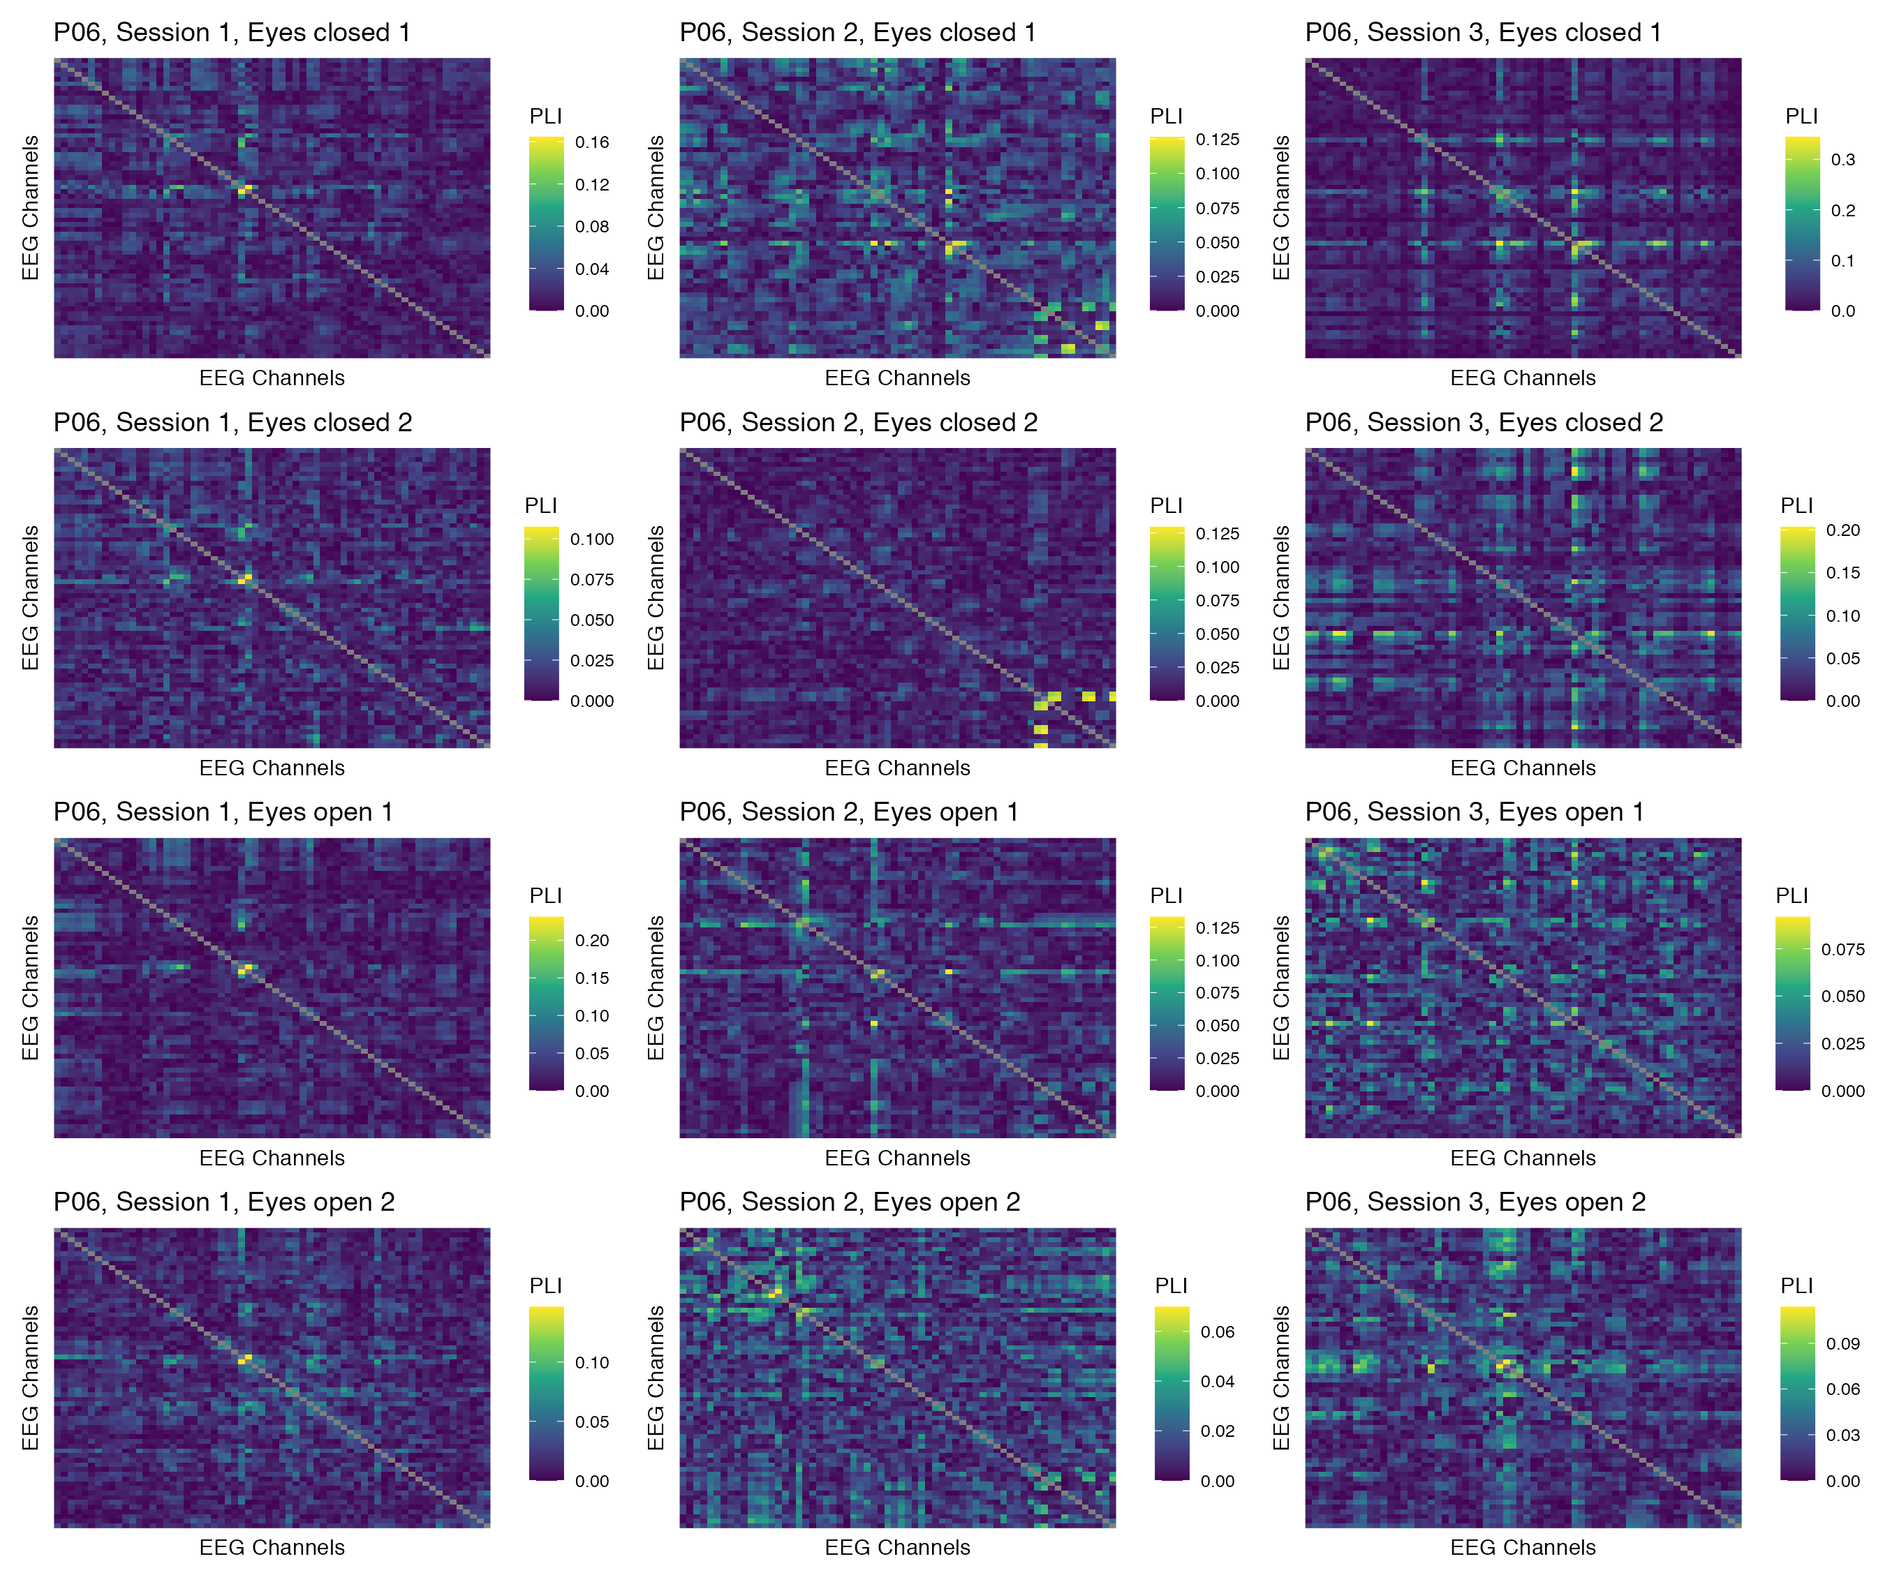

Figure 59: Phase coupling functional connectomes for participant P06 in the gamma band. For each functional connectome, EEG channels are ordered as follows (from left to right, and from top to bottom): Fp1, Fp2, AF7, AF3, AFz, AF4, AF8, F7, F5, F3, F1, Fz, F2, F4, F6, F8, FT9, FT7, FC5, FC3, FC1, FCz, FC2, FC4, FC6, FT8, FT10, T7, C5, C3, C1, Cz, C2, C4, C6, T8, TP9, TP7, CP5, CP3, CP1, CPz, CP2, CP4, CP6, TP8, TP10, P7, P5, P3, P1, Pz, P2, P4, P6, P8, PO7, PO3, POz, PO4, PO8, O1, Oz, O2.

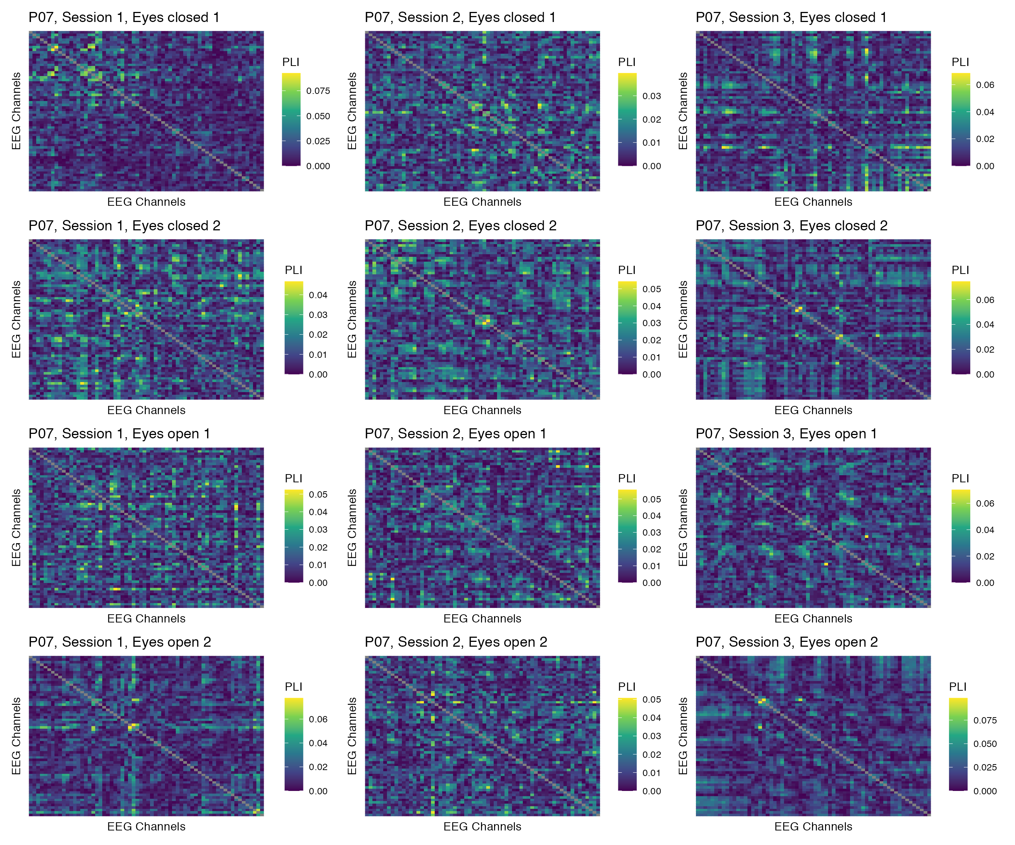

Figure 60: Phase coupling functional connectomes for participant P07 in the gamma band. For each functional connectome, EEG channels are ordered as follows (from left to right, and from top to bottom): Fp1, Fp2, AF7, AF3, AFz, AF4, AF8, F7, F5, F3, F1, Fz, F2, F4, F6, F8, FT9, FT7, FC5, FC3, FC1, FCz, FC2, FC4, FC6, FT8, FT10, T7, C5, C3, C1, Cz, C2, C4, C6, T8, TP9, TP7, CP5, CP3, CP1, CPz, CP2, CP4, CP6, TP8, TP10, P7, P5, P3, P1, Pz, P2, P4, P6, P8, PO7, PO3, POz, PO4, PO8, O1, Oz, O2.

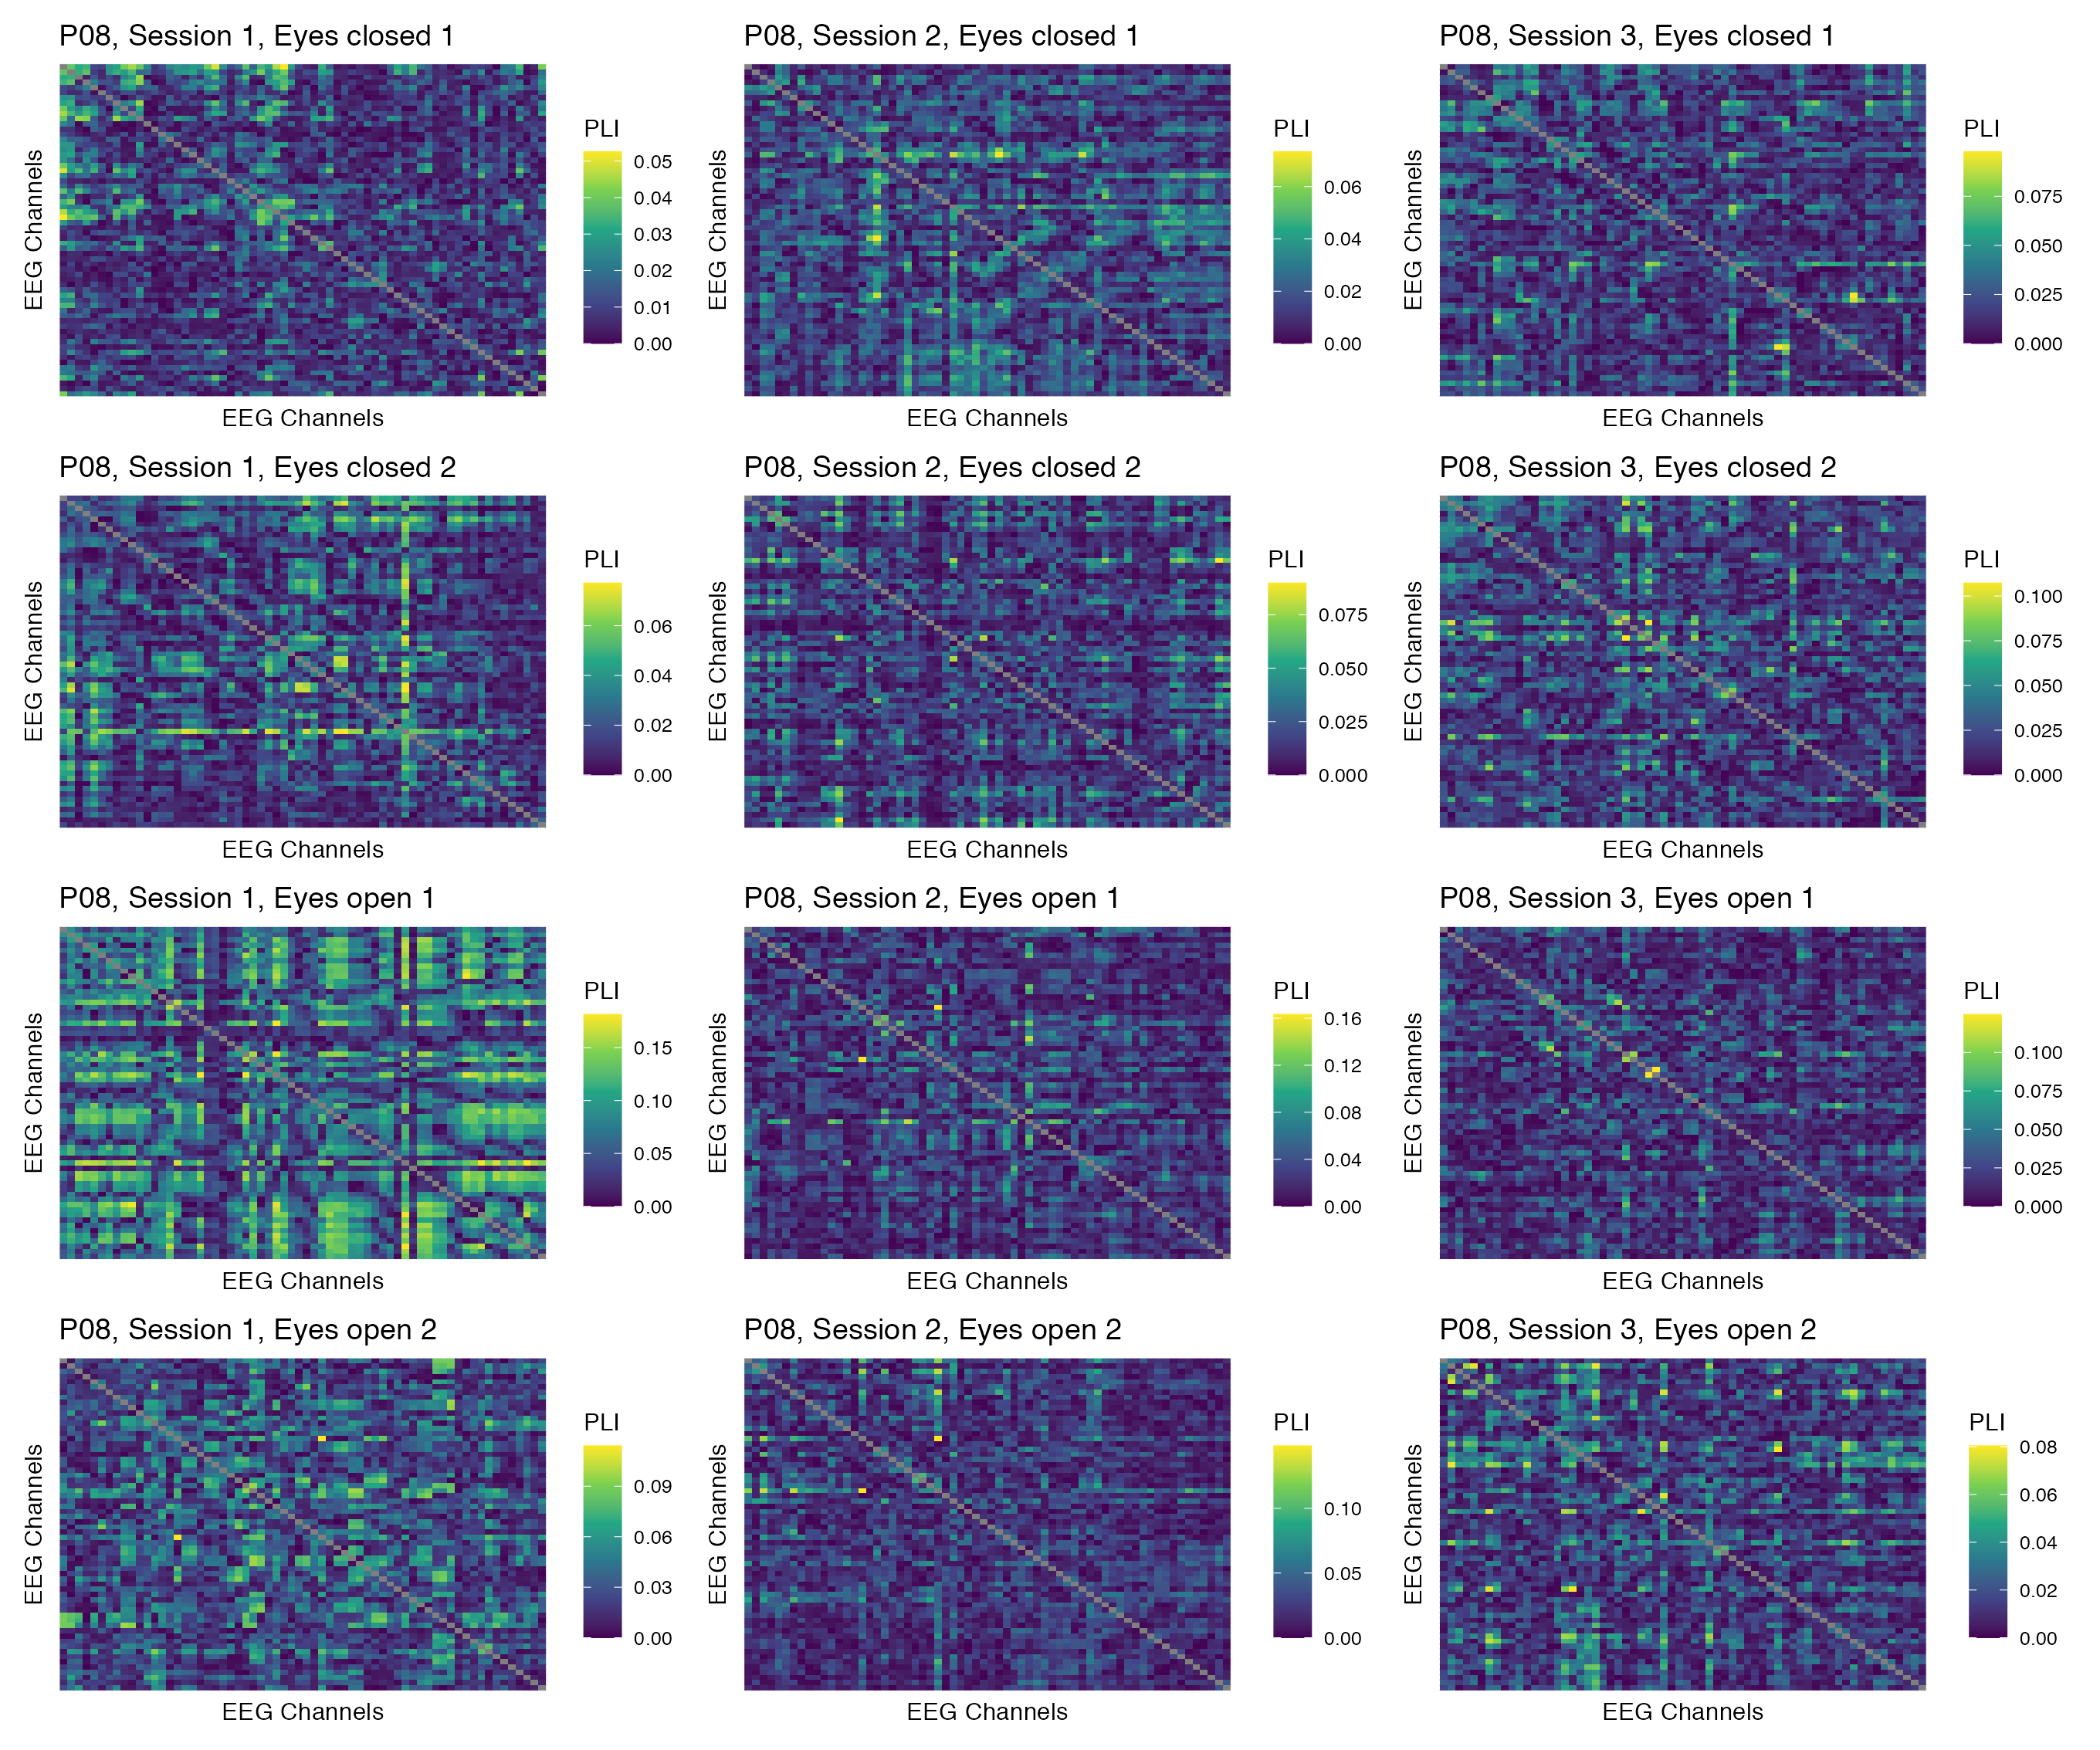

Figure 61: Phase coupling functional connectomes for participant P08 in the gamma band. For each functional connectome, EEG channels are ordered as follows (from left to right, and from top to bottom): Fp1, Fp2, AF7, AF3, AFz, AF4, AF8, F7, F5, F3, F1, Fz, F2, F4, F6, F8, FT9, FT7, FC5, FC3, FC1, FCz, FC2, FC4, FC6, FT8, FT10, T7, C5, C3, C1, Cz, C2, C4, C6, T8, TP9, TP7, CP5, CP3, CP1, CPz, CP2, CP4, CP6, TP8, TP10, P7, P5, P3, P1, Pz, P2, P4, P6, P8, PO7, PO3, POz, PO4, PO8, O1, Oz, O2.

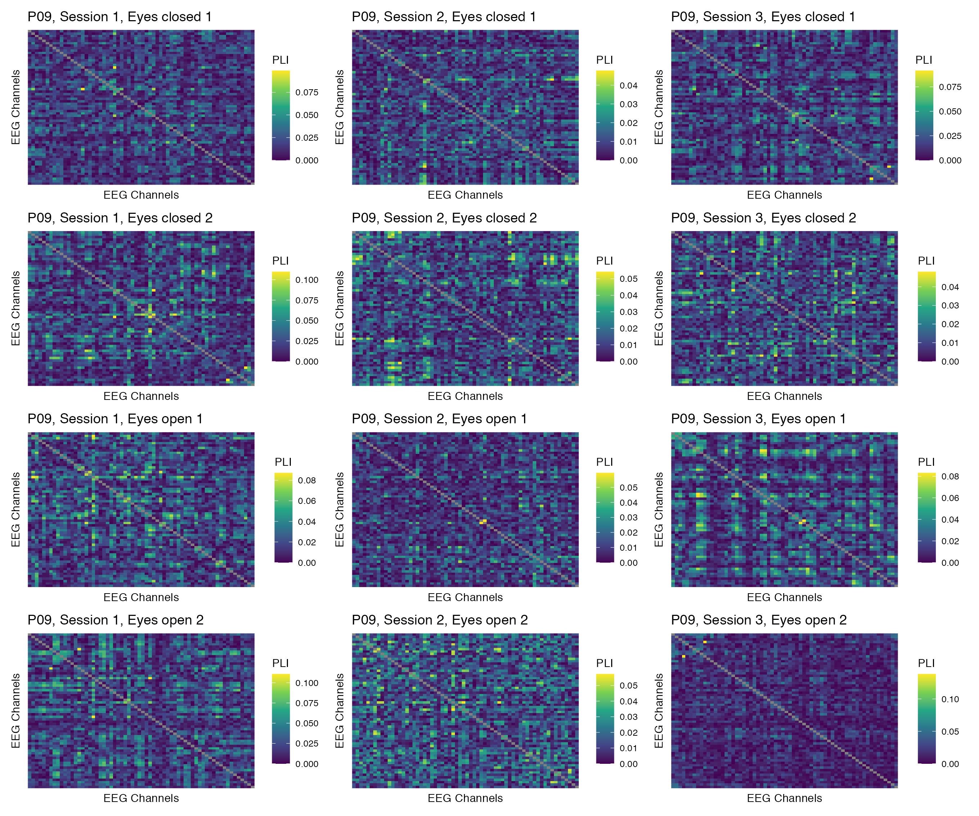

Figure 62: Phase coupling functional connectomes for participant P09 in the gamma band. For each functional connectome, EEG channels are ordered as follows (from left to right, and from top to bottom): Fp1, Fp2, AF7, AF3, AFz, AF4, AF8, F7, F5, F3, F1, Fz, F2, F4, F6, F8, FT9, FT7, FC5, FC3, FC1, FCz, FC2, FC4, FC6, FT8, FT10, T7, C5, C3, C1, Cz, C2, C4, C6, T8, TP9, TP7, CP5, CP3, CP1, CPz, CP2, CP4, CP6, TP8, TP10, P7, P5, P3, P1, Pz, P2, P4, P6, P8, PO7, PO3, POz, PO4, PO8, O1, Oz, O2.

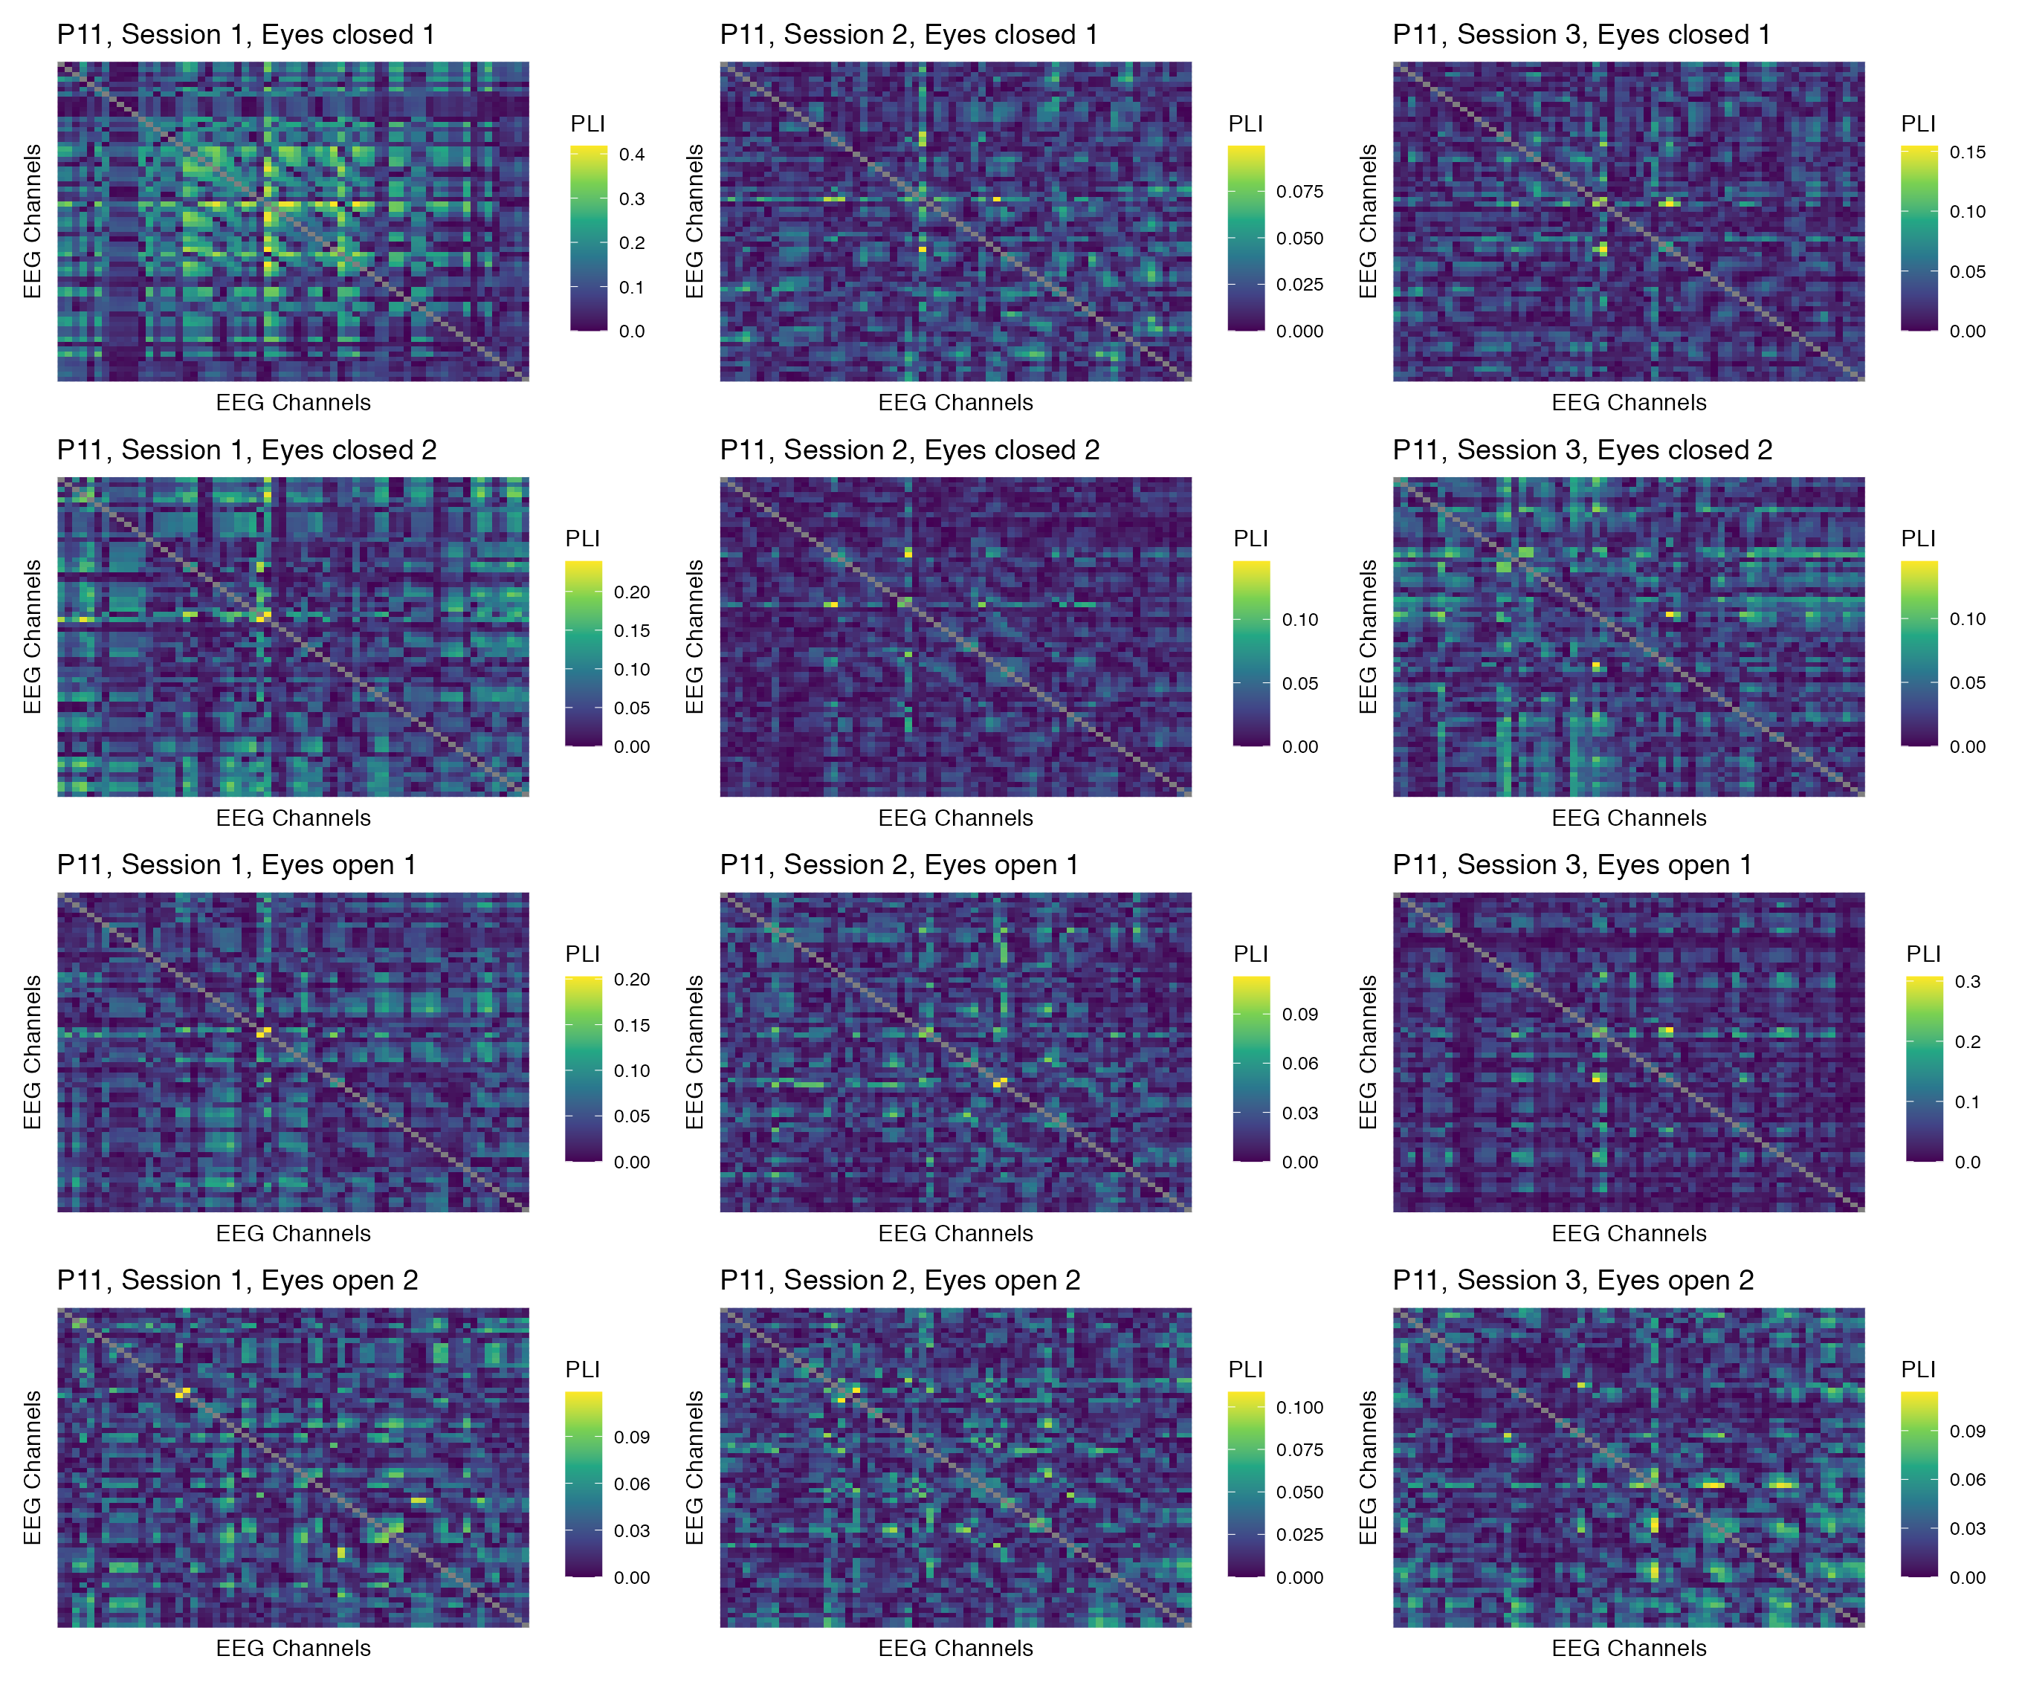

Figure 63: Phase coupling functional connectomes for participant P11 in the gamma band. For each functional connectome, EEG channels are ordered as follows (from left to right, and from top to bottom): Fp1, Fp2, AF7, AF3, AFz, AF4, AF8, F7, F5, F3, F1, Fz, F2, F4, F6, F8, FT9, FT7, FC5, FC3, FC1, FCz, FC2, FC4, FC6, FT8, FT10, T7, C5, C3, C1, Cz, C2, C4, C6, T8, TP9, TP7, CP5, CP3, CP1, CPz, CP2, CP4, CP6, TP8, TP10, P7, P5, P3, P1, Pz, P2, P4, P6, P8, PO7, PO3, POz, PO4, PO8, O1, Oz, O2.

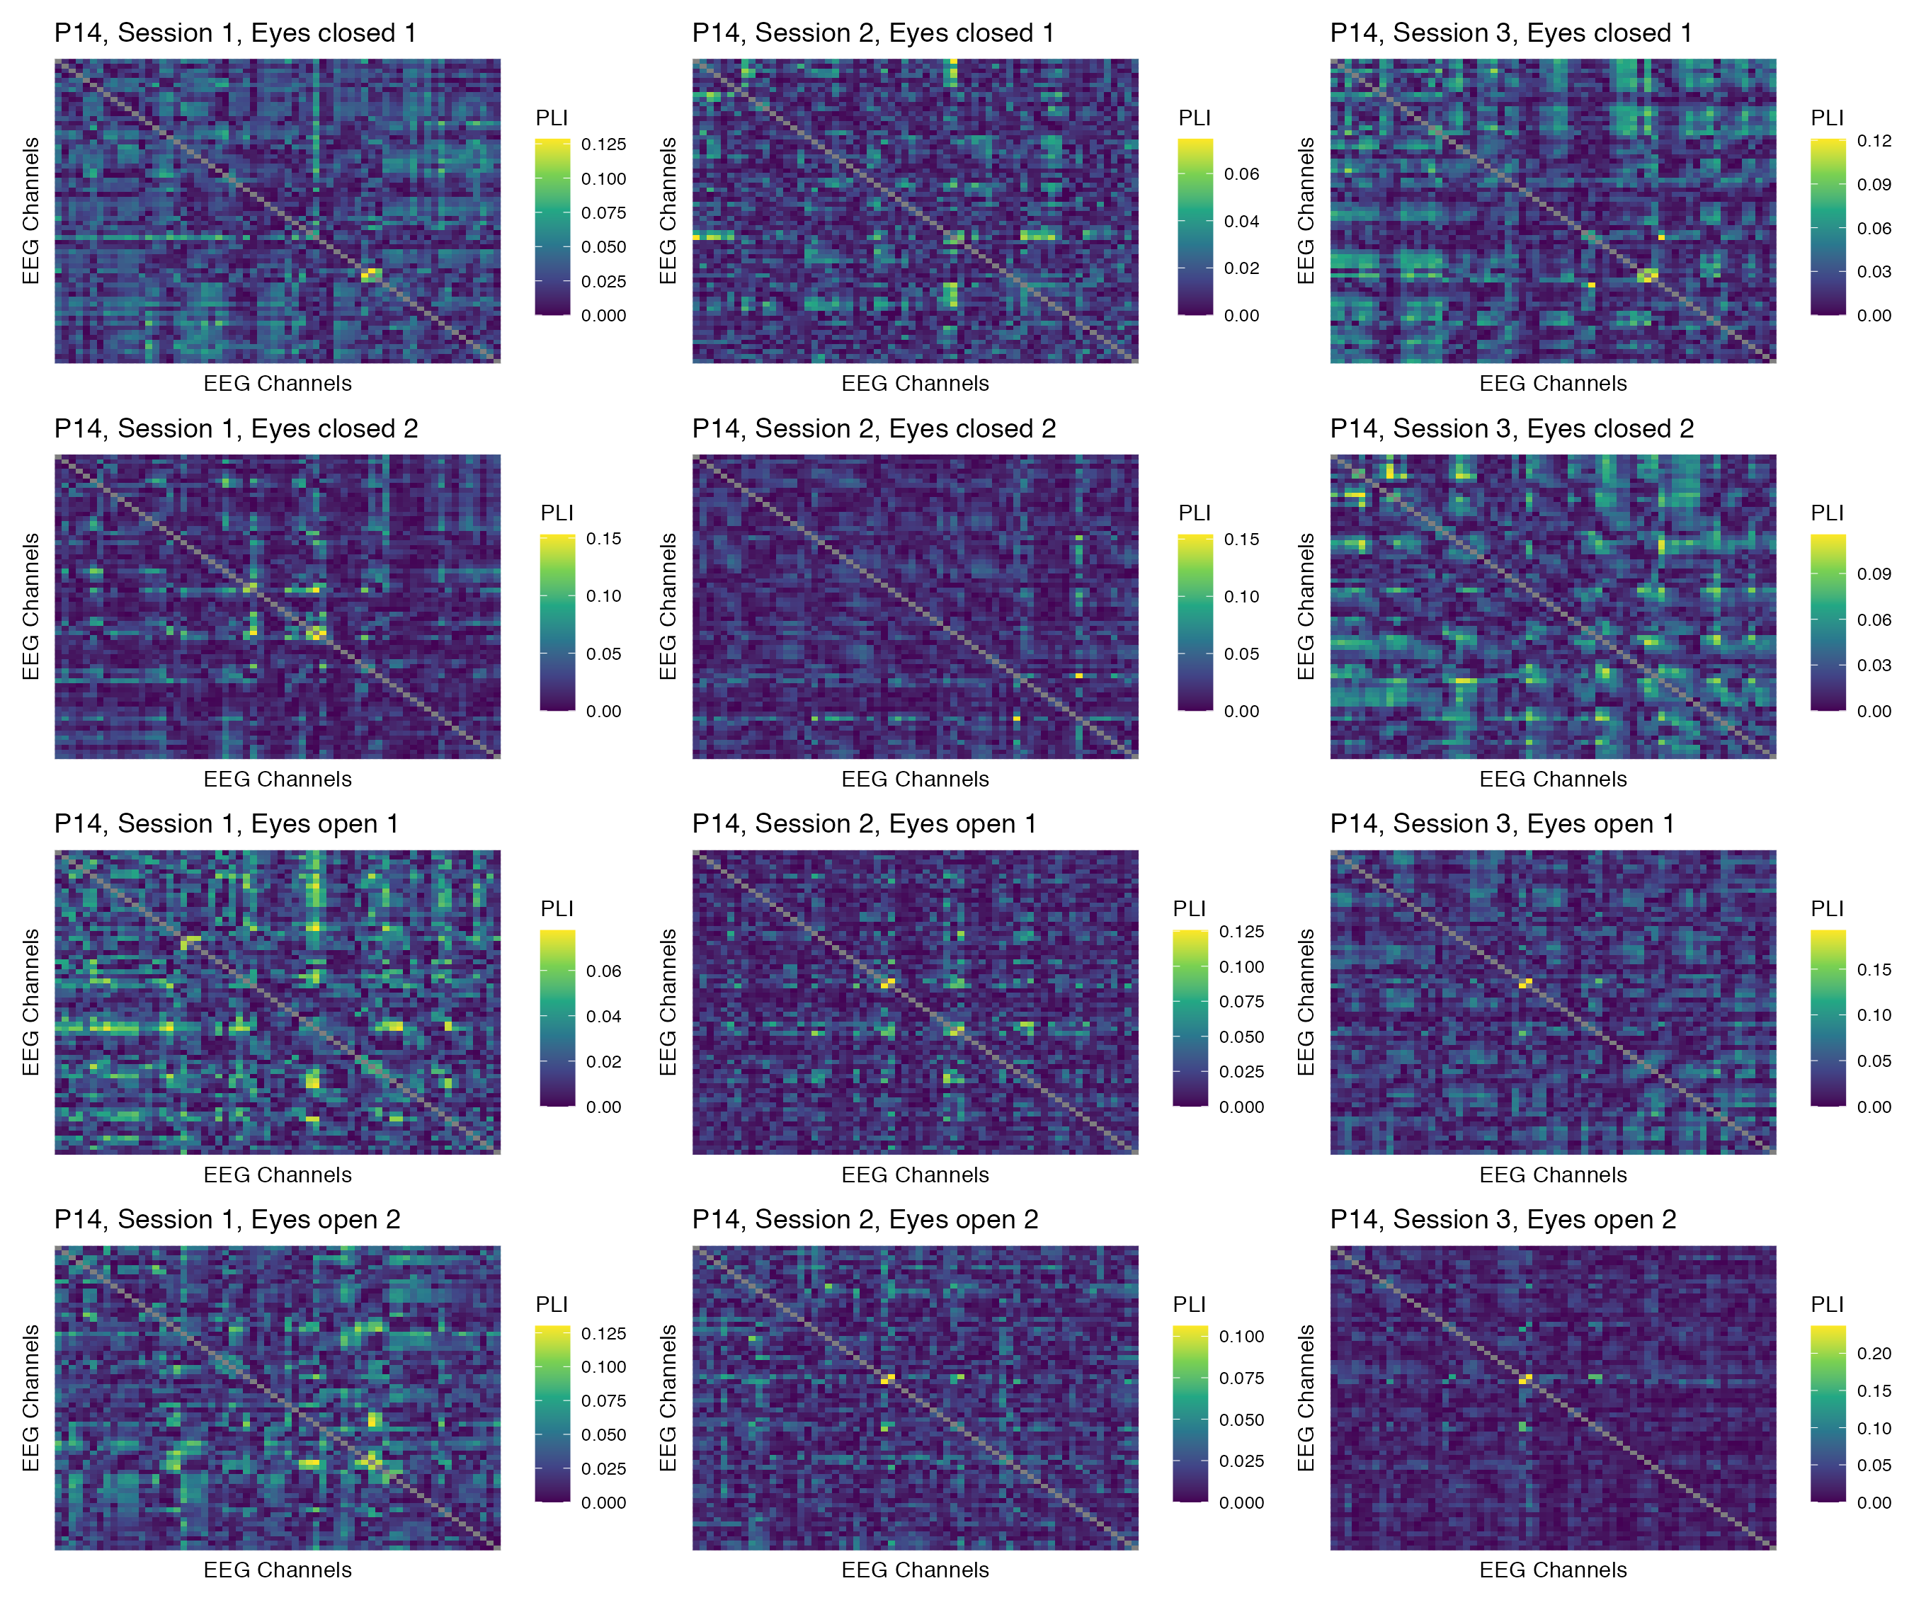

Figure 64: Phase coupling functional connectomes for participant P14 in the gamma band. For each functional connectome, EEG channels are ordered as follows (from left to right, and from top to bottom): Fp1, Fp2, AF7, AF3, AFz, AF4, AF8, F7, F5, F3, F1, Fz, F2, F4, F6, F8, FT9, FT7, FC5, FC3, FC1, FCz, FC2, FC4, FC6, FT8, FT10, T7, C5, C3, C1, Cz, C2, C4, C6, T8, TP9, TP7, CP5, CP3, CP1, CPz, CP2, CP4, CP6, TP8, TP10, P7, P5, P3, P1, Pz, P2, P4, P6, P8, PO7, PO3, POz, PO4, PO8, O1, Oz, O2.

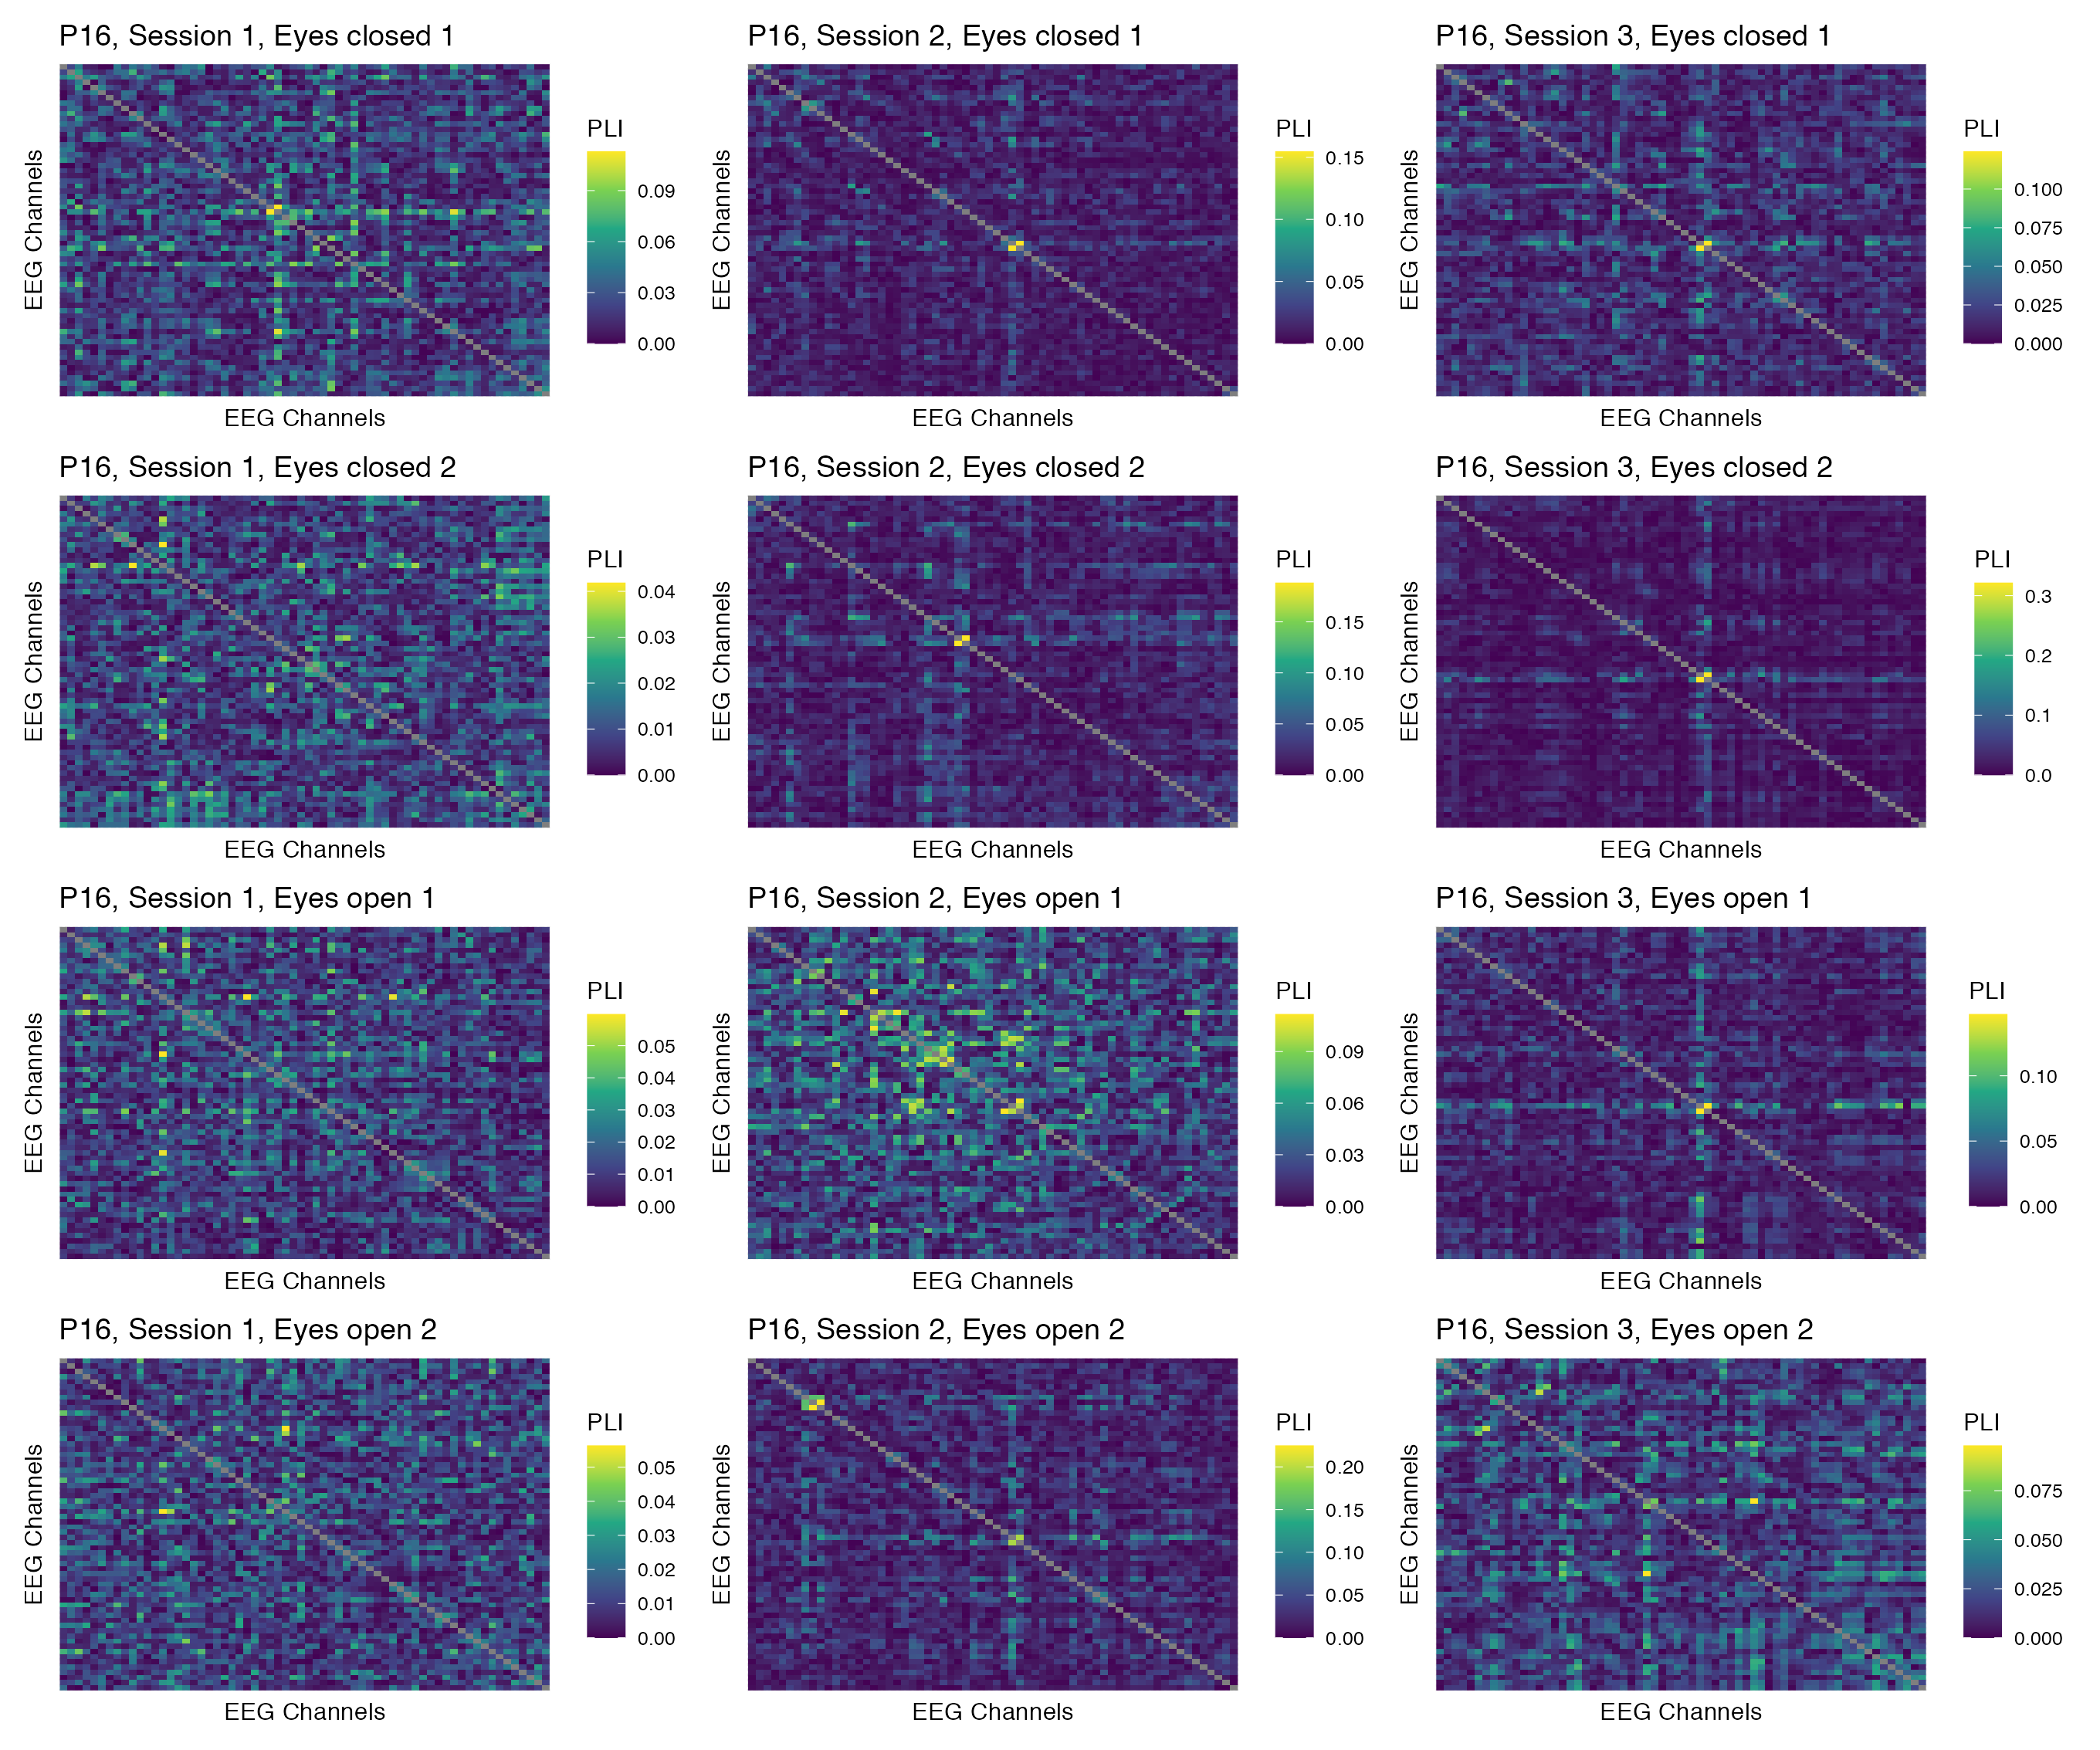

Figure 65: Phase coupling functional connectomes for participant P16 in the gamma band. For each functional connectome, EEG channels are ordered as follows (from left to right, and from top to bottom): Fp1, Fp2, AF7, AF3, AFz, AF4, AF8, F7, F5, F3, F1, Fz, F2, F4, F6, F8, FT9, FT7, FC5, FC3, FC1, FCz, FC2, FC4, FC6, FT8, FT10, T7, C5, C3, C1, Cz, C2, C4, C6, T8, TP9, TP7, CP5, CP3, CP1, CPz, CP2, CP4, CP6, TP8, TP10, P7, P5, P3, P1, Pz, P2, P4, P6, P8, PO7, PO3, POz, PO4, PO8, O1, Oz, O2.

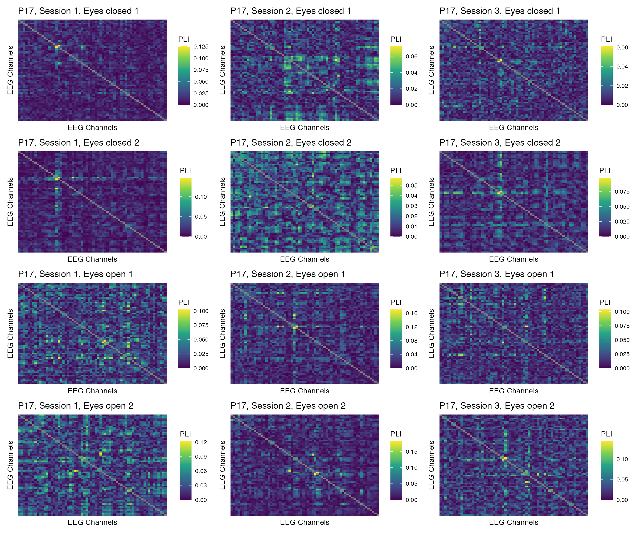

Figure 66: Phase coupling functional connectomes for participant P17 in the gamma band. For each functional connectome, EEG channels are ordered as follows (from left to right, and from top to bottom): Fp1, Fp2, AF7, AF3, AFz, AF4, AF8, F7, F5, F3, F1, Fz, F2, F4, F6, F8, FT9, FT7, FC5, FC3, FC1, FCz, FC2, FC4, FC6, FT8, FT10, T7, C5, C3, C1, Cz, C2, C4, C6, T8, TP9, TP7, CP5, CP3, CP1, CPz, CP2, CP4, CP6, TP8, TP10, P7, P5, P3, P1, Pz, P2, P4, P6, P8, PO7, PO3, POz, PO4, PO8, O1, Oz, O2.

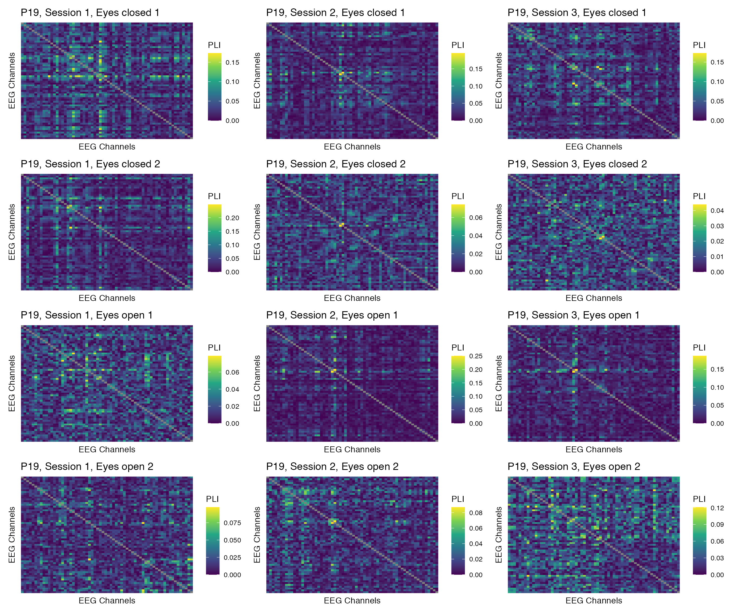

Figure 67: Phase coupling functional connectomes for participant P19 in the gamma band. For each functional connectome, EEG channels are ordered as follows (from left to right, and from top to bottom): Fp1, Fp2, AF7, AF3, AFz, AF4, AF8, F7, F5, F3, F1, Fz, F2, F4, F6, F8, FT9, FT7, FC5, FC3, FC1, FCz, FC2, FC4, FC6, FT8, FT10, T7, C5, C3, C1, Cz, C2, C4, C6, T8, TP9, TP7, CP5, CP3, CP1, CPz, CP2, CP4, CP6, TP8, TP10, P7, P5, P3, P1, Pz, P2, P4, P6, P8, PO7, PO3, POz, PO4, PO8, O1, Oz, O2.

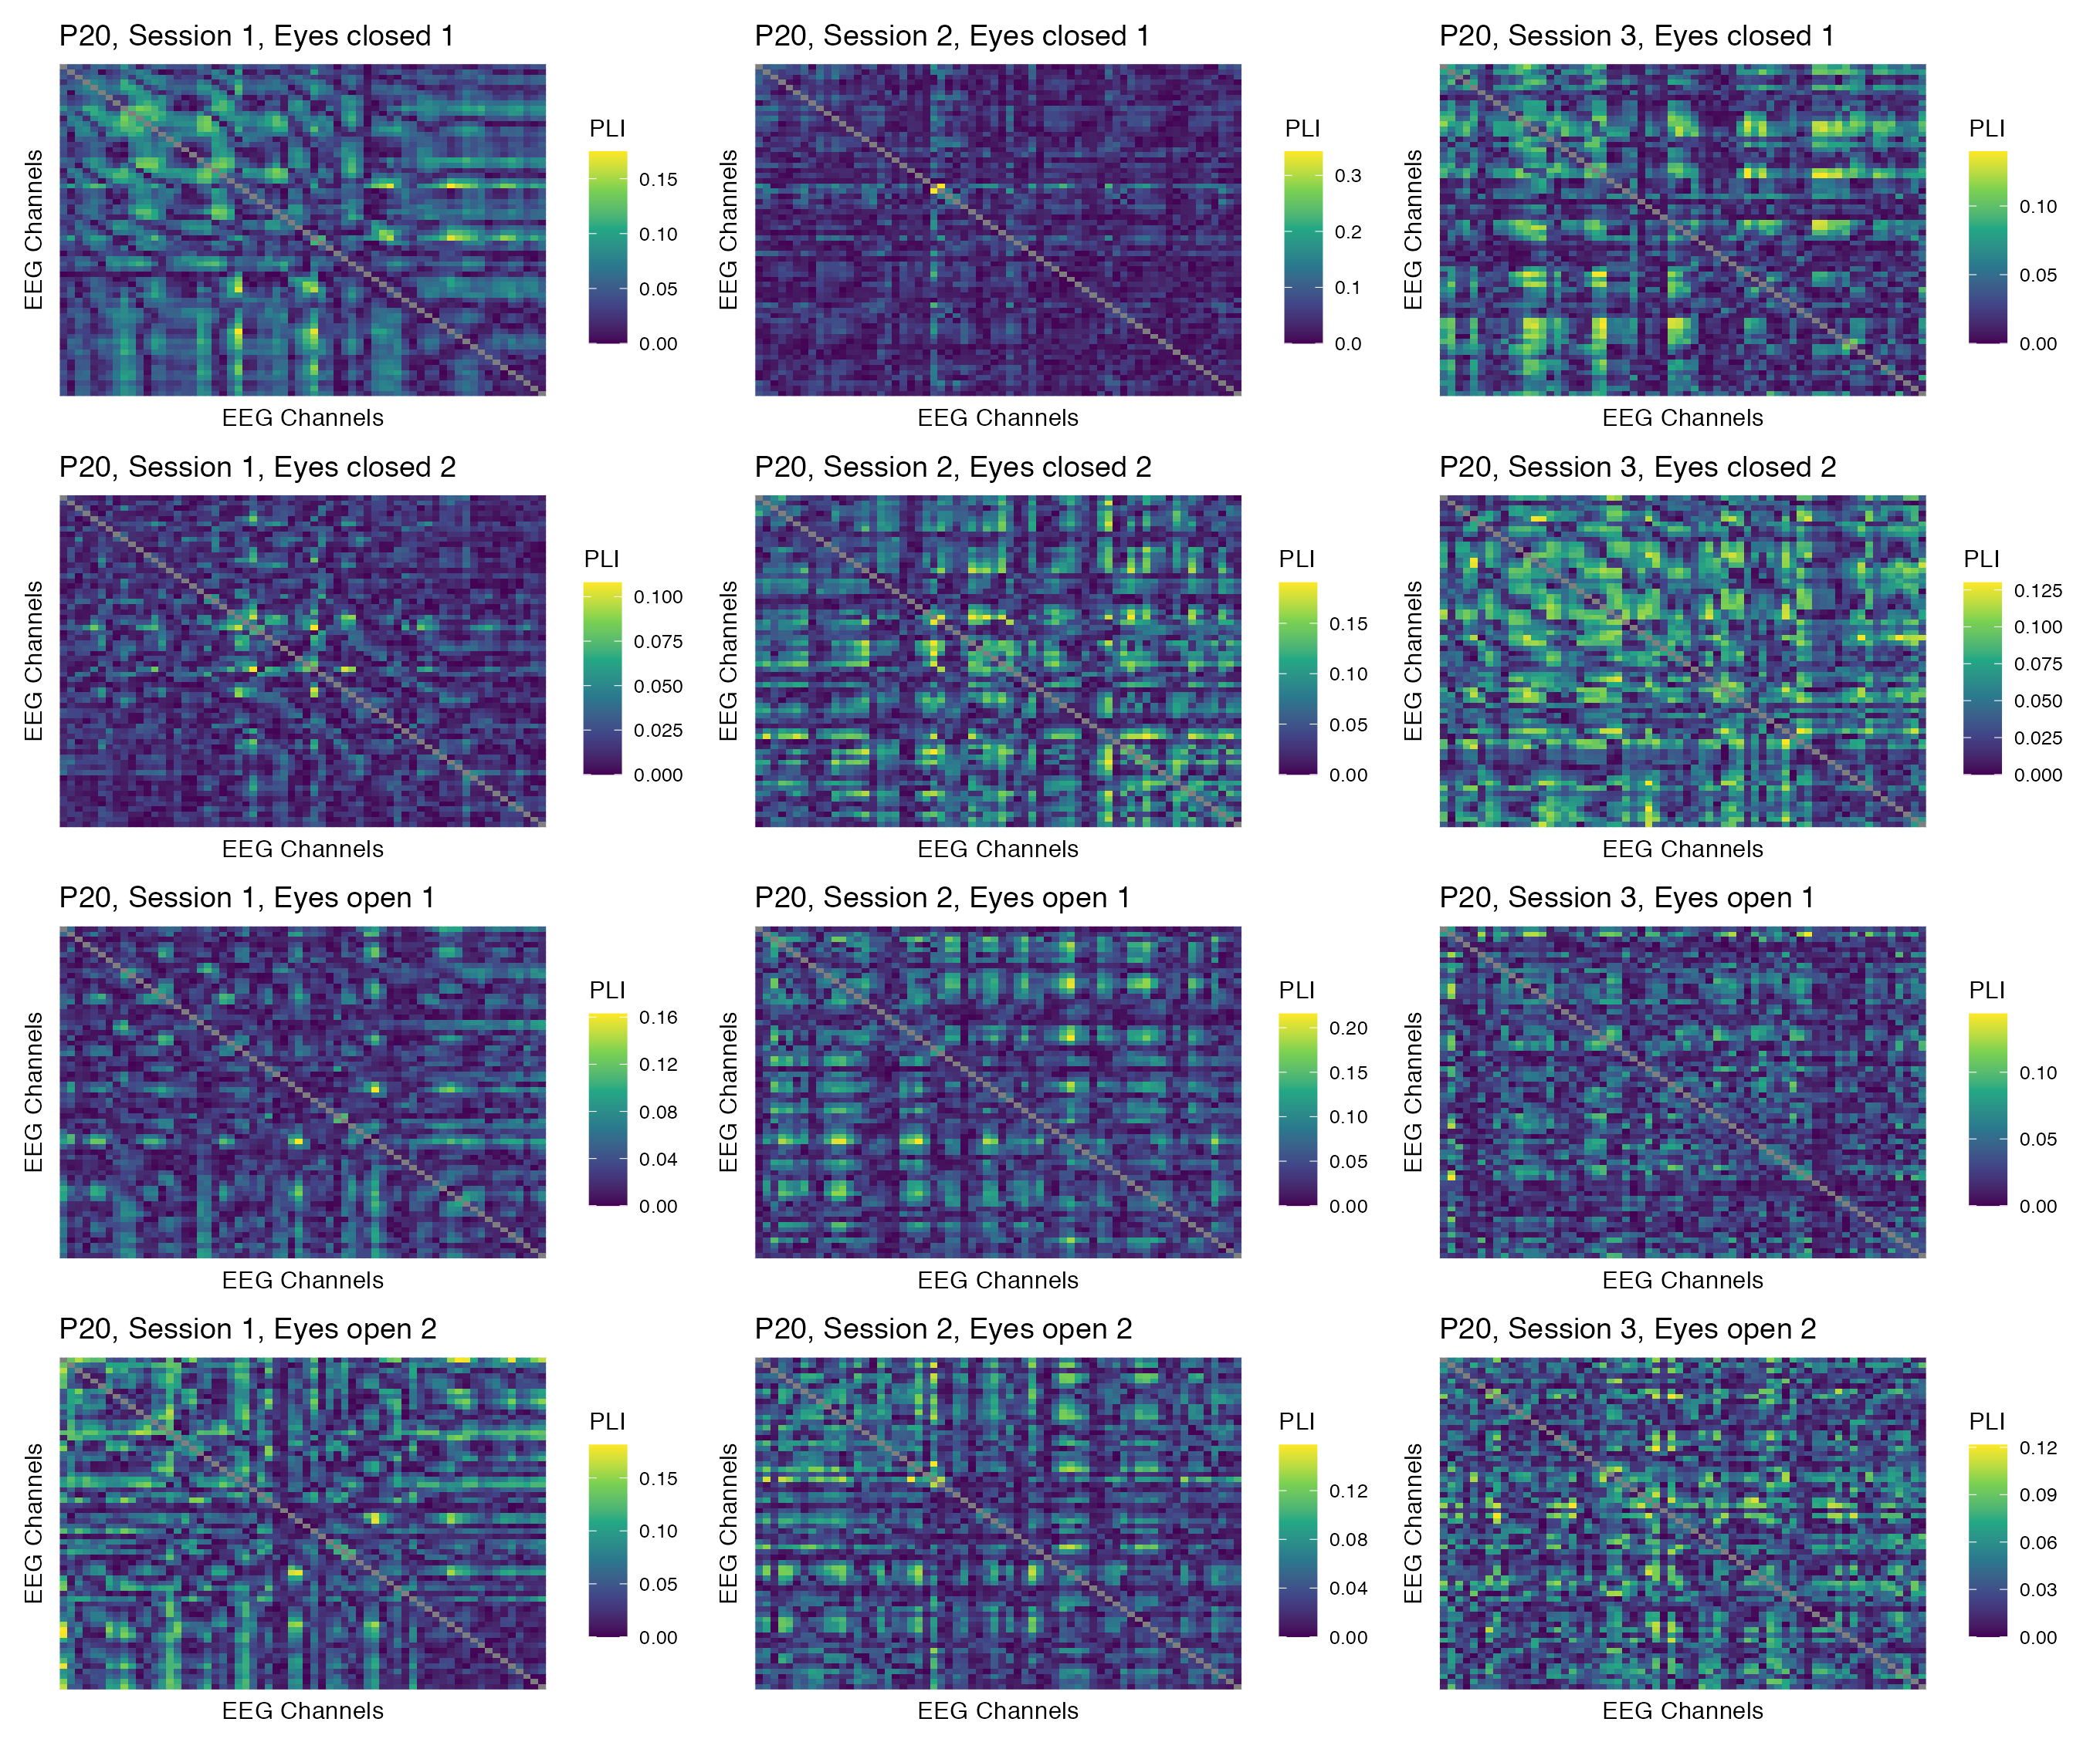

Figure 68: Phase coupling functional connectomes for participant P20 in the gamma band. For each functional connectome, EEG channels are ordered as follows (from left to right, and from top to bottom): Fp1, Fp2, AF7, AF3, AFz, AF4, AF8, F7, F5, F3, F1, Fz, F2, F4, F6, F8, FT9, FT7, FC5, FC3, FC1, FCz, FC2, FC4, FC6, FT8, FT10, T7, C5, C3, C1, Cz, C2, C4, C6, T8, TP9, TP7, CP5, CP3, CP1, CPz, CP2, CP4, CP6, TP8, TP10, P7, P5, P3, P1, Pz, P2, P4, P6, P8, PO7, PO3, POz, PO4, PO8, O1, Oz, O2.

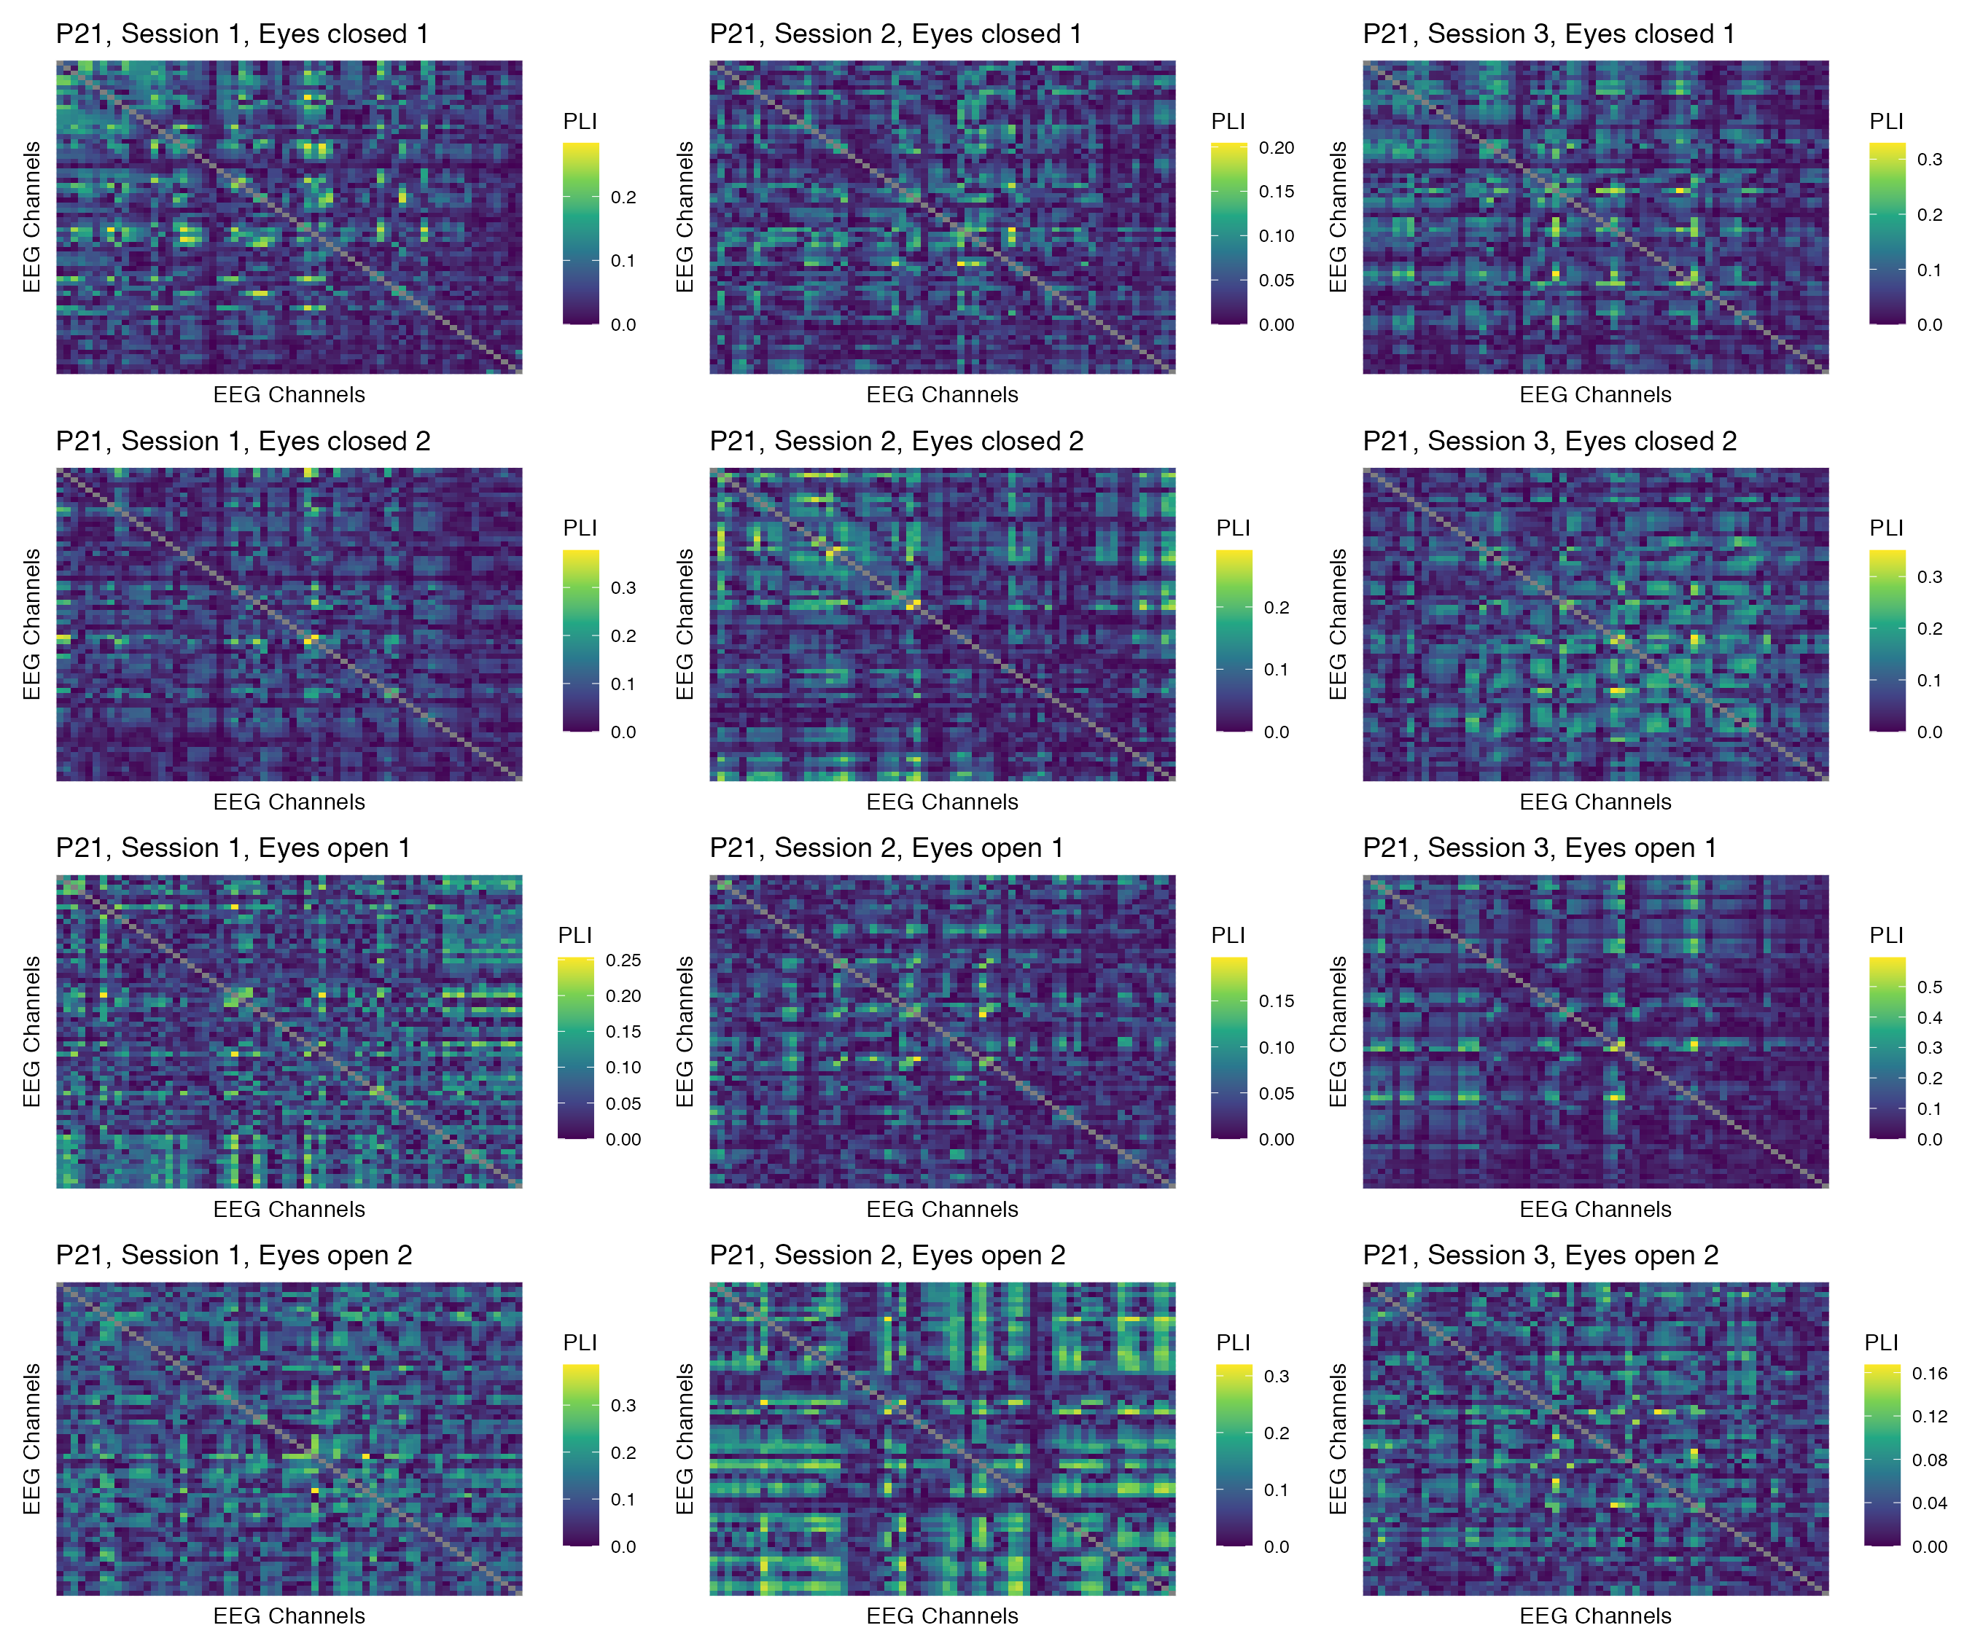

Figure 69: Phase coupling functional connectomes for participant P21 in the gamma band. For each functional connectome, EEG channels are ordered as follows (from left to right, and from top to bottom): Fp1, Fp2, AF7, AF3, AFz, AF4, AF8, F7, F5, F3, F1, Fz, F2, F4, F6, F8, FT9, FT7, FC5, FC3, FC1, FCz, FC2, FC4, FC6, FT8, FT10, T7, C5, C3, C1, Cz, C2, C4, C6, T8, TP9, TP7, CP5, CP3, CP1, CPz, CP2, CP4, CP6, TP8, TP10, P7, P5, P3, P1, Pz, P2, P4, P6, P8, PO7, PO3, POz, PO4, PO8, O1, Oz, O2.

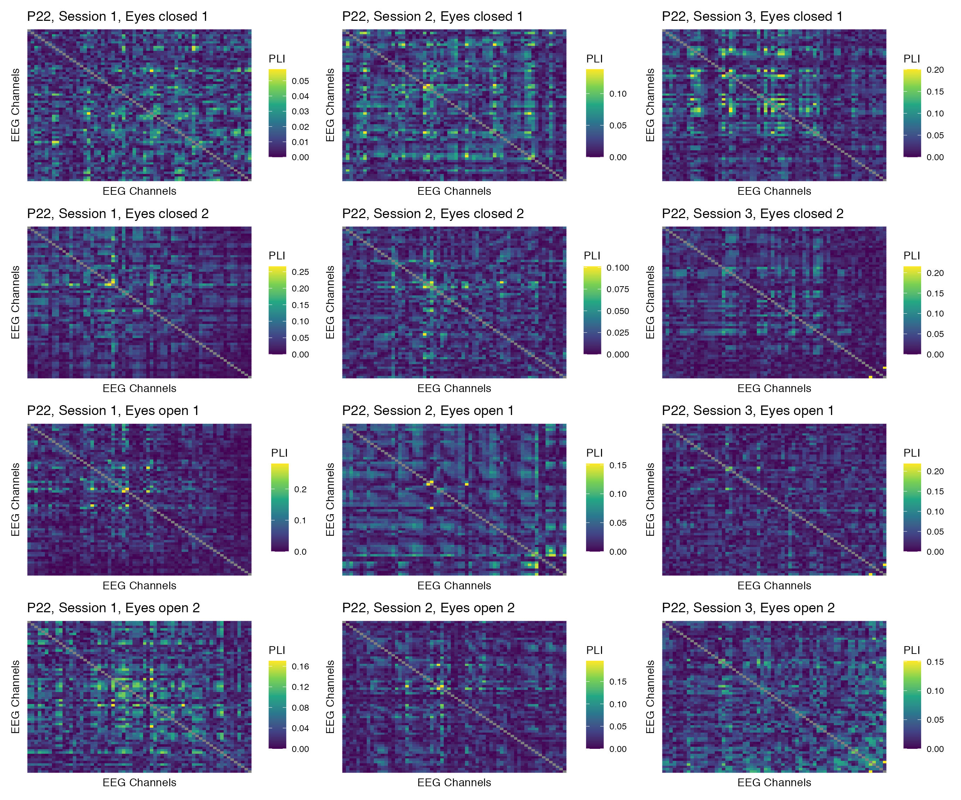

Figure 70: Phase coupling functional connectomes for participant P22 in the gamma band. For each functional connectome, EEG channels are ordered as follows (from left to right, and from top to bottom): Fp1, Fp2, AF7, AF3, AFz, AF4, AF8, F7, F5, F3, F1, Fz, F2, F4, F6, F8, FT9, FT7, FC5, FC3, FC1, FCz, FC2, FC4, FC6, FT8, FT10, T7, C5, C3, C1, Cz, C2, C4, C6, T8, TP9, TP7, CP5, CP3, CP1, CPz, CP2, CP4, CP6, TP8, TP10, P7, P5, P3, P1, Pz, P2, P4, P6, P8, PO7, PO3, POz, PO4, PO8, O1, Oz, O2.